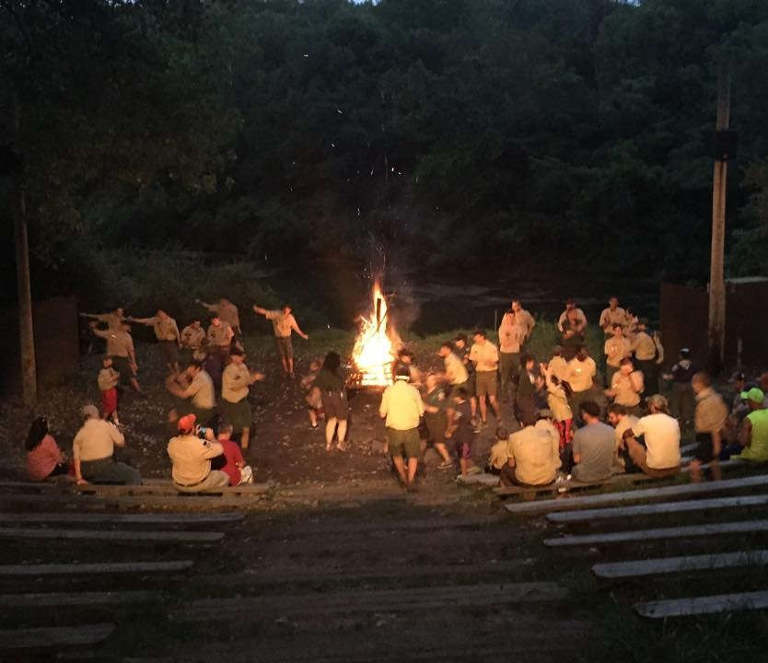
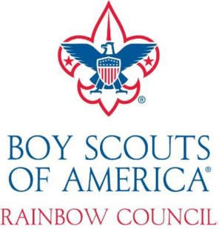

201
7

AOL Camp Guide

Rainbow Council Arrow of Light

Rainbow Scout Reservation

2600
North Winterbottom Road

Morris, IL 60450

(815) 942
-
4450

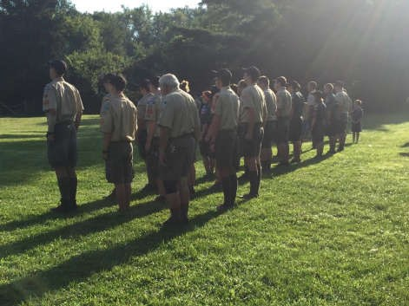
AOL, Arrow of Light, is an opportunity for the Webelos to spend a weekend at Rainbow Scout Reservation learning about boy scouts, experiencing the patrol method, and working on their rank requirements.
AOL is also an opportunity for the boy scouts to represent their troop to packs and webelos, demonstrate leadership skills, practice team building, and recruiting new members while camping in patrols.
AOL is open to open to Webelos, boy scouts, and boy scout and Webelos recruits.

Introduction

Mission Statement
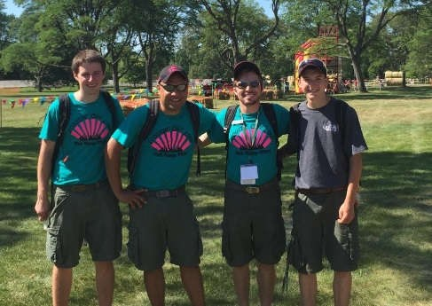
At RSR, our mission is to offer the finest camp experience which includes a safe, quality, fun filled Scouting program for every Scout, leader, and their families in camp.
In order to make this possible, we recruit only the best volunteer staff members who are dedicated to the Scouting program, professional in demeanor, and attentive to detail and customer service. We strive to be the “Living breathing example of the Boy Scouts of America, right off the cover of Boys’
Life Magazine!”

About RSR
RSR is operated by Rainbow Council, which delivers the scouting program to the communities located in Will, Grundy, and Kankakee counties. Rainbow Scout Reservation is a 737-acre preserve located in Grundy County approximately 60 miles southwest of Chicago and 25 miles southwest of Joliet. The Rainbow Council Service Center is also located on the reservation. The camp has been in service since 1968 and contains a variety of terrain, including prairie remnants, lakes, wooded river bottoms, soft and hard woods, and rugged topography.

Important Contacts
Camp Director  Cub Scouts | Rob Koziorowski | Koziorowski@comcast.net  815.690.5574
Camp Director  Boy Scouts | Bob Spence | rls@spencefamily.us
Staff Liaison | Dawn Allen | dawn.allen@scouting.org
Rainbow Council | Rainbow Scout  Reservation  2600 Winterbottom Road  Morris, IL 60450 | Rainbowcouncil.org  815-942-4450  815-942-6716 (fax)
Emergency 911

Who is AOL For?
Program | Suggested Age Range | Description
Boy Scouts camping in patrol method  Webelos  AOL, Arrow of Light  Webelos/boy scout recruits  Parents of Webelos/AOL and recruits | Cub scout 4th and 5th graders  Boy scouts 6th grade and up to 18 years of age | AOL Camp is designed for Webelos, AOL, boy scouts, recruits, and parents to participate in and enjoy. This camping experience not only gives new scouting families an opportunity to get familiar with our world class BSA Scout camp, but to get a real feel for what our Rainbow Council has to offer its youth. Rainbow council strives to advance their cub scout youth into boy scouts ranks by offering programs such as this to ease the transition for scouts and parents.

Program Activities
What does our program have in store for you?

Webelos – Cast Iron Chef, First Responder, and Stronger, Faster, Higher advancements.
AOL – Outdoorsmen, Scouting Adventure, and Building a Better World advancements.
Cub scouts learning about boy scouts and experiencing the patrol method.
Cub Scout Adults – Please use this time to familiarize yourself with the boy scout program and ask questions.
Boy Scout Adults – Please be available to answer any questions about boy scouts for cub scouts transitioning to boy scouts or new recruits. Topics could be things like how to advance, camping items, camping schedule, summer camping, high adventure, etc.
Boy Scouts – use this time to demonstrate patrol method, explain about boy scouts camping, instruct younger scouts for their advancement, recruiting, and comradery.
Boy Scouts, we are asking you to:
- Volunteer at least 2 scouts from each patrol to teach round-robin style advancement to Webelos in the morning and afternoon
- Volunteer at least 2 scouts to retrieve meal baskets for Saturday lunch, Saturday dinner, and Sunday breakfast for patrols, cub scouts, and adults
- 2 scouts to return meal baskets to dining hall after each meal
- Conduct team building games
- Set up dining hall, Wilhelm center on Friday evening and take down Saturday evening
- Teach and incorporate the cub scouts into the patrol method and activities
- Encourage (or incorporate) cub scouts to participate in campfire skits and songs
- Guide the cub scouts in setting up and breaking down of camp
- Bring your boy scout spirit and enthusiasm for the Webelos, AOL, and adults

Dietary Needs
Scouts, unit leaders, and family members that have special dietary requirements need to be communicated to the AOL Team. This information needs to be communicated to us BEFORE arrival. We will do our best to accommodate your special needs but will have limited opportunity for meal and menu adjustment if communicated on the day of camp.

Identify Your Unit Leader/Patrol Leader
In the interest of a smooth and efficient AOL experience for all, we recommend that each unit identify leaders (Scout Master and Patrol Leader, and/or Den Leader) from your group to assist in providing direction and leadership to your unit members. Some participants will be experiencing RSR Camp for the very first time and we want everyone to enjoy their time sharing in the experience together. Your help and leadership will ensure the prospect of a memorable and enjoyable experience for all.

Health Office
NOTE: Bring a completed medical form for every person attending.
RSR has a first aid building/medical office with supplies; available at all times to provide first aid services to any camper, visitor, or staff member. Designated persons will be available to attend to emergency needs if they arise. The majority of health concerns and first aid needs are minor and handled at the health office. In the event a camper requires further medical treatment; designated contacts will be immediately notified by the camp director.
RSR complies with local, state, federal, and Boy Scout of America standards and regulations. Medications need to be brought to camp in their original container.

Trading Post
RSR’s trading post is stocked with a wide variety of snacks including ice cream, candy, chips, beef jerky, and much more! In addition, be sure to check out a large assortment of Scouting related literature, patches, and Order of the Arrow merchandise. The trading post will be open Saturday after each meal for a short time.

RSR Guidelines

Emergency Plans
RSR places the utmost importance on maintaining the safety and security of our campers, unit leaders, visitors, and staff. While enjoying the outdoors and the features of our wonderful camp, there are a variety of situation that come up unexpectedly. Campers’ and unit leaders’ cooperation and preparedness are essential to RSR resolving any situation calmly and safely. Unit leaders and campers will be briefed on emergency procedures when they arrive for check-in. However, please review the instructions with your unit adults and Scouts, and ask any questions when you check in.

RSR Rules and Regulations
Please review the following rules regarding unit leaders, campers, and visitors to RSR:

Alcoholic Beverages and Illicit Materials: Possession of these on camp property is strictly prohibited and violators are subject to removal from camp property. In addition, local law enforcement authorities will be notified, if necessary.

Cash and Valuables: Scouts and unit adults are encouraged to bring extra cash to camp in order to take advantage of our Trading Post and various open programs. Please note that Scouts and unit leaders are responsible for any cash and valuables while at camp.

Clothing and Shoes: Appropriate clothing must be worn at all times by youth and adults. Open toe shoes/sandals are not allowed anywhere on RSR property. In addition, clothing with any references to drugs, alcohol, tobacco, or any other non-Scouting related clothing deemed inappropriate may not be worn.

Electricity: Scouts and Scouters should be prepared to make camp in their site without access to electricity. Campers using CPAP machines should consider a battery option for their week at camp. (Exceptions are made for special situations. Please see a Camp Coordinator for more information)

Firearms Restriction: In compliance with Boy Scouts of America National Standards, the use or possession of firearms or ammunition is strictly prohibited. Law enforcement officials required to carry duty weapons must present written notice from agency stating that carrying a weapon at all times is mandatory.

Fuel: Flammable liquid fuels are not allowed in campsites. The camp commissioner/ranger can assist with storing any fuels you bring to camp. Any type of open flame is not permitted in any tent.

Generators: The use of gas generators in campsites is prohibited

Pets: No pets are allowed on camp property.

Tobacco: Rainbow Scout Reservation has established a policy restricting smoking to a designated area that is away from campers and youth. Please do not smoke anywhere other than the designated area.

Tour Permits: Any troop traveling over 50 miles and outside their council borders should file a tour permit. The camp will sign the permit at check-in.

Vehicles in camp: During check in, units are allowed one vehicle to tow any troop trailer to their campsite. By 6PM on Sunday, ALL vehicles must be moved to the parking lot. NO vehicles will be allowed on camp roads without first securing authorization from the camp director.

Camp Check In, Check Out, Schedule, and Early Release

Check In and Schedule
RSR’s streamlined check in allows units to arrive at camp at their convenience, set up camp, and proceed through the formal check in process when they are ready.

- Arrive as early as 9/22/2017 at 7pm. Be advised program does not start until 7am next day.
- Check in at old dining hall (see map on page 9) on Friday or Sat morning.
- At check-in, you will be assigned your campsite.
- Turn in your individual medical forms for each participant (Extra blank medical forms will be available at check in).
➢ Set up camp. 
- Program starts 7am breakfast, 8:30 flags, then program at 8:45.
- Schedule available upon check-in.

Medical Forms / Medications
Please review the BSA’s Annual Health and Medical Record. This document must be completed and a copy provided for each camper at check in.
BSA policy requires that RSR comply with the guidelines of the Annual Health and Medical Record, which requires a physician’s visit. If you have questions about this document, please contact the camp director or council service center.
Medications will NOT be stored. Please make arrangements to facilitate storage of your own medications and take proper precautions to keep them safe and locked up so that no inappropriate access is granted to these items.

Check Out
Sunday morning 9/24/2017 after breakfast, your units are free to break down camp and head home. No formal check out is required at this point. We ask that unit leaders ensure that the “Leave No Trace” policy is practiced before your unit vacates the camp sites. There is limited staff for AOL and many hands make light work.

Early Release
Campers will only be released early from camp to a custodial parent or legal guardian. Release to other adults during the stay must be indicated on the BSA Annual Health and Medical Record, in the appropriate spaces.
For the Scout’s safety, unit leaders and a second leader or adult (as specified in the
Guide to Safe Scouting) must escort the Scout to the Medical Office and sign the
Scout over to the approved person. A photo ID of the person picking up the scout MUST be shown to camp personnel at check-out. Camp personnel will make a copy of the ID for Council’s records.

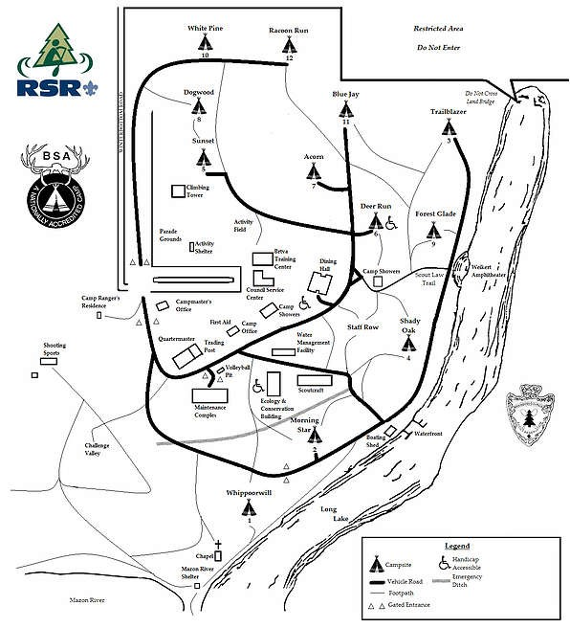

What to Bring? (for first time campers or recruits)

These items are required to make for an enjoyable and comfortable camping experience.

❖ Tent  Ground Tarp  Mallet for tent stakes  Sleeping bags  Flash lights  Grub kit (eating utensils, plate, bowl, cup) Extra shoes  Rain gear  Lawn chairs for adults  Water bottles  Class A Uniforms for Flag Ceremonies  Bug repellant  Extra roll of toilet paper  Hand soap for the camp site sinks (if you like using soap when you wash) Extra blanket  Sweatshirt or jacket for the evenings 

We encourage each boy scout unit to bring a song and or skit to participate in Saturday Nights Camp Fire. The more involvement we have the better the AOL will be. Let us know at Check In if your unit would like to participate.
We are looking forward to seeing you all there!
AOL Schedule
Saturday
7:00am Registration and Camp Set Up
8:30am Flags
8:45-9:45 Required Adventure 1 Web:
Cast Iron Chef / AOL: Outdoorsman
10:00-11:00 Required Adventure 2 Web:
First Responder / AOL: Scouting Adventure
11:15-12:15 Required Adventure 3 Web:
Stronger, Faster, Higher /
AOL : Building a Better World
12:30-1:45 Lunch (Walking Tacos)
2:00-3:00 Aware and Care (Elective)
3:15-4:15 Adventures in Science (Elective)
4:30pm Closing Flags
5:00pm Dinner (Make your foil pack at dining hall)
6:00pm Free Time with Boy Scouts
8:30pm Campfire at Amphitheater
Sunday Morning
7:45 am Flags 8:00 am Interfaith Services at Chapel
8:30 am Breakfast

****Webelos/AOL bring your books to advancements****

