Yahara District Polar Cubs
February 1, 2020
Deerfield Rod & Gun Club
4372 Rod and Gun Rd
Deerfield, WI 53531

Get ready for some fun at our Polar Cubs event. Cub Scouts and their families are invited to join us for some outdoor fun and adventures this February. The day will start with an opening ceremony followed by winter activities. Scouts will play games, explore nature and further develop their scout skills.

The opening ceremony will begin at 8:30 and activities will conclude at 2:00.

All Cub Scouts, Webelos and Siblings are welcome.

Cost: Youth $12, Adults $5 before January 25.
Lunch will be served during this event.

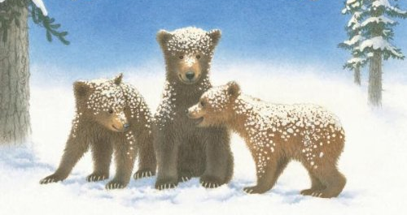

Event Contacts
Name Title Phone Email
Kelsey Schultz Yahara District Activities 313-399-0075 kschultz027@gmail.com
Oliver Dupree Yahara District Executive 608.273.1005 oliver.dupree@scouting.org

