Mountaineer Area Council, BSA
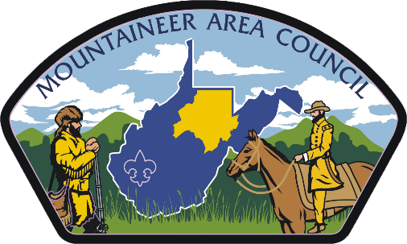

2019
Cub Scout Day Camp
Parent & Leader Guide

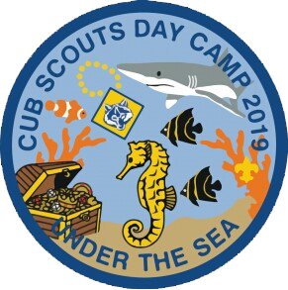
Welcome

Welcome to Day Camp 2019.
Our goal in 2019 is to make day camp convenient for our parents and exciting for our Scouts. It is vitally important that all our Cub Scouts attend a day camp at some point when they are a Cub Scout. For many, this is the highlight of their Scouting year.
2019 will be a year of new format and change to better fit the needs of our Cub Scout Families. We are excited and proud of what we are presenting for day camp in 2019.
New this year, we are experimenting with offering day camp where we provide the leadership for your Scouts.
This guide is designed to provide dates and pertinent information for our day camp this year.
We look forward to having you camp with us!

Camp Director Program Director
Evan Siefke Christina Wiley
Evan.Siefke@scouting.org Corwin2015@yahoo.com
304-366-3940

Website
This guidebook is designed to offer basic information that can be shared with parents and used by a pack’s camp coordinators to rally Scouts to attend day camp! The most in-depth information, exact schedules, and policies can be found at the website http://www.MACBSA.org. This site will hold all things day camp including forms, maps, programs, and links to the online registration. Be sure to check it out.
Be sure to like us on Facebook for up-to-date information and news from our day camp!

www.facebook.com/macbsa

Dates and Pricing
Day Camp Dates
August 1-3 at East Marion Park, Fairmont
August 5-7 at Camp Mountaineer, Morgantown
Day Camp Pricing
Early-Bird Fee (if paid by May 31) - $50
Regular Fee - $55
Late Fee (if paid after June 15) - $70
Day Camp Leadership
Packs are highly encouraged to provide a minimum of 2 leaders at no cost to assist in the camp operation.
The only exception to this rule is for Tigers (1st graders in the fall of 2019) who must have their adult partner attend with them.
Pick up
All Scouts must be picked up at 4:30 PM.

To register for day camp, follow the link below:

Fairmont:
www.scoutingevent.com/615-Fairmontdaycamp

Morgantown: www.scoutingevent.com/MorgantownDayCamp2019

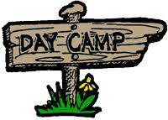

Program
Day 1 | Day 2 | Day 3
Daily Check-in
Opening Ceremony
Program Rotation
3 - 45 min stations
Lunch & Lunch Program
Program Rotation
3 - 45 min stations
Family Day on Saturday / Campfire
Closing / Lowering of Flag

Above is a typical daily schedule for day camp. Program rotations will include crafts, archery, slingshots, and more.

2019 Theme: Beneath the Sea
Advancement
Each Scout will leave day camp earning a partial loop for their rank and level 1 pins for archery and slingshots.

Tigers- Games Tigers Play / Team Tiger
Wolves- Call of the Wild / Council Fire
Bears- Bear Necessities / Baloo the Builder
Webelos- Into the Wild / Castaway

What to bring
Please ensure that each person in your Pack brings the following items for day camp

- Water bottle
- Hat
- Rain gear
- Sunscreen
- Bug spray
- Closed-toed shoes
- Backpack
- Lunch
- Towel
- Swimsuit (girls: one-piece or non-bikini two-piece; boys: non-Speedo)
- Some cash for the Trading Post

Check-in / Check-out
Check-in for day camp will start at 8:15 AM and check-out ends at 4:30 PM each day. Daily program will begin at 8:45 AM. Please plan for check-in on the first day to take more time then the rest of the camp.
Camp wraps up everyday at 4:15 PM and all Scouts need to be picked up by 4:30 PM. Please ensure that all Scouts have transportation to and from day camp.

Meals and Food
Lunches will not be provided Thursday and Friday, so Scouts will need to bring a lunch. Please remember we don’t have any places to keep food cold, so plan accordingly. Saturday there will be pizza provided for lunch. This is for Scouts only. If families want to attend they will need to plan accordingly. Also new this year is a Trading Post. Please remember this will only have small things and should not be used for lunch.

Pets
With the exception of service animals with documentation, no pets are allowed at day camp.

Sibling and Walk-Along Policy
Per Scouts BSA we can not allow siblings who are not Registered. (Siblings can be registered day of camp)

Refunds
There will be No Refunds given.

