Clarksburg Cub Scout Day Camp
Scout Registration Form
June 10 -14, 2019

SCOUT NAME 2019 FALL RANK
 | TIGER*** |  | WOLF |  | BEAR

PACK
WEBELOS 1 WEBELOS 2

*** TIGER Adult Partner Name:

SCOUT DOB
 | YS |  | YM |  | YL

T-Shirt Size

AS AM AL AXL AXX AXXX

Address Home # |  | Scout Information
Address  Home # Alternative # | Father Information  SAME AS SCOUT
Address  Home # Alternative # | Mother Information  SAME AS SCOUT

My Scout and I understand that inappropriate Scout behavior will not be tolerated. The Camp Director and Mountaineer Area Council reserve the right to contact the parents/guardians to remove the Scout from camp. No Refunds will be given.
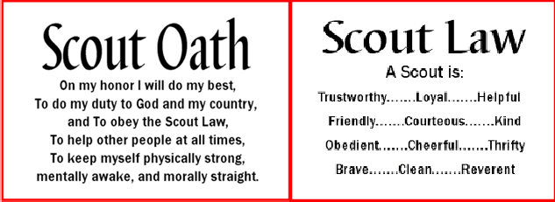
I have reviewed the Scout Oath and Scout Law with my Scout:

Parent Signature: |  | Date:
Scout Signature: |  | Date:

Please return this form directly to your Cubmaster or
Peggy Sue Miller, 98 Hickory Heights Dr, Clarksburg, WV 26301

