2019
Cub Scout
Resident Camp Leader’s Guide

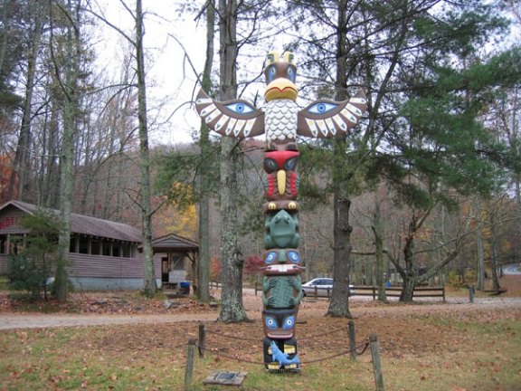

Welcome to the 2018 Cub Scout Resident Camp! Please read over this leader’s guide and fell free to copy and distribute the enclosed information as you plan your Resident Camp experience.

The following are some vital things to keep in mind:

•Resident Camp will take place from Saturday, July 27 to July 29.

• Visit blueridgecouncil.org for registration and other information not provided in this guide.

•Cub Scouts will have FUN while at camp.

•The cost is $135 for Cub Scouts and $100 for adult leaders.

•Check in takes place at 3pm on Saturday, July 27. Cub Scouts and leaders will receive a camp tour and have a swim test.

• Check out takes place at 3pm on Monday, July 29

May we express our sincere gratitude for your devotion to the Scouting program as you continue to enrich the lives of today’s youth.

Josh Hipps
Camp Director
Blue Ridge Council, BSA
1 Park Plaza
Greenville, SC 29607
864-233-8363 Fax 864-233-2424
Michael Kirby
Program Director
Blue Ridge Council, BSA
1 Park Plaza
Greenville, SC 29607
Kirbym14@gmail.com
Saturday, July 27  3:00 Check in/Camp Tour  5:50 Assembly(Class A)  6:00 Dinner  7:00 Den Time  8:00 Games  10:00 Sleepy Time  Sunday, July 28  7:00 Rise and Shine  7:50 Assembly  8:00 Breakfast and Chapel  9:00 Activity Session 1  9:30 Activity Session 2  10:00 Activity Session 3  10:30 Activity Session 4  11:00 Activity Session 5  11:30 Activity Session 6  12:20 Lunch  1:00 Take Ye Break  2:00 Activity Session 7  2:30 Activity Session 8  3:00 Activity Session 9  3:30 Activity Session 10  4:00 Activity Session 11  4:30 Activity Session 12  5:50 Assembly(Class A)  6:00 Dinner  7:00 Twilight  8:30 Campfire  10:00 Sleepy Time | Monday, July 29  7:00 Rise and Shine  7:50 Assembly  8:00 Breakfast  9:15 Meadow Games  12:20 Lunch  1-2:30 Free Time  3:00 Check Out
2018 Resident Camp Schedule

*This is a sample schedule

Emergency Procedures
Limitation of Activity
Campers and leaders will be notified as necessary if activity must be limited because of temperature,
humidity, or severe weather.

Emergency Call
The general emergency call will be the ringing of the bell near the Dining Hall and the playing of
the bugle. Units should line up in the meadow in formation when they hear this call.

Fire
In the case of fire, evacuate the tent, building, or area immediately. Notify the Program Director,
Ranger, or Camp Director or the nearest staff member who will direct you from there.

Medical
Stay Calm! Immediately notify the Camp Medical Officer or nearest staff member. All injuries
must be logged in at the Health Lodge.

Child Abuse
Suspected child abuse-whether physical, mental, emotional, or sexual-should be reported to the
Camp Director or, if he is not present, the Program Director or Ranger. You should not try to seek proof yourself.

Earthquake/Flood/Severe Weather
Take cover. The Program or Camp Director will assemble units if required. Commissioners may be
sent to each campsite to give appropriate instructions.

Lost Person/Lost Swimmer
If you suspect a lost person or lost swimmer, immediately notify the Program or Camp Director.

Unauthorized Persons
If you suspect unauthorized persons have intruded into Camp, immediately notify the Program
Director, Camp Director, or Ranger. Authorized visitors must sign in at the Camp Office.

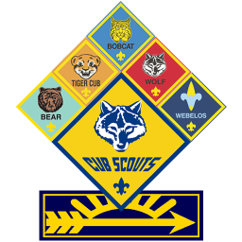

Camp Old Indian Facilities
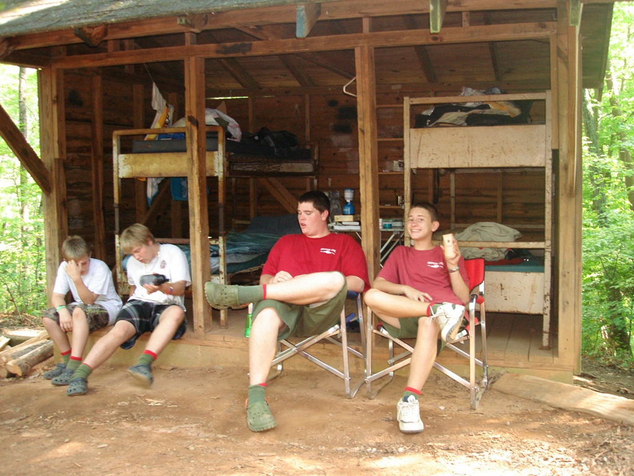

Housing

Camp Old Indian houses its campers and leaders in permanent housing. Campsites are comprised of either cabins or adirondacks. Adirondacks are three-sided units with an over-hanging roof. Most hold four campers and their gear. Some adirondacks hold eight campers and have a built-in porch with table. In the event of overﬂow housing in a campsite a tent will be provided to house additional campers.

Campsite Bathhouses

Each campsite has a bathhouse which includes: a large sink and mirror, separate hot water shower stalls, ﬂush commodes, ﬂush urinals and lighting.

Visitor's Bathhouse
Located in the parking lot is separate male and female shower rooms. Each features lavatories,
toilets, and hot showers. These bathhouses are available for Cub Scouts and leaders only between 8AM and 3:30PM.

Field Sports Area
The range have been built and certified according to Boy Scouts of America standards. The camp furnishes BB guns and archery equipment. The Field Sports Director has absolute authority for all activities at the Field Sports Range. BB’s will take place at the range and archery will take place at the archery range near the Oconee A’s campsite.

Scoutcraft Area
The Scoutcraft area includes a program shelter and tarps with tables for instruction.

First Year Camper (Pathfinder) Area
The First Year Camper Area features a program shelter and a small teaching area.

Camp Office
The Camp Office is your first destination when you reach camp, as a leader. Here, you will check
your den in, pay any remaining balances, and get further information, followed by a tour of camp. During the week, leaders will have times where they can access the internet from the Camp Office. Bandwidth and data usage are limited, so donations are accepted to upgrade the capabilities of our internet.

STEAM Area
The STEAM area is located beside the Director’s Cabin at the bottom of the meadow.

Handicraft Lodge
The Handicraft Lodge houses tools for craft work and is located near the parking lot.

Nature Lodge
The Nature Lodge includes animals, displays, literature, and other items. It is located behind the camp office.

Trading Post
The Trading Post has Scout literature, t-shirts, souvenirs, and refreshments for sale. It also serves
as the Camp Post Office. There is a $10.00 minimum card purchases. NOTE: Council gift cards do not work at camp.

David Peden Health Lodge
The Peden Health Lodge serves as a 24-hour contact resource for a unit's first aid needs. The Health
Lodge features an isolation room and bathroom for sick campers.

Waterfront Area
The Camp Old Indian Waterfront includes lakes for swimming, rowing, canoeing, kayaking, and
fishing. Cub Scouts and leaders may swim at the first lake during the times listed on the program schedules. "Free swim" is open to everyone according to their swim classifications. Non-swimmer instruction will also be available during the week.
A swimmer must accompany a non-swimmer in a rowboat. Only swimmers are allowed in
canoes unless the non-swimmer is with a 21-year old certified lifeguard. Everyone using row boats and canoes must wear a life jacket. Absolutely no camper or leader will use the waterfront without a medical form and swim test. The Aquatics Director has absolute authority for all activities held at the waterfront area.
A certified lifeguard must conduct any swim tests not conducted on camp property. Swim Classifications There are three classifications of swimmers a camp. Scout and leaders, who were unable to complete their swim test prior to camp, will take a swim check test Sunday afternoon to determine their swimming classification. The classification and swim test requirements are listed below.
1. Non-swimmer-Get in the water.
2. Beginner-Jump into water over one's head, level off, swim 25 feet, turn sharply, and return
to the starting point.
3. Swimmer-Jump into water over head, level off, swim 75 yards in a strong manner using
side, breast, crawl, or trudgen strokes. Swim 25 yards using an elementary back stroke. At the end of the 100 yards, rest by ﬂoating.

Dining Hall-Patterson Lodge
Completed in 1994, the Patterson Lodge is a state of the art dining facility and seats up to 450
campers. Rules: No wet bathing suits, chewing gum, hats, hiking staffs, or ﬂag poles are allowed in the dining hall.
Table Waiter System
1. Units will be assigned tables on Saturday and will sit at these tables for every meal.
2. Table waiters will be assigned for every table and will serve for three meals beginning Wednesday evening, then rotating with other Cub Scouts in the den. An adult leader needs to assist their Cub Scouts clean.
3. Table waiters will report to the dining hall at 7:45 a.m. for breakfast, 12:05
p.m. for lunch, and 5:45 p.m. for dinner.
4. Table waiters will set up their den seating area before meals, and will clear the area after
meals. Clean-up includes wiping tables and sweeping around the tables and mopping.
5. After the meals, the waiter leaves the dining hall when they are dismissed by the Dining Hall
Steward.

Totem System
Most tables will have a seat reserved for a Camp Old Indian staff member. The table waiter should
pick up the totem for the staff member he wants and place it at his table. Totems allow for positive interaction between the Staff and Cub Scouts.
Menus
Dining Hall menus are well-balanced and designed to feed hungry Cub Scouts and leaders. In addition
to the main entree offered at each meal, other options are available for those with special dietary needs. Bagels are breakfast options; peanut butter and jelly, and a salad bar is available at most noon and evening meals. Be sure to notify the director of any special needs before camp.

Family Style
Camp Old Indian will run family style at all meals. The table waiters will not only set
the table but they will also bring ALL food to their table. After grace outside, you will go into the dining hall (no more concern about who goes first) and immediately sit down at your table where the food will already be in serving trays placed there by your waiter. Adults/staff will oversee serving distributions (family style!) at each table. We expect this to eliminate food waste and time spent in line not only for the first serving but also seconds since only the waiter will go to the kitchen for seconds based on demand.

Activity Building
The activity building is located above the meadow and provide a central rain location for merit badges, campfires and chapel services.

Handicap Accommodations
Camp Old Indian believes that all registered leaders and members deserve an experience at summer camp. Therefore, everyone is encouraged to attend. The Maria Dukes Lodge is the camp’s handicap accessible facility. It features a wheelchair ramp and a built in shower and restroom. Preference will be given to units with participants requiring special accommodations.

Chapel
It is located on the first lake in a beautiful waterfront setting.

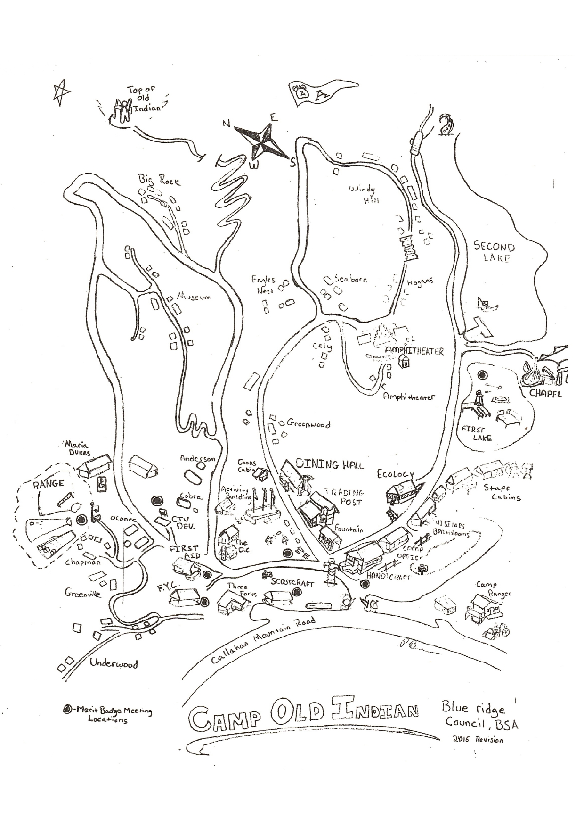
Map of Camp Old Indian

