

**Blue Ridge Council**

**Sports, Entertainment, and Travel Auction**

*Count me in! For the Sports, Entertainment & Travel Auction*

Tickets

-

$30 each Two tickets

-

$50

Menu to include:

Crab Cake and Short Rib Slider Station, Mac & Cheese Bar, Ribeye Carving, Dessert,

& Beer and Wine

Company / Individual Name: __________________________________________________________________

Address: ____________________________ City, State, ZIP: _________________________________________

Email: ___________________________________ Phone: _____________________________________________

**Register Online at**

https://scoutingevent.com/551-2017AuctionTickets

**or Return Form To**

Park Plaza Greenville SC 29607 | P. (864) 233.8363 | F. (864) 233.2424 |

1

Robin.mullinax@Scouting.org

**(Tickets will be available at check-in the day of the event or at the Council office)**

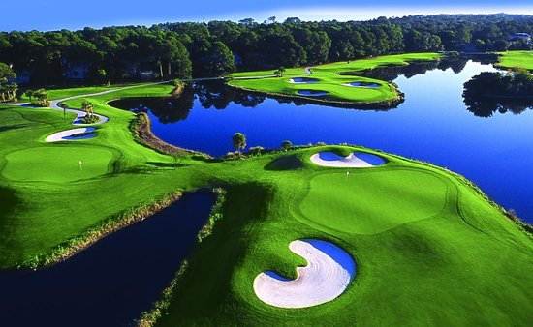

Proceeds from the auction support the nearly 10,000

youth in the Blue Ridge Council. Through Scouting,

thousands of young men, and women become

“Prepared. For Life.”

**Tuesday, October 3rd, 2017, 6:30 pm**

**Hyatt Regency, Downtown Greenville**

*Auction Includes: African Safaris, Beach Trips, Golf Packages, Restaurant Certificates, and* ***NEW THIS YEAR A LIVE PERFORMANCE BY JARED EMERSON FOLLOWED BY AUCTION OF HIS PAINTING!***

[***www.jaredemerson.com***](http://www.jaredemerson.com)

**More Information and Sponsorship Opportunities at**

[www.BlueRidgeCouncil.or](http://www.BlueRidgeCouncil.or)g

**Purchase Tickets Directly At**

<https://scoutingevent.com/551-2017AuctionTickets>

