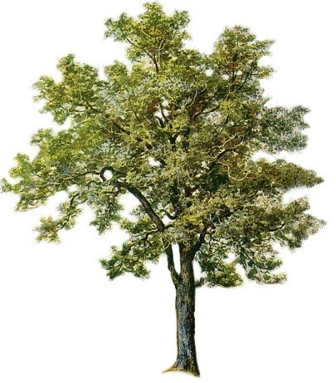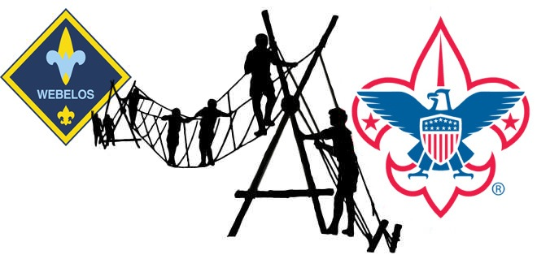

Webelos Woods
Blue Ridge Council

Where: Camp Old Indian
When: November 3-5, 2017

What:
Webelos Woods in a transition camping experience for Webelos. The boys will act and function according to the patrol method and will elect leadership positions in their patrol. Parents will be introduced to the patrol method and skills to help the troop. Every scout deserves a trained leader, and the parents will take several steps towards that goal. Two different training courses for parents will be offered: Troop Committee and the Scoutmaster/Asst. Scoutmaster classroom training

Who:
Current Arrow of Light, and Webelos I are invited to attend. Scouts will be randomly assigned to a patrol of boys; your child may not be assigned to a patrol with members from his current unit. A boy scout will also be assigned to each patrol. A parent must be present for the entire weekend; sorry there is no room for siblings.

Schedule:
You will need to arrive Friday Nov. 3th by 7:00pm and we will finish up Sunday at 10:00 am. The boys will work toward a few requirements included in the new program. They will also work on a service project to give back to Camp Old Indian. A special flag retirement ceremony will be held at Saturday’s campfire in honor of Veteran’s Day; active and retired military are encouraged to participate.

Cost:
$30.00 per person ($60.00 for Scout/Parent) includes a Shirt for scouts. T-Shirt for Parents is $15.00. Please register by October 21st to receive shirts in time for Camp.

Registration:
Additional information will be available on the council and district websites or email Bill Steigerwald Steigerwaldw@gmail.com
Registration begins September 1st and ends October 21st.
Registration will be available online and through the council office.

