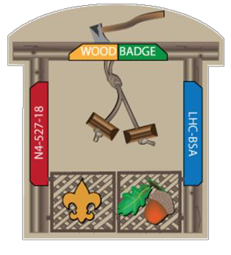
wood badge n4-527-18 staff apparel order form

Item | Sizes  Avail. | Size  Ordered | Qty | $/ | Total
 |  |  |  | each
Items Included in Course Fee
Course T-Shirt (cotton) | S - 3 XL |  | 2 | N/A | 0
Course Hat |  |  | 1 | N/A | 0
Additional course apparel options
Extra Course T-Shirt (cotton) | S, M, L XL |  |  | 6
 | 2 XL |  |  | 7
 | 3 XL |  |  | 8
Course T-Shirt moisture wicking | S, M, L XL |  |  | 11
 | 2 XL |  |  | 12
 | 3 XL |  |  | 13
Course T-Shirt Long Sleve T-Shirt (Cotton) | S, M, L XL |  |  | 8
 | 2 XL |  |  | 9
 | 3 XL |  |  | 10
Extra Course Hat | No Name |  |  | 15
 | Name Added |  |  | 18
Fleece Jacket | S, M, L XL |  |  | 30
 | 2 XL |  |  | 35
 | 3 XL |  |  | 40
Fleece Vest | S, M, L XL |  |  | 30
 | 2 XL |  |  | 35
 | 3 XL |  |  | 40
Microfiber Jacket | S, M, L XL |  |  | 30
 | 2 XL |  |  | 35
 | 3 XL |  |  | 40
Total

Name on Course Jacket and Hat: (First Name Only)

All staff members receive 2 course staff T-shirts (cotton) & 1 course hat with first name printed

Payments are due at the March Staff Developmental Weekend.

