51st ANNIVERSARY POLAR BEAR

December 16, 2019
To: All Bucktail Council Scoutmasters
From: 51st Annual Polar Bear Committee

Planning is nearly finished for 51st Annual Polar Bear Event. The event will be held at Camp Mountain Run on January 17-19, 2020, regardless of weather conditions.
Pre-registration:
To pre-register for the Polar Bear event, complete the registration form at https://scoutingevent.com/509-PolarBear and return your payment to the Bucktail Council Service Center. The Polar Bear fee is $12.00 per scout and leader if pre-registered by close of business on January 10, 2020 (registration fees must be turned into the Council Service Center by this date to be eligible for the discount). Registration after January 10, 2020 up to the day of the event will be $15.00 per Scout or leader.
Camping out:
All troops are encouraged to camp out during Polar Bear. We recommend setting up in one of the existing campsites where fire rings are present.
Every Troop must check in at Hallstrom Lodge prior to occupying any campsite or camping spot. The Camp Ranger has final say as to whether your Troop can occupy the site you’ve chosen. Contact the Ranger with any questions at (814) 637-5530. No camping will be permitted near any of the buildings or under the pavilions. Please do not move platforms in the campsites, they have been leveled or stacked and are not to be moved. Troops must bring their own firewood.
Be Prepared:
We encourage you to start planning now! If you feel your troop is not ready to camp in winter weather, we strongly encourage you to at least attend the Polar Bear Event on Saturday so that your troop can compete in the events. A limited number of cabins are available on a first-come, first-served basis. Please contact the Council Service Center to reserve. You can also go to http://campreservation.com/509/Home/ to reserve cabins.
The Health Office and Dining Hall will be open as warming stations during the event for any scouts who are not able to handle the conditions.
Site set-up by Troops:
Some Troops set up camp the day of the event and some like to set up or reserve their site the week before. Polar Bear volunteers will be available to help you pick your site on Saturday, January 11 from 1:00 PM to 3:00 PM. No Troops can occupy a campsite any earlier than 1:00 PM on Friday, January 17, 2020.
Campsite deposit:
The committee has decided to waive the campsite deposit requirement for this event. We feel scouts know how to clean their campsites before departing and will do it. Before departing, a Polar Bear Staff member needs to inspect the campsite. Please remove any hay to the adjacent woods prior to your campsite inspection. If everything is in order, they will hand over the patches.

Campfires:
In an effort to comply with the Outdoor Code and Leave No Trace principles of Scouting, campfires are restricted to existing fire rings in designated campsites. Those units setting up camp in non-designated sites are required to use a burn-barrel or other device that will not leave a permanent burn scar on the ground.
Bring your own firewood. No chainsaws.
Vehicles in Camp:
No vehicles are permitted off road (i.e. into campsites) without permission from the Camp Ranger or Polar Bear Chairman. Vehicles will be permitted into camp long enough to unload, but then must be parked in one of the parking lots for the weekend.
Nolan Road is a public road that must be kept open. Plan accordingly. Violation of these or any other rules will forfeit your entire troop's Polar Bear patches and awards. Parking will be permitted in designated lots, the area by the lake, and if needed the activity field. Please do not block any gates when parking.
Check-in:
This year’s event will be kicking off at 8:00 AM on Saturday. Check-in will be on Friday night from 6:00 to 8:00 PM and Saturday morning from 7:00 to 8:00 AM in Hallstrom Lodge. Please have your Patrol Names ready at check-in. Pre-registration is required, but last-minute additions can be made at $15 per person (see the Pre-Registration section for more details). Friday arrival is encouraged. Do not show up at 8:00 am on Saturday and expect to be registered on time. Troops that register late will miss stations that have already occurred and will not be able to make those stations up. Even if you are pre-registered, you must report to Hallstrom Lodge to verify your Troop’s presence at Polar Bear.
At registration, you must provide the following information and pay any unpaid fees: Total number of scouts and scouters; patrol names and roster for Polar Bear Patrols and vehicle license plate numbers. Only Scoutmasters and Senior Patrol Leaders are needed at registration. Please do not bring Scouts into the Hallstrom Lodge during registration.
The Polar Bear Event:
All Scouts will be running the same Polar Bear Course regardless of their rank. Patrols will be comprised of 4-8 scouts; if your unit can’t form patrols within those limits, please contact another unit beforehand to complete the patrol numbers. This means if your Troop is attending with 9 scouts, they should be divided into two patrols. Patrols consisting of more than 8 scouts will be asked to divide. It is recommended that at least a quarter of your patrol has scouts that are a Scout through First Class. (Remember that this is a learning experience, in addition to being a competition.)
The course will consist of several stations with patrols being scored at each station. There will be a maximum of 25 points per station. The top three patrols will be awarded prizes.
For the 51st Anniversary, the events are going back to the basics, which include: Fire Building, Rifle Shooting, Orienteering, Tree/Animal Identification, First Aid, Sled Race, Knots & Lashings, Citizenship & Scouting Knowledge, and Lunch on the Trail. Prepare accordingly!
Special note for the fire building event: All fuel must be obtained in the area of this event. The sleds are NOT permitted to bring any materials with them besides a standard match. HINT: Give your scouts pointers in looking beyond the immediate area to obtain fine, dry materials.
Scouts will again cook “Lunch on the Trail” as one of the stations. Each patrol will prepare a lunch on the trail at the town they occupy at noon. Lunch will be judged! At a minimum, each patrol must cook two hot sandwiches and a bowl of soup or chili. These will be served to the judge who will rate the meal on taste, looks, amount of time to prepare, presentation of soup and sandwich together and warmth of the delivered meal. We encourage all patrol members to join in this menu, but realize hot soup and sandwiches will not be appealing for everyone. Patrols are welcome to have their adult leaders participate in this station with them. Each patrol will need to use a backpacking stove or other portable Leave No Trace cooking device to cook this lunch, so remember to pack cooking supplies on the sled. Due to damage in the grassy areas over the past few years during this station, open fires will not be permitted for the Cooking on the Trail station this year.
Dutch Oven Contest
For those adults who are not staffing a station, we will be having a Dutch Oven Contest. Each troop is to enter one item, either main course or dessert. Those troops that enter both will receive 10 points for all of the sleds in their troop. Therefore, it is imperative that you participate, or your troop’s sleds will be at a point disadvantage. Judging will take place at 3:00 PM in the Dining Hall. Awards will be given for the best main course and best dessert.
Lunch
The lunch break will last 1 hour beginning at 11:35 am.
EQUIPMENT LIST CAN BE FOUND ON THE LAST PAGE OF THIS PACKET.
Miscellaneous:
- Patches have been purchased for all scouts and leaders who attend the event (including overnighter strips for those who camp out). Only those troops who pre-register will receive their patches at the event.
- Emergencies should be reported to the Health Office in Gilmore Lodge. A Paramedic will be on duty at the First Aid Station in Gilmore or contact the registration office in Hallstrom Lodge in case of any injuries. Report All Injuries!
- The Awards ceremony will start at 8:00 PM in the Dining Hall. Units must be present at the awards ceremony to receive any prizes. If your unit is not present at the award presentation, your point standings will remain unchanged, but the next unit in the standings will receive the award.
- No meals will be furnished as part of the fee! All troops are expected to plan and cook hot nourishing meals (breakfast, lunch, and dinner). There will be a cracker barrel on Friday Night.
MAYORS’ MEETING
There will be a short Mayors’ meeting on Saturday morning at 7:30 AM in Hallstrom Lodge.
The event will be starting with Assembly at 8:00 AM and the patrols will be on the trail for the first event shortly thereafter; so those troops staying in camp will have to prepare an early or quick breakfast. Patrols do get points for attending the opening!

Catholic, Protestant, and a Scout’s Own services will be held on Saturday evening at 5:00 PM (prior to dinner). Please encourage all Scouts and Scouters to attend one of the services based on their beliefs. Time and locations will be provided at the time of check-in. A SCOUT IS REVERENT!!!

The Polar Bear Committee can't wait for this 51st Polar Bear to begin. We are hopeful that all of our troops will participate. This is the only information packet that Troops will receive.

Thank you again for your dedication to Scouting and the Bucktail Council. Look forward to seeing you at Camp Mountain Run for Polar Bear. If you have any questions, please contact Sheri Price, Polar Bear Staff Advisor, by email at sheri.price@scouting.org.

Best regards,

51st Annual Polar Bear Committee

Equipment:

Patrols should use a Polar Bear Sled to transport the following items that will be used on the trail.
  - (5) – 15 ft. pieces of rope to be used for lashing
  - Pencil and paper
  - Boy Scout Handbook
  - Hand ax with sheath
  - (6) Scout staves or similar (5-6 ft.)
  - First Aid kit
  - Sweat Shirts or blanket for stretcher
  - Patrol flag
  - Bow saw with sheath
  - Backpacking stove or other portable cooking device (and necessary fuel)
  - Pot for cooking soup
  - Pan or other device for making hot sandwiches.
  - Eating utensils for serving the judge their sandwich and soup.
  - Lunch – for your patrol. At a minimum bring a quart of soup and materials for making two hot sandwiches.
- One gallon of water
- One “hobo stove” (see images for an example)
Each Patrol should bring the following items to be used at the Wilderness Survival Station. All of these items should be able to fit into a small parcel like a fanny pack. One point will be awarded for each item.
  - Flashlight (in working condition)
  - Space/emergency blanket (these are available at the Camp Trading Post, but must be in the Patrol’s possession prior to the station)
  - Poncho
  - (2) – AA Batteries
  - Steel Wool
  - Birch Bark
  - Matches
  - Candle
  - Pocket Knife
  - Aluminum Foil (one piece)
  - Light-weight rope
  - Tape
  - Small First Aid Kit
  - Drinking Container
  - Compass

Examples of Hobo Stoves:
Keep in mind that these will be used to cook a pancake, so #10 cans are recommended, but other varieties may be functional.

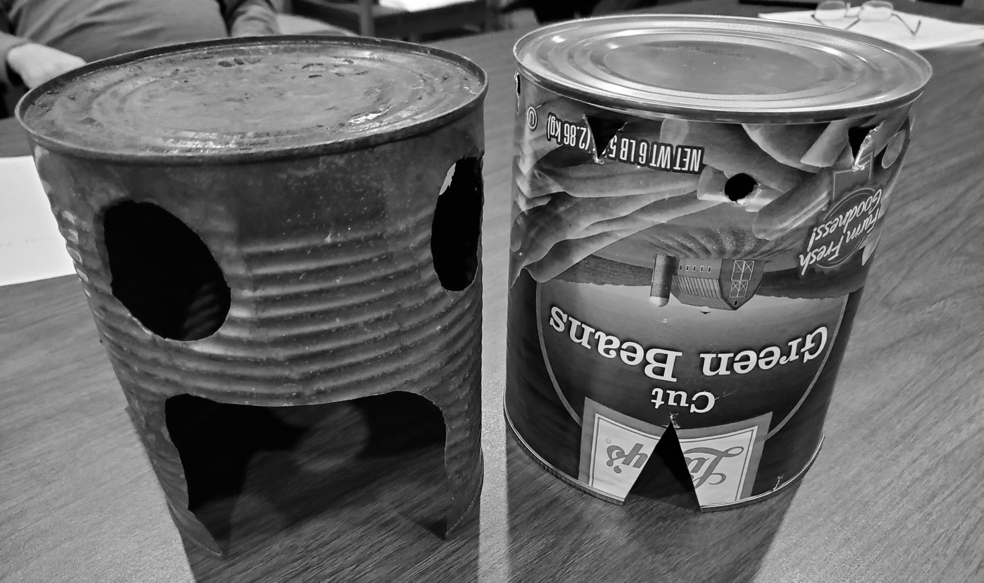

Instructions and other Examples: NOTE: Most of these websites are not affiliated with Scouting.
http://blog.utahscouts.org/camping/buddy-burner-scouts-first-stove/
https://www.motherearthnews.com/diy/how-to-make-hobo-stove-zmaz84zloeck
https://www.primalsurvivor.net/hobo-stove/
http://www.practicalsurvivor.com/hobostove

