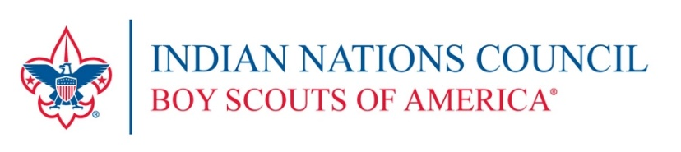

2020 Cub Scout Family Adventure Camp

Special Request Form
Form due by May 15th, 2020
District |  |  |  |  | Pack # |  |  |  |  |  |  | Den #  or Name
Session |  | ❑ | June 5 – June 7, 2020 |  |  | ❑ |  | June 12 – 14, 2020
 |  | ❑ | June19^{t} – June 21, 2020 |  |  | ❑ |  | June 26 – 28, 20209

(Please check one)

Participant’s Name
Address |  |  |  |  |  |  |  | City |  |  |  |  |  |  |  |  |  | Zip
E-mail |  |  |  |  |  |  | Daytime Phone |  |  |  |  |  |  |  | Evening Phone

Please list specific nature of special request and need:

______________________________________________________________________________________

______________________________________________________________________________________

______________________________________________________________________________________

______________________________________________________________________________________

______________________________________________________________________________________

We will make every effort to insure that all youth are able to enjoy the outdoors experience of Cub Scout Resident Camp. The individual care and responsibility for all youth, however, rests with the parents, leaders, and unit to which the youth is registered.
Return form to:  Indian Nations Council  Boy Scouts of America  4295 S Garnett Rd  Tulsa, OK 74146-4261 |  |  |  |  |  |  |  |  |  |  |  |  |  |  |  |  |  | EVENT #6711

For additional information contact Holly Worden at (918) 392-1233.

