http://www.USScouts.Org • http://www.MeritBadge.Org
Please submit errors, omissions, comments or suggestions about this workbook to: Workbooks@USScouts.Org
Comments or suggestions for changes to the requirements for the merit badge should be sent to: Merit.Badge@Scouting.Org
______________________________________________________________________________________________________________________________________________
1. Do the following:
a. Explain to your counselor the hazards you are most likely to encounter while participating in snow sport activities, and what you should do to anticipate, help prevent, mitigate, and respond to these hazards.

b. Discuss first aid and prevention for the types of injuries or illnesses that could occur while participating in snow sports, including hypothermia, frostbite, shock, dehydration, sunburn, fractures, bruises, sprains, and strains.
Winter sports safety:
Hypothermia:
Frostbite:
Shock:
Dehydration:
Sunburn:
Fractures:
Bruises:
Sprains:
Strains:

Tell how to apply splints.

2. Do the following:
a. Explain why every snow sport participant should be prepared to render first aid in the event of an accident.

b. Explain the procedure used to report an accident to the local ski patrol for the area where you usually ski, ride, or snowshoe.

3. Explain the international trail-marking system.

4. Discuss the importance of strength, endurance, and flexibility in snow sports.

Demonstrate exercises and activities you can do to get fit for the option you choose in requirement 7.
5. Present yourself properly clothed and equipped for the option you choose in requirement 7.
Discuss how the clothing you have chosen will help keep you warm and protected.:

6. Do EACH of the following:
a. Tell the meaning of the Your Responsibility Code for skiers, snow-boarders, and snowshoers.
(A copy of Your Responsibility Code can be found at the end of this workbook.)

Explain why each rider must follow this code.

b. Explain the Smart Style safety program. (A copy of Smart Style can be found at the end of this workbook.)

Tell why it is important and how it applies to participants at snow sport venues like terrain parks and pipes.

c. Explain the precautions pertaining to avalanche safety, including the responsibility of individuals regarding avalanche safety

d. Tell the meaning of the Wilderness Use Policy.
(A copy of the Wilderness Use Policy can be found at the end of this workbook.)

Explain why each skier and snowboarder must adopt this policy.

7. Complete all of the requirements for ONE of the following options: downhill (Alpine) skiing or cross-country (Nordic) or snowboarding.
Downhill (Alpine) Skiing Option
a. Show how to use and maintain your own release bindings and explain the use of two others.

Explain the international DIN standard and what it means to skiers.

b. Explain the American Teaching System and a basic snow-skiing progression.

c. Discuss the five types of Alpine skis
1.
2.
3.
4.
5.

Demonstrate two ways to carry skis and poles safely and easily.
g. Demonstrate how to ride one kind of lift and explain how to ride two others.

e. On a gentle slope, demonstrate some of the beginning maneuvers learned in skiing. Include the straight run, gliding wedge, wedge stop, sidestep, and herringbone maneuvers.
straight run
gliding wedge
wedge stop
sidestep
herringbone
f. On slightly steeper terrain, show linked wedge turns.
g. On a moderate slope, demonstrate five to 10 christies.
h. Make a controlled run down an intermediate slope and demonstrate the following:
1. Short-, medium-, and long-radius parallel turns
2. A sideslip and safety (hockey) stop to each side
3. Traverse across a slope
i. Demonstrate the ability to ski in varied conditions, including changes in pitch, snow conditions, and moguls. Maintain your balance and ability to turn.
c. Name the major ski organizations in the United States and explain their functions.
Organization | Functions

Cross-Country (Nordic) Skiing Option
a. Show your ability to select, use, and repair, if necessary, the correct equipment for ski touring in safety and comfort.
b. Discuss classical and telemark skis.
Classical
Telemark:

Demonstrate two ways to carry skis and poles safely and easily.
c. Discuss the basic principles of waxing for cross-country ski touring.

d. Discuss the differences between cross-country skiing, ski touring, ski mountaineering, downhill skiing.
Cross-country skiing:
Ski touring:
Ski mountaineering:
Downhill skiing:

Demonstrate exercises and activities you can do to get fit for skiing.
e. List the items you would take on a one-day ski tour.

f. Demonstrate the proper use of a topographic map and compass.
g. On a gentle, packed slope, show some basic ways to control speed and direction. Include the straight run, traverse, side slip, step turn, wedge stop, and wedge turn maneuvers.

straight run
traverse
side slip
step turn
wedge stop
wedge turn

k. On a cross-country trail, demonstrate effective propulsion by showing proper weight transfer from ski to ski, pole timing, rhythm, flow, and glide.
l. Demonstrate your ability, on a tour, to cope with an average variety of snow conditions.
m. Demonstrate several methods of dealing with steep hills or difficult conditions. Include traverses and kick turns going uphill and downhill, sidesteps, pole drag, and ski-pole "glissade."

traverses going uphill
traverses going downhill
kick turns going uphill
kick turns going downhill
sidesteps
pole drag
ski-pole "glissade."

Snowboarding Option
a. Discuss forward-fall injuries.

b. Show your ability to select the correct equipment for snowboarding and to use it for safety and comfort.
c. Show how to use and maintain your own bindings, and explain the use of the different binding methods. Explain the need for leashes.

d. Discuss the four types of snowboards.
1.
2.
3.
4.

Demonstrate how to carry a snowboard easily and safely.
e. Demonstrate how to ride one kind of lift and explain how to ride two others.
f. Demonstrate the basic principles of waxing a snowboard.
g. Do the following
1. On a gentle slope, demonstrate beginning snowboarding maneuvers. Show basic ways to control speed and direction. Include the side slipping maneuver.
2. On slightly steeper terrain, show traversing.
h. On a moderate slope, demonstrate an ollie, a nose-end grab, and a wheelie.
Ollie
Nose-end grab
Wheelie
i. Make a controlled run down an intermediate slope and demonstrate the following:
1. Skidded, carved, and jump turns
2. Stops
3. Riding fakie
j. Demonstrate your ability to ride in varied conditions, including changes in pitch, snow conditions, and moguls. Maintain your balance and ability to turn.
k. Name the major snowboarding organizations in the United States and explain their functions.
Organization | Functions

Snowshoeing Option
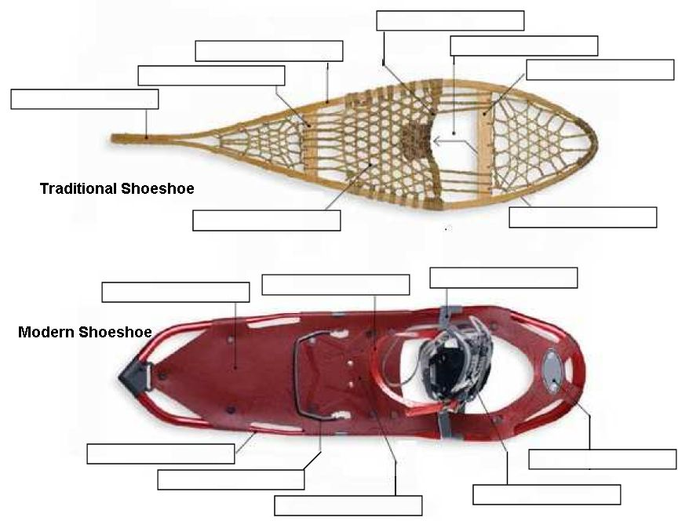
- Name the parts of a snowshoe.

b. Explain how to choose the correct size of snowshoe.

c. Describe the different types of snowshoes and their specialized uses. Discuss factors to consider when choosing a snowshoe.

d. Explain how to properly care for and maintain snowshoes.

e. Describe how to make an emergency snowshoe.

f. Describe areas that are best for snowshoeing. Discuss some advantages and dangers of backcountry snowshoeing.

g. Discuss the benefits of snowshoeing.

h. Demonstrate the most efficient ways to break trail, climb uphill, travel downhill and traverse a slope.
i. Take a two-mile snowshoe hike with a buddy or your troop.
k. Demonstrate your ability, on a hike, to cope with an average variety of snow conditions.
When working on merit badges, Scouts and Scouters should be aware of some vital information in the current edition of the Guide to Advancement (BSA publication 33088).Important excerpts from that publication can be downloaded from http://usscouts.org/advance/docs/GTA-Excerpts-meritbadges.pdf.
You can download a complete copy of the Guide to Advancement from http://www.scouting.org/filestore/pdf/33088.pdf.

Your Responsibility Code
Skiing and snowboarding can be enjoyed in many ways. At areas you may see people using alpine skis, snowboards, telemark skis, cross country skis, and other specialized equipment, such as that used by the disabled. Regardless of how you decide to enjoy the slopes, always show courtesy to others and be aware that there are elements of risk in skiing that common sense and personal awareness can help reduce. Observe the code listed below and share with other skiers and riders the responsibility for a great skiing experience.

1. Always stay in control, and be able to stop or avoid other people or objects.
2. People ahead of you have the right of way. It is your responsibility to avoid them.
3. You must not stop where you obstruct a trail, or are not visible from above.
4. Whenever starting downhill or merging into a trail, look uphill and yield to others.
5. Always use devices to help prevent runaway equipment.
6. Observe all posted signs and warnings. Keep off closed trails and out of closed areas.
7. Prior to using any lift, you must have the knowledge and ability to load, ride and unload safely.

Know the code. It's your responsibility.

This is a partial list. Be safety conscious.

The Smart Style Program
There are four main messages that are associated with Smart Style:
1. MAKE A PLAN
Every time you use freestyle terrain, make a plan for each feature you want to use. Your speed, approach and take off will directly affect your maneuver and landing
2. LOOK BEFORE YOU LEAP
Scope around the jumps first, not over them. Know your landings are clear and clear yourself out of the landing area.
3. EASY STYLE IT
Start small and work your way up. (Inverted aerials not recommended).
4. RESPECT GETS RESPECT
From the lift line through the park.

Wilderness Use Policy of the Boy Scouts of America
All privately or publicly owned backcountry land and designated wildernesses are included in the term “wilderness areas” in this policy. The Outdoor Code of the Boy Scouts of America and the principles of Leave No Trace apply to outdoor behavior generally, but for treks into wilderness areas, minimum-impact camping methods must be used. Within the outdoor program of the Boy Scouts of America, there are many different camping-skill levels. Camping practices that are appropriate for day outings, long-term Scout camp, or short-term unit camping might not apply to wilderness areas. Wherever they go, Scouts need to adopt attitudes and patterns of behavior that respect the rights of others, including future generations, to enjoy the outdoors.
- In wilderness areas, it is crucial to minimize human impact, particularly on fragile ecosystems such as mountains, lakes and streams, deserts, and seashores. Because our impact varies from one season of the year to the next, it becomes important for us to adjust to these changing conditions to avoid damaging the environment.
- The Boy Scouts of America emphasizes these practices for all troops, teams, and crews planning to use wilderness areas:
- Contact the landowner or land-managing agency (USDA Forest Service, National Park Service, Bureau of Land Management, U.S. Fish and Wildlife Service, U.S. Army Corps of Engineers, state and private agencies, etc.) well before an outing to learn the regulations for that area, including group size limits, to obtain required permits and current maps, and to discuss ways Scouts can fulfill the expectations of property owners or land managers.
- Obtain a tour permit (available through local council service centers), meet all of its conditions, and carry it during the trip.
- Review the appropriate BSA safety literature relating to planned activities. (See Safe Swim Defense, Safety Afloat, Climb On Safely, and Trek Safely.) Also see the Guide to Safe Scouting on the BSA Web site at http://www.scouting.org/pubs/gss/toc.html for more information on current BSA policies and procedures for ensuring safe activities, as well as the Fieldbook Web site at http://www.bsafieldbook.org.
- Match the ruggedness of high-adventure experiences to the skills, physical ability, and maturity of those taking part. Save rugged treks for older unit members who are more proficient and experienced in outdoor skills.
- Conduct pretrip training for your group that stresses proper wilderness behavior, rules, and skills for all of the conditions that may be encountered, including lightning, missing person, wildfire, high winds, flooding, and emergency medical situations.
- Participate in training in how to apply the principles of Leave No Trace, and be proficient and experienced in the leadership and skills required for treks into wilderness areas.
- Adhere to the principles of Leave No Trace.

Outdoor Code

As an American, I will do my best to—
Be clean in my outdoor manners. I will treat the outdoors as a heritage. I will take care of it for myself and others. I will keep my trash and garbage out of lakes, streams, fields, woods, and roadways.
Be careful with fire. I will prevent wildfire. I will build my fires only when and where they are appropriate. When I have finished using a fire, I will make sure it is cold out. I will leave a clean fire ring, or remove all evidence of my fire.
Be considerate in the outdoors. I will treat public and private property with respect. I will follow the principles of Leave No Trace for all outdoor activities.
Be conservation-minded. I will learn about and practice good conservation of soil, waters, forests, minerals, grasslands, wildlife, and energy. I will urge others to do the same.

The Principles of Leave No Trace

1. Plan Ahead and Prepare
2. Travel and Camp on Durable Surfaces
3. Dispose of Waste Properly (Pack It In, Pack It Out)
4. Leave What You Find
5. Minimize Campfire Impacts
6. Respect Wildlife
7. Be Considerate of Other Visitors

