Twin Lakes District
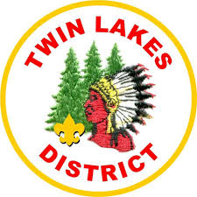
Klondike Derby

Where: Camp Tomo Chi Chi Knolls
40W095 Freeman Road
Gilberts, IL 60136

When: February 23rd 2019
Check in ~ 8:15 AM
Race starts ~ 9:00 AM
Awards ~ 4:00 PM

Cost: $15.00 Per Scout
$10.00 Per Adult
Every Scout Must Bring One Can of NON Cream Soup!
Lunch Included

Remember to dress for the weather . . . No GYM Shoes!!

(You will not be allowed to participate with gym shoes!)

Be prepared for the Derby!

