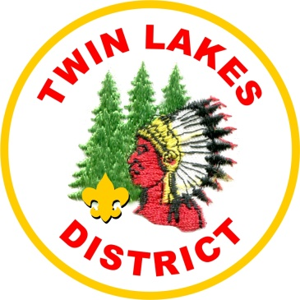 | Twin Lakes  District Dinner

Where: River Grove Moose Lodge
8601 W. Fullerton Ave.
River Grove, IL 60136

When: February 28th 2019
6:00 PM Fellowship
7:00 PM Dinner
8:00 PM Awards

Cost: $25.00 Per Person

This is a NON uniform Event

