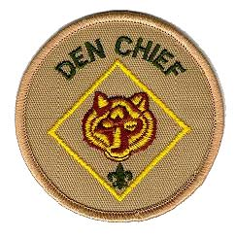
DEN CHIEF SEMINAR
Saturday September 29, 2018
Estelle Sieb Center,
7750 West Irving Park Road, Norridge IL
8:30am – 12:30pm (Sign in begins 8:15 am)

Just what is a Den Chief? The Den Chief is a critical member of the Cub Scout leadership team. To be successful, he must realize how important his job really is. Den Chief Training is intended to build enthusiasm for the job, develop high morals, and teach the skill the Den Chief will need to be successful.

Den Chief Training is required for Boy Scouts who wish to serve as a Den Chief for a Pack and when trained, becomes worth his weight in Gold!

This is the seminar that we have been talking about for a long time and is an excellent opportunity to take advantage of a one day, one stop training for every adult and Boy Scout involved with the Pack.

We have brought this seminar to the district and have had great success with it. The new Den Chiefs are doing well and the Packs are asking for more trained Den Chiefs!

The seminar will run from 8:30am to 12:30pm. It is a great way to start out the Scouting Year. The Den Chiefs will have a whole day of skills presented to them, to help them fulfill the position within the Pack. The position of Den Chief fulfills one of the leadership requirements within Boy Scout requirements for Eagle.

Registration deadline, Wednesday, September 26th
There is no registration fee!

Questions to: Shar Wyatt shar55555@juno.com or
Diane Gedroc dgedroc@aol.com

Details and registration can be found at: https://scoutingevent.com/456-22251
Den Chief Training- Norridge
Come and see what all the excitement is about.

