Boy Scout Night
With the Schaumburg Boomers
Friday, June 22 at 6:30 p.m.
or
Friday, Aug. 10 at 6:30 p.m.
Come Join the Schaumburg Boomers for a funfilled night of baseball and camping!

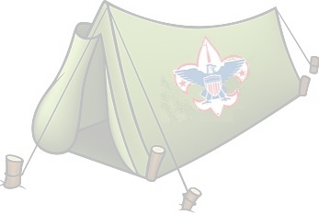
Scout Night Package Choices:

$20 Camping option:
- (1) Box Seat
- (1) Concessions Voucher (Hot Dog, Small Soda, Chips)
- (1) Scout Patch
- Overnight Campout on the Field
$12 Non-Camping option:
- (1) Box Seat
- (1) Concessions Voucher (Hot Dog, Small Soda, Chips)
- (1) Scout Patch

For more information, contact Drew at (847)-461-3695 or dwinter@boomersbaseball.com
Go online to (portal address) and use promo code “SCOUT” to purchase tickets or fill out form
Troop/Pack:____________________________________________________________________________
ContactName:__________________________________________________________________________
Address: _________________________________________________________________________________
City: ______________________________________ State: _____Zip:_______________________________
Phone: _____________________________________ Email: ______________________________________
# of ticket Camping: ___________ x $20 = $________________
# of ticket Non-Camping ________ x $12 = $ _______________
Complete and return this form to:
Schaumburg Boomers
Attn: Drew Winter
1999 Springinsguth Rd.
Schaumburg, IL 60193
Sub-total = $________________
Payment Type: _____ Cash _____ Card ______ Check
Credit Card #: _________________________________________
Exp. Date: _________ Security Code: _____________________
Name on Card: ___________________________________Signature:_____________________________

