Tri Fires Day Camp
Presents:
Parent/Leader Guide to Day Camp
(An informational guide)
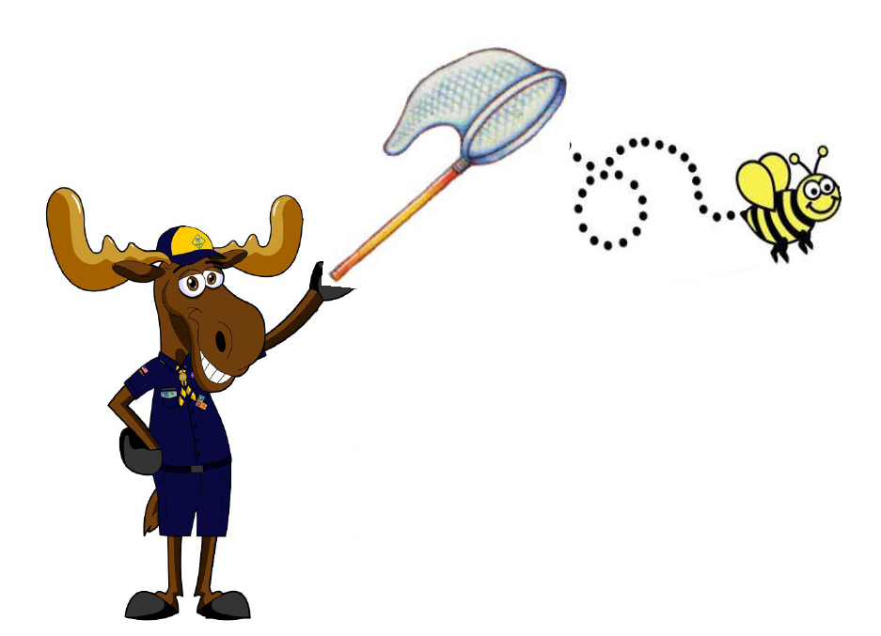

July 19-21, 2018 Camp Butler
Directors:
Todd Mosko Camp Director
Tosha Curren Camp Director
Marnie Mellinger Program Director
A letter from the Camp Director:
Welcome! It is a pleasure to present this guide to you on behalf of the Day Camp Staff. I hope you will find this guide informative and useful. It will serve as an introduction to those who are new to our program and a refresher for those who have been to day camp a few times.
Our theme this year is Cub Scout Bug hunters. We will focus on fun activities including investigations of science, nature, crafts, water sports and bugs showing us what they do. We will promote the Scouting spirit in our activities and provide both education and achievement while we are at it.
If you have any questions, please do not hesitate to contact us. We want your experience at day camp to be a great one. Thank you for your support and dedication to retaining our Scouts through year-round programming and FUN.

Yours in Scouting,
Todd Mosko
Camp Director, Day Camp 2018
“It’s all about Scouts, Memories and Smiles”

General Information
Who can attend Day Camp?
Day Camp is for registered Cub Scouts who will be in grades 1-5 in the fall. Their families may attend as well (please note that younger siblings may not be able to participate in all activities due to height or physical limitations).
What is the required ratio of Adults to Scouts?
Each pack must have at least one adult for every five Cub Scouts.
When and Where is Day Camp?
Day Camp is July 19-21, 2018. Arrive by 8:30am (flag-raising is at 8:45am). On Thursday and Friday, we will end with our closing at 5pm at the flagpole. On Saturday, we will have skits and songs and will be done around 6pm.
Day Camp is held at Camp Butler 880 West Streetsboro Road (Route 303) Peninsula, Ohio 44264

Health and Safety and Emergencies
Medical Forms
Any person attending Day Camp (including adults) must have a Boy Scouts of America Medical Form filled out and signed. Any person under the age of 18 must have their form signed by a parent or legal guardian.
If a child has special needs (medical, physical or behavioral), these must be listed on the Medical Form. Please inform the leadership team in advance of any youth or adults who are physically and/or emotionally challenged. Knowing ahead of time allows us to help make appropriate accommodations to assist parents at camp.
We also need to know if any attendee has an Epi-Pen or Inhaler. Any person with an Epi-Pen or Inhaler must keep them on their person at ALL times. Epi-Pens and Inhalers will be reviewed by the Health Officer, who will verify expiration dates. Expired Epi-Pens or Inhalers will NOT be accepted.
Parts A and B of the current edition of the standard BSA Annual Health and Medical Record form are required for ANYONE coming to Camp Butler. This means that every Scout, adult, and sibling must have a form filled out BEFORE coming to camp. Part A must be signed by the parent/guardian of anyone under the age of 18. These forms are available online at http://www.scouting.org/scoutsource/HealthandSafety/ahmr.aspx
New forms are required each year. All forms should be turned in with your advance registrations. Medical Forms will be kept on file with the Health Officer until camp is over. These forms are required in case of a medical emergency while at camp. Also, please insure emergency phone numbers are listed on the Medical Forms.
The camp will have on staff a Health Officer during all hours of camp. There are local hospitals and EMS services available for medical treatment.

Medications
All medications (in the original prescription bottle) MUST be given to the Health Officer with written instructions. If the camper requires an asthma inhaler or epi-pen, please notify the directors and the health officer upon check-in.
First Aid / Illness/ Injury/ Accidents
The First Aid station will be located in the Atwater Lodge. All accidents must be reported to the Health Officer for documentation purposes, regardless of severity. This is a National Boy Scouts of America policy. The Health officer provides first aid, NOT medical treatment.
Camp Siren
Camp Butler has a siren for emergencies. If you hear the siren, all program areas will close immediately. If there is bad weather coming, seek shelter immediately.
Insurance
Your camp fee includes accident coverage on every registered Scout and adult leader. Insurance does NOT cover additional unregistered adults and unregistered siblings who may be in attendance.
Leadership and Buddy program
Two-deep leadership will be maintained at all times throughout camp. Scouts should maintain the Buddy program. No Scout should be walking without a Buddy at any time. Buddy tags will be assigned at each of the aquatics program areas. Throughout the rest of program areas, the Buddy program will be maintained.
Youth Protection Training must be completed by all adults at camp. If you are not currently trained, Youth Protection Training will be provided on July 19th at 6pm. YPT is also available online at http://www.scouting.org/Training/YouthProtection.aspx
Camp Security and Other problems
If at any time during camp, an issue or problem arises, please direct these comments to the Camp Director or the Program Director.
In case of emergency during camp, staff members have been trained to handle many emergencies. Additionally, at each program station, there will be emergency contact phone numbers posted in a prominent spot.
Lost Camper
If a boy should get lost from your group, please notify a Staff Member IMMEDIATELY. The Camp Director will conduct a search for the boy according to established procedures. DO NOT try to find the boy yourself. Your responsibility is to the rest of the group at this point.
Camp Phone
The Day Camp phone number is 330-657-2422. This number will ring at the Camp Butler Conference Center. Please call this number for emergencies only.

Fees and Registration Details

Cub Scouts: $70.00
Siblings who will take part in the program (ages 5 & up): $40.00
(T-Shirts and mugs are included with the fees for Scouts and Siblings)
Siblings who will NOT take part in the program: FREE
Parents, Leaders, Chaperones FREE
Older siblings who will serve as Den Chiefs FREE
T-Shirts for adults or non-paying siblings: $10.00
Adult XXL Shirts $11.50
Adult XXXL Shirts $13.00

Day Camp Coordinator
Each Cub Scout Pack should appoint one person to act as their Pack’s Day Camp Coordinator. All fees and registrations should go through this person before being sent to the Scout Office. The Day Camp Coordinator or a designated representative shall be responsible for the daily registration process.
Registrations, fees, and Medical Forms must be completely filled out and signed by a parent/legal guardian. Please register as early as possible – we cannot guarantee T-Shirts for forms turned in after June 10th.
Each registered, paid participant will receive a T-shirt. The individual sizes and number of each size must accompany your registration.

Cancellation and Camp Refund Policy
The cancellation procedure is as follows:
Please contact the Council office for cancellation. If your registration has been completed and payment processed, see below for refund policy.
When preparing for camp, our District purchases food, program supplies and other supplies based on the number of registered attendees. When cancellations occur, in many cases, the purchases have already been made by the district and are responsible for all of the costs. When refunds are given, additional resources are lost in time and money. In order to help us be more fiscally responsible, the following refund policy is in effect:
Full refund for the following reasons (with appropriate documentation) at any time prior to camp arrival:
Medical issue regarding Scout or leader (Doctor’s note required)
Summer school (School district note required)
Extreme family emergency
Partial refunds up to two weeks prior to start of camp:
Requests for refunds must be made in writing no later than two weeks prior to the beginning of camp in order to be considered. Please submit requests to: Council office Attention Tri Fires Day Camp Refunds.
No show forfeiture
Any Scout or leaders who are no-shows will have their entire fee forfeited. This is unfortunate, however, by the time camp has started; all food and materials have been purchased on the expectation of attendance.
Pre-Camp Adult Meeting
We will have an adult meeting on Wednesday, July 18th at 6pm. At this meeting, we will pass out your shirts and mugs, collect last minute items, and review what is going to happen at camp. We strongly encourage each pack to send at least one adult to this meeting. This will make your first day at camp go much more smoothly.
We will also be offering Youth Protection Training at this meeting for those who have not yet been trained.

Camp Program
The Daily Program
When you arrive at camp each morning, you will receive a schedule for the day. Your group will rotate to each program area. If you are unsure about the location of an area, ask any staff member. Program areas include the pool, lake, crafts, sports, archery, and BB guns.
We begin each morning at 8:30am. On Thursday and Friday, we will end with our closing at the flagpole at 5pm. On Saturday, we will have skits and songs and will end around 6pm.
Your Pack will have an assigned table at the Baden Powell Pavilion. You may keep your Pack and personal items there during the day. We also encourage each Pack to bring your own cooler and keep your food stored in them. If your Pack does not have a cooler, limited refrigeration space is available.
Tiger Cubs
Tiger Cubs (Scouts going into the 1st grade) must have at least one adult with them (this is a National Boy Scouts of America policy).
Siblings
Siblings will travel in the same group as his/her Scout brother. All siblings must have a parent/legal guardian as a Chaperone every day. All siblings and adults in camp must be included on the daily camp roster (again, please note that younger siblings may not be able to participate in all activities due to height or physical limitations).

Chaperones
Each Pack MUST provide one adult chaperone for every five Cub Scouts. Chaperones can be Scout Leaders, parents or family members. These adult chaperones will accompany the boys throughout the day to each activity and be responsible for their behavior. All Chaperones need to have taken BSA Youth Protection Training. Tigers must have at least one adult present at all times. Chaperones may purchase a T-Shirt.
Swim Tests
Swim tests will be offered on the following days:
Wednesday, July 19th 5pm – 7pm
All Packs are encouraged to come before camp for your swim tests.
Anyone who wants to swim in the middle or deep end of the pool must take the swim test. This includes adults and siblings. Note: in order to swim at Day Camp, siblings must be able to stand in the pool on their own, or be a strong swimmer (the shallow end is about three feet deep).
Advancement
The major intent of our program is for the attendees to have fun. Boys learn while having fun, and may earn partial credits for some achievements needed to advance. Camp staff does not keep track of advancement.

What to bring and wear to Day Camp
Dress according to weather conditions (program runs rain or shine). All clothing worn to camp should have the participants name and Pack number on it (especially Day Camp T-Shirts). Shoes and shirts must be worn at all times. The only place permitted to be barefoot and without a shirt is in the pool area.
- Completed sections A and B of the BSA medical form
- Everyone wears their official camp T-shirt daily
- Clearly label a healthy lunch and drink with your name and Pack number
- Swim trunks, towel and extra change of clothes
- Sunscreen is very important to apply before camp and throughout the day
- Rain gear (we have fun in the sun AND the rain)
- Backpack or drawstring bag to carry your things
- All items should be clearly marked with Scout name and unit number
- Comfortable shoes (NO flip-flops – water shoes may be worn at the lake only)
  - You will also want to bring an old shirt to wear at the lake (it WILL get wet)
  - Shoes worn at the lake will get wet and/or muddy
- Leaders: Please bring a Sharpie to write Scout names on their belongings
- Don’t forget to bring your good attitude and your smile!

What NOT to bring and wear to Day Camp

- Flip flops, crocs, sandals or brand new shoes
- Knives
- Toys
- Valuables
- Electronics
- Water guns and super-soakers
- Please leave your bad attitude at home

Day Camp Rules and Code of Conduct
- Have fun
- Scouts must be checked –in and signed out daily. We ask that you be prompt in picking up your Scout. Youth will only be permitted to leave the camp with an authorized person.
- The camp director must approve any camper leaving camp any time outside of check out time. This includes any time between opening ceremony and camp dismissal.
- No fighting, teasing or name-calling. Scouts must be respectful at all times.
- Scouts will be respectful towards all adults, staff members and visitors.
- Proper language will be used at all times. (No use of foul, profane or abusive language)
- No sandals may be worn. Only closed-toe shoes may be worn outside the aquatics program areas.
- The only time a Scout may throw an object in camp is as part of a supervised camp activity.
Repercussions:
First time: Handled by Den leader or Station Leader
Second time: Handled by Camp Director
Third time: Sent home
Fourth time: Asked not to return

Tobacco use and Alcohol Use
Smoking in designated areas only (this includes E-Cigs). Smoking should not occur within sight of any Scout.
Alcoholic beverages or drugs (unless prescribed by a physician) are prohibited at all times.
Weapons
Firearms are only permitted to be carried by police officers, regardless of your CCW status. Knives are not permitted to be carried by youth while at camp.

Other Miscellaneous Items
Restrooms
Restrooms are located in each building in camp. Porta-potties are also available in remote areas, along with pit latrines.
Showers
Per Boy Scouts of America Youth Protection Guidelines, Scouts and adults may not use the same shower areas.
Pets and Animals
No pets are allowed on Camp property. Please leave all pets at home.
Camper and Staff Identification
All campers will wear the official T-Shirt. Any person not wearing the camp T-Shirt will have to wear a camp wrist band (issued each morning). Wrist bands will be a different color each day.
Food
Please remind all youth and adults not to share snacks or meals with others due to allergies. Those with special dietary considerations should include this information on Health Forms.
Campers will need to bring your own lunch and snacks.
Water
Potable (safe for drinking) water is available at each program area. A plastic mug is provided on the first day of camp for each participant. Please mark your mug with your name and pack number.

Trading Post
The Trading Post will be open daily and available during specific times as well as during free time.
Vehicles
Vehicles are not permitted to be driven in camp except on an emergency basis. Vehicles are not permitted for movement between program areas unless pre-approved. Please speak to the Camp Director about the approval process if this may be necessary to allow a youth to participate in the program.

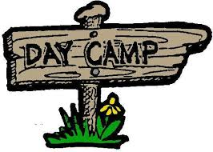

Registration online ONLY.

Before you go online – Make sure that you have:
- A Pack Day Camp Coordinator
- A completed Pack Registration form
- Cub Roster
- Webelos Roster
- Sibling Roster
- Chaperone Roster (mark day each attending)
- A completed Registration Form for each scout
- Medical Form for each person attending (must be signed by parent/legal guardian for youth under age 18)
- T-shirt sizes listed on Rosters
- Youth Protection dates listed on Rosters for every adult attending
- One check made payable to: Great Trail Council

When you have all of the above completed go online to:
https://scoutingevent.com/433-tfcsdc

Registration online ONLY.
2018 Tri-Fires District Day Camp Worksheet
Pack Registration Form

PACK: _________ District: ________________ Date: _________

Coordinator: ________________________________________________

Address: ___________________________________________________

City: _________________________ State: _____ ZIP: _____________

Phone: _____________________________________________________

Email address: _______________________________________________

A. # of Scouts ________ x $70.00 A. _______

B. # of Siblings ________ x $40.00 B. _______

C. T-shirts are included with registration for scouts and siblings.

Chaperone T-shirts ________ x $10.00 C. ________

AS ____ AL ____ AXL ____ AM ____

D. # of XXL Shirts ______ x $11.50 D. _______

E. # of XXXL Shirts ______ x $13.00 E. _______

F. Pack cost for Cub Day Camp (A + B + C + D + E) = F. _______

Tri-Fires Cub Scout Day Camp Worksheet
Cub Scout Roster
Pack # ___________
First Name | Last Name |  | Grade | T-Shirt  Size | Paid | Health  Form
1
2
3
4
5
6
7
8
9
10
11
12
13
14
15
16
17
18
19
20

Tri-Fires Cub Scout Day Camp Worksheet
Webelos Scout Roster
Pack # ___________
First Name | Last Name | Grade | T-Shirt  Size | Paid | Health  Form
1
2
3
4
5
6
7
8
9
10
11
12
13
14
15
16
17
18
19
20

Tri-Fires Cub Scout Day Camp Worksheet
Sibling Roster
Pack # ___________
First Name | Last Name | Grade | T-Shirt  Size | Paid | Health  Form
1
2
3
4
5
6
7
8
9
10
11
12
13
14
15
16
17
18
19
20

Tri-Fires Cub Scout Day Camp Worksheet
Chaperone Roster
Pack # ___________
First Name | Last Name | Youth  Protection  Date | Thurs.  7/19 | Fri.  7/20 | Sat.  7/21 | Shirt  Size | Paid | Health  Form
1
2
3
4
5
6
7
8
9
10
11
12
13
14
15
16
17
18

