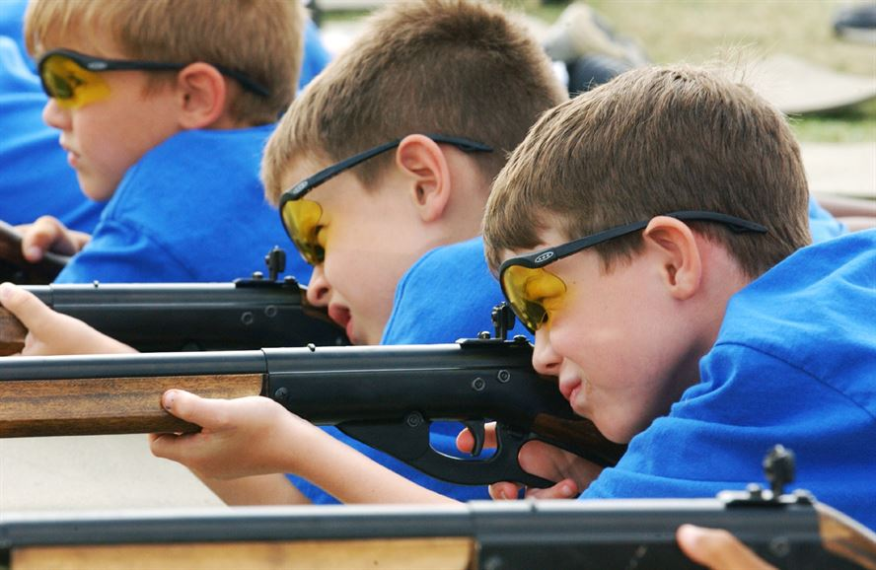

**Come join us for a fun filled evening July 11th, 2019 3-9 PM**

* **BB Guns**
* **Archery**
* **Slingshots**
* **Crafts**
* **Physical fitness**
* **And a fun dinner performance!**

Register today <https://scoutingevent.com/429-28088>.

Cost is $38 for early bird registration and $45 after.

Early bird registrations end July 1, 2019

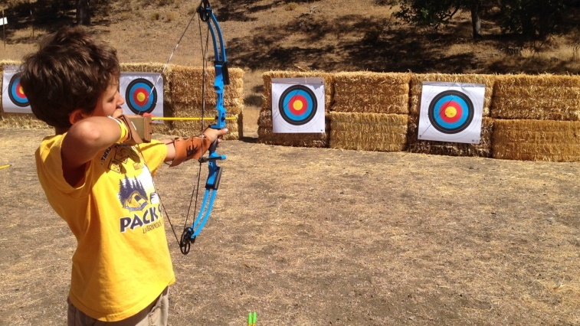

For questions please feel free to contact:

Camp Director:

Thomas Huether @ 406-780-0690 or Thomas.huether@scouting.org

Camp Program Director:

Cameron Carlson at 218-686-9174 or [cameronpcarlson@gmail.com](mailto:cameronpcarlson@gmail.com)

Camp Advisor:

Mark Landa at 701-739-2362 or [MaLanda@scouting.org](mailto:MaLanda@scouting.org)

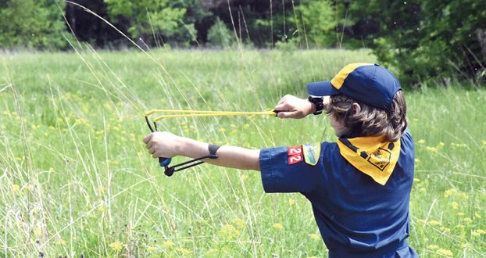

Other Day Camps to look out for are:

Grand Forks June 13, 2019

Devils Lake August 10, 2019