2019 Civil War Spring Camporee
May 17-19
Heritage Village – East Grand Forks, MN

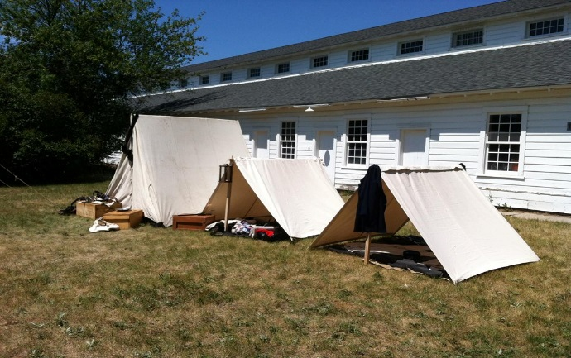

“Scouts of the Lake Agassiz District depart for their annual Spring Camporee, but as they travel begin a storm over takes the scouts and their leaders. Upon waking the scouts and their leaders have been transported 150 years into the past and wake up at a Civil War fort. To survive in this world, they have but one choice to live the lives of soldiers in 1864….”

Scouts will get to experience the daily routine of Civil War soldiers.
Experiences Include:
- Infantry Drill
- Guard Duty
- Artillery Drill
- Food of the period
- Medicine and Surgery
- Period Meal Contest
- Period Baseball game
- And more!
All scouts and leaders are welcome to attend.

Cost:
$20.00 per scout covers cracker-barrel, program materials, and patch
$5.00 per adult covers cracker-barrel, program materials, and patch

We will also be offering the combine Combined Outdoor Leader Skills Training. See attached flier.

Registration will be live soon…so stay tuned!

