Save the Date

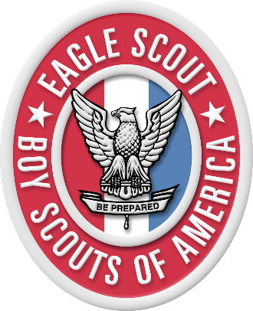
Mother & Scout
Eagle Scout Brunch

Saturday, August 10, 2019
11:00 AM to 1:00 PM
Soaring Wings Vineyard
17111 S 138th Street
Springfield, NE 68059
$60 for set of tickets
(If sponsorship is needed, please reach out to Sherry Brady 402-514-3029 or Sheryl.brady@scouting.org)

Brunch for moms and their Scout (First Class Rank and higher) to hear speakers from both business and military professions on the impact the Eagle Scout rank could have on a Scouts life and future (scholarships, college applications, future employment opportunities).

An Eagle Scout speaker will share his experience of being an Eagle and what opportunities he’s experienced due to his Eagle Rank.

A panel of Eagle Scout moms and Eagles will share tips and suggestions on how to plan for and stay “on track” for the Scouts -- Trail to Eagle.

For more information, contact Sherry Brady at 402-514-3029 or Sheryl.brady@scouting.org

