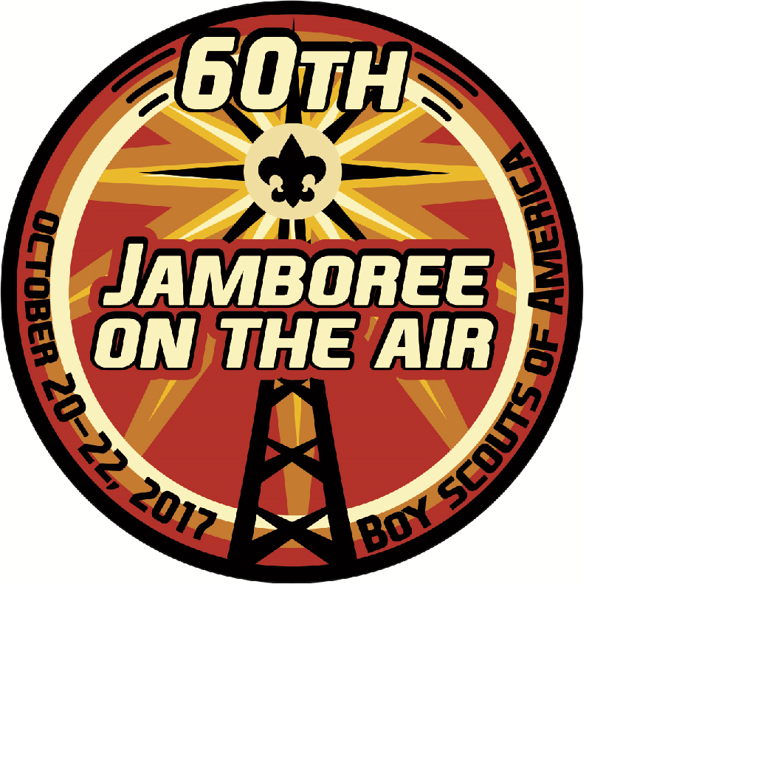
Salt Valley District’s Fall Camporee
Become a part of the “Jamboree-on-the-Air,” the largest Scouting Event in the World. This weekend program will utilize amateur radio to link Scouts and ham radio operations in Lincoln and around the nation and the world.
Friday, October 20 to Sunday, October 22
at the Boy Scout Outdoor Education Center (OEC), Walton, NE
Online Registration is now Open – Early Bird $10
Participants will receive the Jamboree patch (see above) and satisfy the requirements for the Radio Merit Badge (below).
