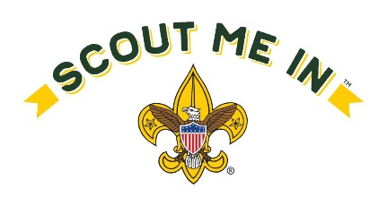
2020 Covered Wagon District Multipack Campout
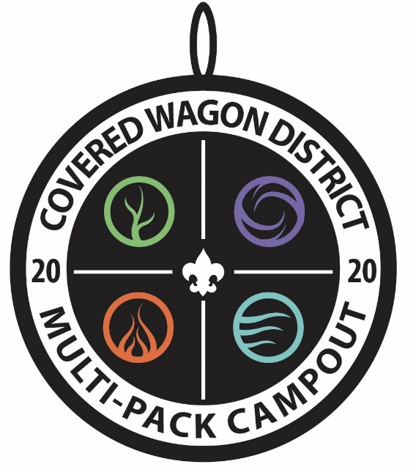
The Scouting Elements
- May 2, 12pm –May 3, 12pm
- Ft. Kearny Youth Area
- $20 for cub scouts/siblings
ages 5-11, Free for younger siblings
- $15 for Adults
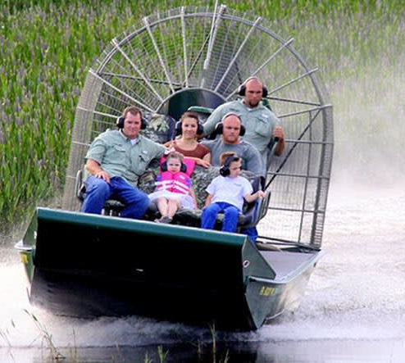
Events include:
Platte River Airboat Rides
(Weather permitting)
Water Bottle Rocket building and launching
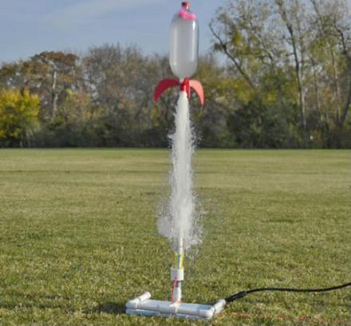
“Fire Extinguisher event” scouts will find a way to dump water on “fire” from a distance away by using knots, lashings, etc.
Eco scouts event
Scoutcraft: catapult, mini-bow
Register at: https://scoutingevent.com/322-Multipack2020
Check in 12pm, no lunch served. Events begin at 1pm, an afternoon snack will be provided. We will have supper, Dutch oven deserts, and a campfire program in the evening so bring your best skit! Sunday will include breakfast and a Worship service; check out around Noon on Sunday. This is an Eco Campout and to minimize our footprint we’re asking all participants to bring a mess kit and reusable water bottle. Hope to see you there!
Questions? Contact event chair: Cody Yendra, 402-980-8792 codyjyendra@yahoo.com

