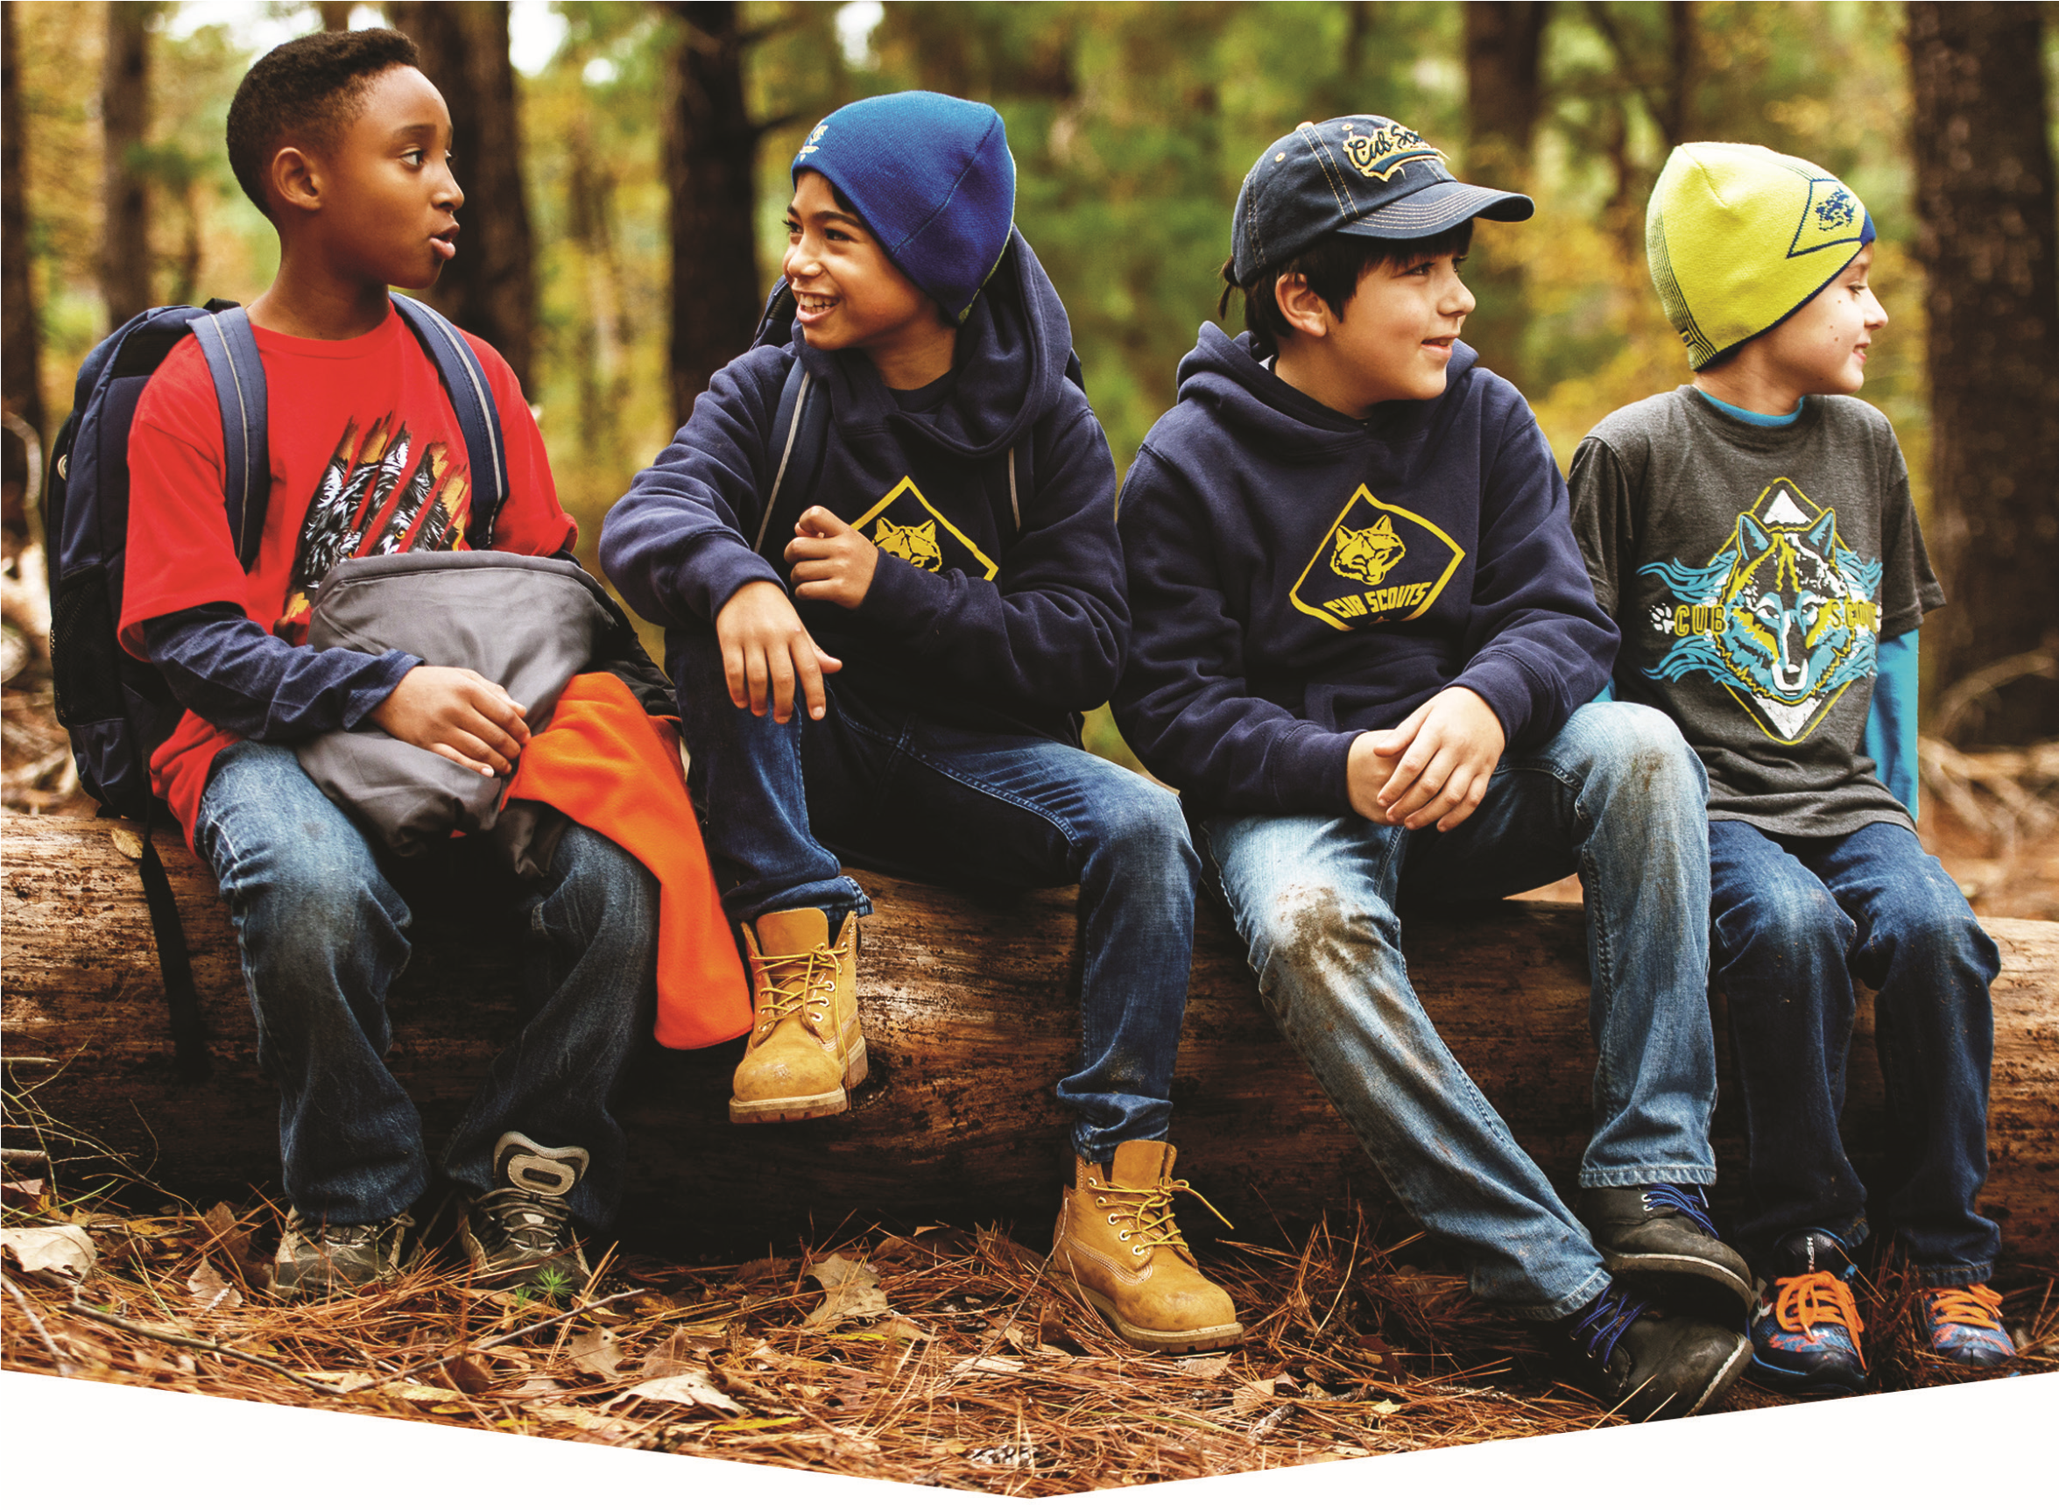

October 20th – 21st
Saturday – Sunday
Beaumont Scout Reservation - Laemmli, Campsite
Call of the wild is an optional overnight camping and advancement workshop for
Lions, Tigers, Wolves and Bear Aged Cub Scouts
Check in 8:30 and Opening Ceremonies at 9:30
Early: $18 Per Scout / $9 Per parent for food / Late: $21 Per Scout / $11 Per adult
Early price ends: September 21st at Midnight!
For more information or to register, visit Scoutingevent.com/312-cotw18
Don’t forget to download the manual! Lunch is included in pricing – Dinner on your own

