Central Minnesota Council Boy Scouts of America

Parker Scout Summer Camp
June 7-9, June 14-16, June 21-23
June 28-30, July 12-14, July 19-21

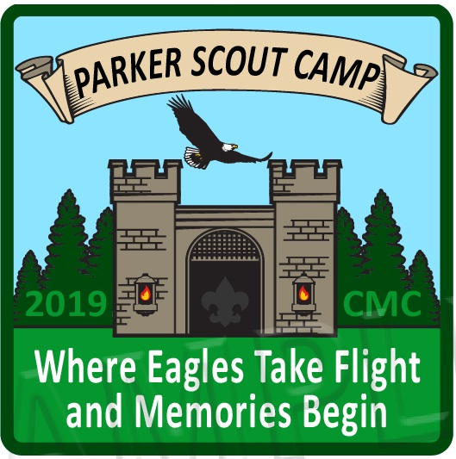
2019 Campers’ Guide
For Parents and Leaders
Of Cub Scouts and Webelos

Many thanks to all our donors, including
Jennie-O Foods, Michaels Foods,
Ron & Grayce Berg, James & Marion Miller

Table of Contents 2-3

Join us for Summer Resident Camp! Letter from the Camp Director 4

2019 Resident Camp for Cub/Webelos Scouts 5
- Registration Fees
- Program Rotation
- Council Web Site
- Parker Lodge (Admin. Bldg)

Getting Ready for Camp 6
- Cub Scout Pack Committee Responsibilities
- Camp Leaders’ Responsibilities
- Den Chiefs

Registration 7-8
- Registration Information
- Registered Campers
- Camperships
- Leadership Requirements
- Leadership Responsibilities/Camp Leader Meetings
- Registration Reminders

Information for Parents 9-11
- Camp Fees
- Medical Form - Pre-Camp Requirements
- Packing list – “What to Bring”
- Leaving Camp Early
- Directions to Camp
- Camp Contact Information
- Emergency Phone Number

Camp Arrival and Check-In Procedures 12
- Check in Time
- Getting to your Theme Area
- Check-in Procedure

Camp Map 13

Camp Facilities and Services 14
- Handicap Accessibility
- Trading Post
- Chapel
- Dining Hall, Pavilion and Food Service
- Meal Serving/Meal Clean-up
Health and Safety 15-18
- Person Hygiene
- Health Form Requirements
- Medication Procedures
- Health Services
- Fires and Firefighting
- Camp-Wide Emergencies
- Buddy System
- Shoes
- Bicycles
- Pets
- Drugs and Alcohol
- Youth Protection
- Fireworks
- Leaving/Entering Camp
- Snack Foods
- Telephone/Cell Phones
- Latrines
- Weather
- Personal Property
- Tenting
- Behavior

Program Areas/Camp Staff 19-20
- Medieval Times
- Finding Your Way
- A Bear Goes Fishing
- Castaway
- Adventures in Science
- Waterfront /Aquatics
- Shooting Sports
- Campfires
- Camp Staff

Basic Program Schedule 21
- Opening Day
- Daily Schedule
- Closing
- Trading Post Hours

Emergency Procedures 22

Check-Out Procedures 22

Forms 23+

Dear Cub Scout and Webelos Leaders and Parents!

Summer is right around the corner and with it, summer camp. We are busy getting ready for fun, and we can help you get ready, too!

This is the 2019 Camp Guidebook for Parents and Leaders, which will be your resource as your Pack/Den prepares for and attends a weekend of fun at Parker Scout Camp! Please take some time to read this guidebook to get an understanding of what you can expect prior to and during your stay at camp. Share this information with your parents and bring a copy to camp with you. Additional copies can be downloaded at www.bsacmc.org, via the Parker Scout Camp link.

I am very excited to be your Camp Director at Parker Summer Camp. We have a great staff, some new, some veteran, all trained and enthusiastic, and we are looking forward to meeting you and serving you at camp. Whether your favorite part of camping is the outdoors, the swimming beach or shooting sports, we will do our best to make your camp experience more exciting, educational, and fun than any summer before!

This guidebook contains all the necessary forms that each person will need to complete prior to attending summer camp. Our national office of the BSA requires that all Scouts, parents, and leaders who will be attending camp bring a completed and signed healthy history form. For Parker camps, only parts A and B need to be completed. NO physician visit required.

If you have any questions, concerns, or need to communicate with camp staff, you may contact me at the Central Minnesota Council Office at (320) 251-3930, or email mary@bsacmc.org.

Come enjoy our Cub Scout and Webelos Resident Camp and see what makes Parker one of the leading Cub Scout camps in Minnesota!

Yours in Scouting,

Mary Herlick
Council Camp and Program Manager
BOY SCOUTS OF AMERICA
Central Minnesota Council
1191 Scout Drive
Sartell, MN 56377
P 320.251.3930 x103 | F 320.251.3933
mary@bsacmc.org

2019 Resident Camp for Cub/Webelos Scouts

Camp Registration Fees
Fees are $95.00 per youth and $65.00 per adult participant. See the registration information link found online at www.bsacmc.org.

Program Rotation
Our Summer Camp program is designed to provide Cubs/Webelos a different experience each year that they attend camp. Specific activity changes may be made to each theme area from year to year to help enhance and improve the camp program. We welcome all age groups every weekend! And we are focusing on advancement through fun! We will have a Tiger group, Wolf group, Bear Group, and 2 Webelos Groups. While themes are advancement based for your grade, it is okay to attend any of our programs on any weekend. Each theme will include a hands-on craft, age-related activities, games, water sports and shooting sports, which will challenge them physically and mentally, providing opportunity growth in inter-personal and leadership skills. And each Scout will have the opportunity to earn 2 or more Adventure Loops!

Council Web Site
All the information in the 2019 Campers’ Guidebook, including all the camp forms, can be found and accessed on the council’s web site. Go to http://www.bsacmc.org and follow links to Parker Scout Camp.

Parker Lodge (Administration Building)
Parker Scout Summer Camp office is the business center of the camp. Much of the administrative work of the camp operation takes place in this building. It also serves as a centrally located information and greeting center for guests and leaders. The Health Officer connection and Trading Post are located at this building during the weekend.

Getting Ready for Camp

Preparation is the key to any successful event. Summer camp is no different. Specific tasks need to be completed by both the Cub Scout Pack Committee and by individual leaders who will be attending camp with the Cub Scouts.

Cub Scout Pack Committee Responsibilities
- Appoint an adult to oversee all preparation.
- Promote the camp program at all pack functions.
- Keep parents interested and informed about camp.
- Be responsible in ensuring all camp fees are paid on time.
- Confirm transportation arrangements to and from camp and inform drivers of directions to camp, check-in and check-out times, meeting places for pick up, etc.
- Assure two-deep leadership and a 1:4 ratio of adult to youth attending. 1:1 is encouraged.
- Ensure adults attending have received and read this guidebook. Additional copies are available online at www.bsacmc.org.

Camp Leaders’ Responsibilities
- Make sure that each camper has the appropriate and completed Annual Health and Medical Record form and medication card (if applicable). Collect forms and cards prior to departure. Make copies before camp begins. DO NOT SEND HEALTH FORMS TO THE COUNCIL OFFICE. Bring them with you to Camp.

- Review the “What to Bring Checklist” with all parents. See page 9 of this guide.
- Review the camp guidelines and health and safety policies of the camp.
- Be knowledgeable about the needs of each youth member attending camp (sleeping habits, eating habits, medications, likes and dislikes, etc.)
- Have the most recent roster of youth and adults attending prepared and ready to turn in upon arrival.
- Ensure all payments have been completed in full and submitted to the Council Office in Sartell, MN.

Den Chiefs
Den Chiefs may attend camp with their den, (and may register at the adult rate) but are not counted as adults needed for the required leadership ratio. The Den Chief should have attended Den Chief Training and must be able to serve as a mature role model and helper for 3 days and 2 nights. Parker Scout Summer Camp should not be a replacement for their own summer camp experience.

Registration

Here are a few easy steps to ensure you have a spot at Summer Camp at Parker Scout Camp.

Registration
Located online at www.bsacmc.org. The Parker Camp page has links to our registration website, with easy to follow instructions. Please read it carefully and follow the step-by-step process as indicated. Fees are $95.00 per youth, which includes a camp patch, and $65 per adult. If you have any questions about online registration, please contact Mary or Anna at the Council Office at
(320) 251-3930.

Registered Campers
All youth attending Parker Scout Summer Camp must be registered members of the Boy Scouts of America. There are no arrangements or accommodations for any other youth family member to attend camp with a Cub Scout Pack or Den.

Leadership Requirements
All Cub Scout packs attending Resident Camp must attend under the Pack’s adult leadership. Each pack is required to have at least two adults, one who must be at least 21 years of age or older and one must be registered with the Boy Scouts of America. Central Minnesota Council suggests at least one adult for every three (1:4) boys in attendance at camp. With a minimum of two for multiple boys. All registered Scout Leaders must have completed current Youth Protection Training.

Leadership Responsibilities at Camp---Adults in attendance at camp are responsible to:
- Provide supervision and guidance for the youth of your Pack attending the camp.
- Assist the youth as needed in the program areas (staff cannot help everyone at once).
- Ensure the safety of all campers by adhering to all camp guidelines (youth and adults).
- Help maintain order and discipline within the membership of the Pack.
- Know and follow the safety and emergency procedures.
- Assist the youth with the preparation and cleanup of your assigned camping areas.
- Be responsible for any Scouts needing medicine.
- Making sure Scouts are prepared for all the day’s activities.
- Respect and follow the direction of Camp Leadership staff.

Camp Leader Meetings
Theme Leaders will hold a camp orientation meeting at your theme area about 9:15pm on the first evening. (If you would like to attend optional training sessions for Youth Protection Training or Safe Swim, these will be held in the Parker Lodge/ Admin. Building based on popular demand.) The agenda includes a review of the camp’s policies and guidelines, meet some of the senior staff members, review program plans and answer any questions leaders may have. There may be a second meeting on Saturday evening following the campfire.

Registration Reminders

- Make payments online through the camp reservation system.

- Reservations by phone will not be accepted. Please register online at www.bsacmc.org. Follow the links on the Parker Scout Camp page.

- All Scouts attending camp must be currently registered with the Boy Scouts of America. NO EXCEPTIONS!!

- Adult Pack/Den leaders must have current Youth Protection Training.

- Please include the Cub Scout Pack number, and session attending on all correspondence. Try to limit the number of changes sent to the Council Office. Keep track of changes in your own records and submit all changes, add-ons, deletion, etc. before the May 31st deadline.

- Please do not use nicknames on registrations.

- When using Popcorn Vouchers, please enter information exactly as it is displayed on coupon.

Please make copies of appropriate information in this guide for parents of boys attending camp. Check out our web site: www.bsacmc.org for the latest information. Copies of this guide is available at the on the council website.

Information for Parents

Camp Fees Youth fee - $95.00, Adult fee - $65.00, subject to late fees after the start of camp.

Camperships
Central Minnesota Council offers a variety of fundraising opportunities to help a Scout pay for camp. Popcorn sales are the number one method of building a Scout account to enable a child to attend camp. We offer “Cash for Camp” in the spring to help grow those accounts for individual Scouts to pay for camp. Packs may also offer fundraising opportunities to make sure every Cub Scout has a chance to afford their camp fees. There is a special pride when a Scout can say he earned his way to camp.

But we know there are times when an illness, a loss of job or home, or other family emergency makes it difficult or impossible to save money or participate in fundraising. In those cases, we offer a solution. Thanks to private donors, we have a limited ability to help.

Financial assistance for families to send their son(s) to camp is available from the Central Minnesota Council. A special Campership form can be found in the Forms section of this guidebook, on the Council web site at www.bsacmc.org or email mary@bsacmc.org. To request assistance, complete the entire form and send to the Central Minnesota Council Office by May 1st. Requests received after this date may not be considered. Units will be notified regarding the amount of financial assistance once the Campership request has been reviewed. Full Camperships are not provided. The family and unit must try to provide at least 50% of the camp fee.

What to bring (Mark everything with Scout’s name) Personal gear
Complete Cub Scout uniform Rank handbook, notebook and pens/pencils
Activity shirt/t-shirts Annual Health and Medical Record
Extra Socks/underwear Backpack, duffel bag
Jeans or pants, shorts Flashlight and batteries
2 towels; I for shower, 1 for swimming Sunscreen, bug repellent
Rain jacket or poncho Toiletries, Toothbrush, paste, and soap
Two pairs of shoes Sleeping bag, pillow, tent for outdoor themes
Swim Suit Sleeping bag, pillow/bedding for Medieval Times
Sweatshirt or jacket Water bottle, Coffee mug

OPTIONAL EQUIPMENT
Camera Garbage bag for wet and dirty clothes
Bible or other religious books Extra blanket for under mattress, sleeping bag

NOTE: Any adult who plans to fish will need a fishing license. A license is not required to help a youth. This includes the Bear goes Fishing program.

All personal items should be kept in a backpack, duffel bag or suitcase and marked with the camper’s name in permanent black marker. All valuables should be locked in a secure box or other container. Central Minnesota Council, Parker Scout reservation, and the Camp staff is not responsible for lost, damaged or stolen articles.

What not to bring to camp
The following items should be left at home, bikes, scooters, skateboards, roller blades, etc. – knives.
All electronic video games – iPods, MP3 players and other audio equipment will not be allowed during program/meal times.

Medical Forms/Medication Forms
A completed Annual Health and Medical Record (part A & B), regardless of age, is needed to participate in any camp activities or to stay overnight in camp. Forms may be obtained through the Cub Scout Pack leadership, by contacting the Council office at (320) 251-3930, or from the Council web site at: www.bsacmc.org.
Forms describing medication and dispensing information are found in this guide. Please make sure any medications are in their original containers with doctor’s orders.

Snacks
All meals are provided at the camp dining hall. There is a trading post where snacks and cold drinks are available for purchase. Snacks may be brought to camp, but all food items must be stored in private vehicles at night. We do have critters in camp, as with any woods setting. For your safety, please do not take any food items except for water into tents.

Leaving Camp Early
Any person, who chooses to leave camp early, must check out with the Camp Director or Program Director and sign out at the administration building (Parker Lodge). A Scout may only leave with their parent/guardian, unless specifically ordered by parent or guardian.

Parker Scout reservation is located approximately 1.5 miles West of Merrifield off County Rd 127.

The camp address is: 21930 Paradise Dr., Nisswa, MN 56468
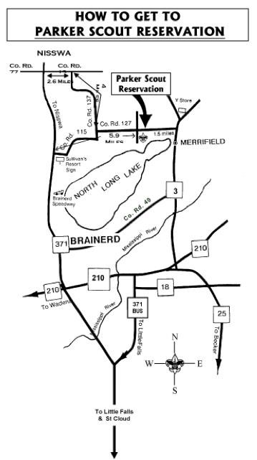

Emergency calls only, Camp Director: Mary Herlick, cell 320-493-1194
Camp Phone: There is NO PHONE at Camp
Best Practice: Contact your Unit Leader at camp
Council Office Phone is not answered on weekends

Camp Arrival and Check-In

Check-in Time
Please plan to arrive at camp between 6:00 pm and 8:00 pm on the first day of your respective session. The check-in process will be not available until 6:00 pm when the entrance to camp is officially opened. All Packs should be in camp no later than 8:00 pm. Please carpool when appropriate as parking space is limited. Carpooling also enables your group to check-in more quickly and efficiently. There will be no meal service on the first night, so please plan to bring evening snacks and eat supper before coming to Camp.

Getting to your Theme Area (Adventure Campsite or Lodging Area)
Cub Scouts and leaders will be greeted in the main camp parking area. Vehicles are unloaded, and all equipment is packed onto large garden carts that are easily moved by campers to the theme areas. You may bring your own trailer/cart for transporting. Each theme area is allotted one to two garden carts, so a couple of trips may be necessary. Vehicles must remain in the main parking area. No vehicles are allowed on camp roads except for emergency and other camp vehicles, or for approved persons with physical limitations.

Check-in Procedure
Getting checked into camp is a step-by-step process that is conducted quickly and efficiently by the camp staff. Try to have all your Pack’s participants arrive at camp at the same time. A staff member will greet you in the parking area upon arrival. A staff member will be available to escort your Pack/Den to your theme area. Garden carts are provided; however, consider bringing an additional cart, wagon, etc. to limit the number of trips. Backpacks can be a great help here.

Step 1: Arrive at camp and gather your group. Carpool whenever possible. This is important to limit overflow parking as much as possible.

Step 2: Leaders ensure all health records; medications and medication cards are with one person.

Step 3: Unit Leader goes to Parker Lodge (Admin Building) for:
- Participant wristbands (to be worn at all times)
- Health Form review
- Medication and Medication Card turn in (optional).

Step 4: Groups will be instructed where to make camp. Scouts and adults wanting a Camp Tour should return to the Admin Bldg. Camp Tours will be on a voluntary basis.

Step 5: Campers meet with their Theme Director in their theme area to get settled in before the Theme Area activities and Campfire.

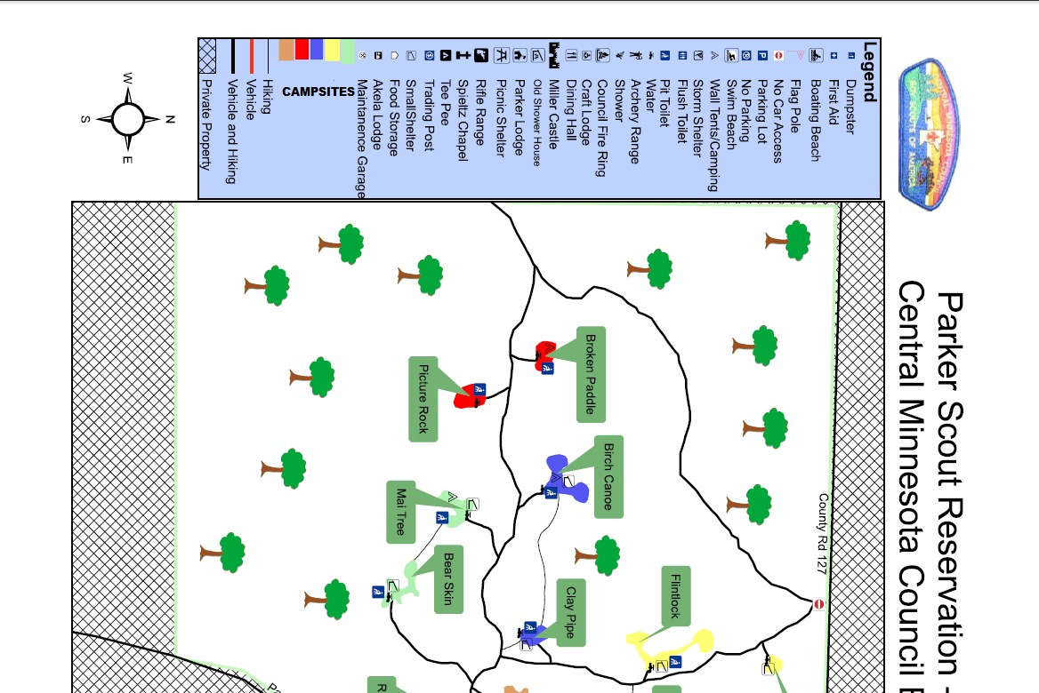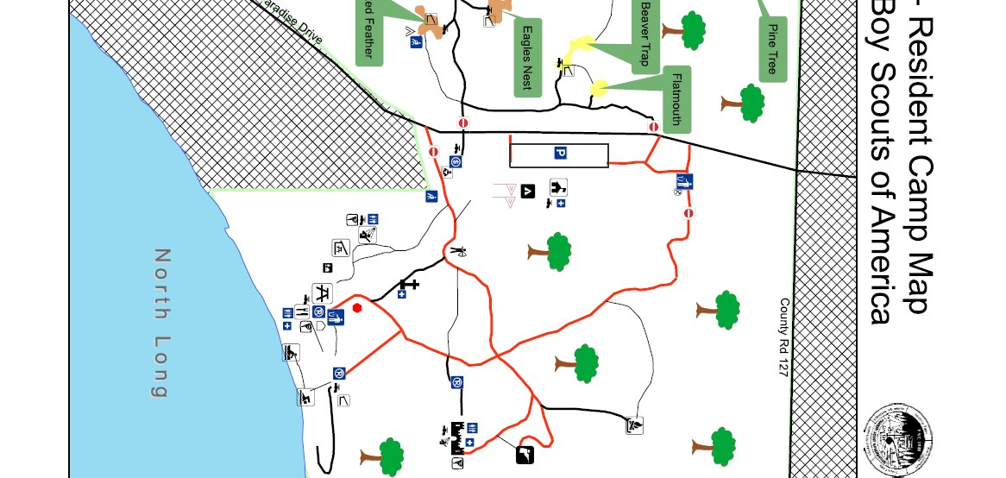

Camp Facilities and Services

Accessibility for Disabled Persons
Most of the buildings at camp are accessible by wheelchair. The trails in camp are mostly hard gravel roads and wheelchairs can be used on many of the trails to the program areas. Adult assistance will be needed to safely escort wheelchairs on these trails and roads.

Trading Post
The Trading Post is the camp’s store. The trading post is in the Administration Building, (Parker Lodge). It is stocked with a variety of merchandise including souvenirs, personal hygiene items, snacks and beverages, camp equipment, handicraft materials and other miscellaneous items. Merchandise costs range from $.50 to $35.00. Trading Post hours are posted in camp. Times are subject to change.

Chapel Service
The camp includes time for worship as part of the regular program schedule. This typically takes place on Saturday before dinner and uniforms should be worn. Campers are encouraged to attend a brief non-denominational service in the Protestant Chapel area behind the Administration building. We offer both a Catholic Mass with communion and a Non-Denominational Service on Saturday evenings. As Scouting has a focus on Duty to God, it is appreciated if you attend.

Dining Hall, Pavilion and Food Service
The camp provides a full-service dining hall where meals are prepared and served. Participants will sit in the nearby Pavilion to enjoy the meal. A certified dietician approves the camp menu. Saturday breakfast, lunch, and dinner are served, and a final breakfast will be available to Packs/Dens on Sunday morning.

If a camper has any special dietary needs or food allergies, please indicate on the medical form and be sure to contact the Council Office at least two weeks prior to session. Please contact the Camp Director or Kitchen Staff for meal options. We will do our best to prepare alternate meal items with the ingredients we have, and you are welcome to stop by the kitchen and read labels, however, we cannot guarantee anything. It is advisable to bring some foods from home to supplement the items we can provide.

Meal Serving & Clean Up
All Saturday meals are served cafeteria-line style from the Dining Hall. To help facilitate the serving process, leaders may be asked to assist the staff in the serving of the meals. This also helps to ensure the proper amount of food is served and that each camper has the opportunity to try every type of food on the menu.

After each meal, 1 adult, minimum should stay behind to ensure their area is clean around the tables. Staff will help where needed. We also appreciate any adults that are willing to help clean up and wash dishes. The members of our kitchen staff are all volunteers, too!
Health and Safety

Personal Hygiene
Personal cleanliness is a great habit to prevent illness. Allow time for hand washing prior to every meal. The camp is equipped with showers and other bathroom facilities for use by all campers.

Health Forms
All campers (Cub Scout and adults, regardless of age) are required to have a completed Annual Health and Medical Record form (part A & B) reviewed while they are at camp. NO PHYSICAL EXAMINATION IS NECESSARY, REGARDLESS OF AGE when attending Cub/Webelos Summer Camp. The health forms are to be collected by the adult leader in charge of the Cub Scout Pack and provided to the Health Officer at camp during the check-in process. Health forms will be reviewed by Camp Staff and returned to you. A copy of the Annual Health and Medical Record form is available in the back of this guidebook, and can be obtained through the Council office in Sartell, the council’s web site at: www.bsacmc.org, emailing ParkerScoutCamp@gmail.com, or through the National Boy Scouts website.

Medication Cards (available in the back of this guide)
All prescription medications, other than immediate emergency need (i.e. inhalers) can be, if you choose, secured at the camp medical office. A Pack adult leader must accompany Scouts to the medical office to take medications. Complete the medication agreement for each youth with the Health Officer.

Medication brought to camp must be in the original (prescription) container and contain the following information:
Camper’s name 4. Date prescribed
Name of prescribing physician 5. Name of medication
Prescription number 6. Directions for use

A Medication Card is required for each type of prescription medication to be taken at camp (if maintained at the Administration Building). The card must contain the required signatures of the parent and the prescribing physician. Completed Medication Cards can be mailed to camp with the Pack’s health forms or brought to the camp on the first day and filed in the health lodge. A copy of the Medication Card can be found in the Forms section of this guidebook.

The Medical Office and Camp Health Officer are located in Parker Lodge (Administration Building) and the Dining Hall. After 10 PM, the Castle is where health staff will be located.

Health Services
First-aid and other health related services are provided for the safety and well-being of all campers. Any camper having an accident or suspected illness must go to, or be assisted to, the Health Officer. Emergency services such as ambulance and 24-hour medical clinics are available in Brainerd. The camp has a written agreement with those medical staffs regarding emergencies in camp.

Camp Wide Emergencies
In the event of a camp emergency, a camp siren will sound. We have a hand-crank portable siren that will travel around camp. In such a case, all campers report to their respective theme area shelter. Cub Scout pack leaders must take roll call of their pack members. Campers are to remain in their theme areas until a camp staff member arrives with additional instructions and information. A camp emergency drill may be conducted the first day of your stay at camp.

Buddy System
The Buddy System is in effect 24-hours a day. Cub Scouts should always have a buddy or two with them wherever they go. The camp staff will be observing and leaders are encouraged to ensure this occurs throughout the camp sessions.

Fires and Firefighting
The camp staff is prepared to handle firefighting in camp. Fireguard charts are furnished and must be posted in the camp program areas and where tents are located. The charts shall be inspected and completed each day by an adult leader camping with the Cub Scout Pack. Fire buckets are also located in these areas and are to be kept full and used for firefighting emergencies only. All tents are to be clearly labeled “No Flames in Tent”. The camp can provide these signs to persons needing them upon arrival.

Shoes
Shoes are to be worn at most all times, to help prevent the chance of foot injuries. It is always a good idea to have two pairs of shoes at camp. No open toe shoes or sandals.

Bicycles
Cub Scouts and leaders are asked not to bring bicycles or other wheeled vehicles to camp unless it is for a physical disability. Summer Camp does not provide wheelchairs or wheeled vehicles to persons requiring them. Please plan accordingly when staying at camp.

Pets
Cub Scouts and leaders are asked not to bring any pets to camp.

Drugs and Alcohol
Being under the influence or in possession of alcohol or any illegal drug on council property is strictly prohibited. Offenders will be escorted off the property immediately and, if necessary, the proper authorities will be notified.

Smoking
No one under 18 years of age will be allowed to smoke. All council-owned buildings of the Central Minnesota Council are smoke-free. Persons who must smoke at camp may do so only in areas well away from the camp activities. Smoking is not allowed in the presence of any youth.

Youth Protection
All BSA youth protection policies will be followed to the letter. If they are not, the individual in violation will meet with the Camp Director regarding consequences.
http://www.scouting.org/Training/YouthProtection/QA.aspx
All registered adult leaders need to have Youth Protection Training prior to coming to camp.

Fireworks
NO fireworks of any type are permitted in camp.

Leaving or Entering Camp
Any Cub Scout or adult leaving camp or arriving in camp after arrival must check-in and out. Sign in/out sheets are posted at the office to ensure accurate accountability of all campers and staff. Any person, who chooses to leave camp early, must check out with the Camp Director or Program Director. A Scout may only leave with their parent/guardian.

Snack Foods
The camp also has a trading post (store) that sells a variety of snack foods and beverages. Cub Scout Pack leaders are encouraged to monitor the amount of snack foods and beverages brought to the camp by Cub Scouts.
Personal food and beverages must be kept in personal vehicles overnight.
There is no food or beverage (other than water) allowed in Parker Scout Camp tents. Food should not be kept in any tents due to animals in the area.
Personal food may be in the campsites during the day, however during the night it should be returned to personal vehicles.
Do not feed the animals no matter how “cute” they look.

Telephone/Cell phones
Try to have Scouts refrain from using cell phones at camp (Unit Leader responsibility). Adults are encouraged to refrain from cell phone use that would distract anyone from the program.

Latrines
There are latrines and/or Porta-Potties available in/near all campsites. Trash must not be disposed of in any of these and must be kept clean and orderly.
Flush toilets are only available in the shower house, dining hall and at Miller Castle.
Water is available at each campsite, so hands can be washed after using the latrine and before meals. If supplies are needed, notify your Theme Leader so that they can be replaced.

Weather
We always hope for good weather, but we are not always lucky
In case of Rain, activities will go as planned, so rain gear is a must. If it becomes too heavy, rain locations for each program area have been assigned.
Camp Staff will monitor weather conditions.
In case of severe weather, Camp Staff will advise the campers to move to the emergency shelters as necessary.

Personal Property
The camp and camp staff do not assume responsibility for damage or loss of personal property. Campers are encouraged to leave any valuables at home that may be damaged or lost, and to bring a locked box for any other personal items. Vehicles should always be locked and parked in the designated parking area.

Parker Scout Reservation Tenting
Adults may not share the same tents with youth unless they are parents, family or legal guardians of that child. One family unit may share a tent -----Two different family units may not share the same tent--PLEASE REFER TO THE BSA YOUTH PROTECTION POLICIES-

No food or beverages should be brought into your tents. There are Raccoons, Skunks, Chipmunks, and Squirrels that may find it. Please keep any snack food items in your vehicle or securable box or cooler.
Please bring your own tent or borrow one from a friend. Parker Scout Reservation may have some tents to rent for the weekends (first come, first served --- advance request required).

Dealing with Inappropriate Behavior
- Program area staff will discuss expectations with the camper.
- Leader should discuss expectations with the camper.
- Alert the camper that the actions are inappropriate in a non-demeaning manner.
- Redirect the behavior.
- Give a verbal warning about consequences
- Remove the individual from the situation
- If cooperative after a few minutes, allow back to the activity, if not, suggest another activity. If this still does not work, a leader and the youth shall visit with the Program Director or the Camp Director.
- If safety is a concern, the Camp Director and/or the Program Director shall be notified immediately.
- The camp director can request the removal of any participant (youth or adult) at any time.

Summer Camp Themes, Activities & Advancements, Camp Staff

Medieval Times/Hawgwarts, Good Knights and Curiosity, Intrigue and Magical Mysteries.
Stef will be your guide to a castle-based theme experience for new Scouts and Tigers going into grades 1 or beyond. Have you ever slept in a castle? Have you ever dreamed of being a knight of the round table? Are you curious about magic and mysteries? Learn secret codes and magic tricks!

Finding Your Way and Digging in the Past
for young explorers who are going into 2nd Grade. Wolves will earn these Elective Adventure Loops by completing the requirements with Holly. Study maps and globes and learn to navigate using compasses. Take a hike and go on a scavenger hunt. Do you like dinosaurs? Learn about the wonders of nature and prehistoric creatures long the way.

A Bear Goes Fishing and Critter Care
for Cub Scouts who are going into 3rd Grade. Bears will earn this Elective Adventure Loop by completing the requirements with Levi, our resident fishing and critter expert. Identify different types of local fish and their habits and habitats, discuss and demonstrate the importance of Fishing Regulations through games and projects, because rules aren’t always fun, but they are important. Learn about different fishing equipment and make a simple fishing pole. Practice casting and then let’s go fishing! On the pontoon and off the dock, use what you have learned about fish and fishing gear. All fishing will be catch and release.

Castaway and Outdoorsman for Webelos
Can you imagine being lost in the woods or stranded on an island? How can you help others find and rescue you? Phil is your guide in this Castaway adventure for Webelos entering grades 4 and 5 with requirements from Outdoorsman! Start fires without matches and create a shelter that could protect you overnight if you were lost. Which items will you need to carry with you on an adventure which are important for survival. Invent a game that everyone can play at camp and teach it to others and more!

Adventures in Science for Webelos
An indoor/outdoor based Webelos Elective for boys going into grades 4-5 Join us for a camping adventure that includes an exploration into the science of time and space. You will conduct experiments in our science lab, learn about our solar system, and make “scientific messes”. Our resident scientist, Beth, will guide you through the Adventures in Science loop!

Waterfront
Jace and his team of lifeguards will be ready at the beach for your group to enjoy the water and work on the aquatics adventure loop for your age group. Star Wars will be the theme, and fun will be the order of the day. Join us early on Sunday, too, for the polar hour swim!

Other Program Areas
The camp also features several traditional program areas that all campers will have an opportunity to experience:

Waterfront/Beach area
The waterfront area of the camp is one of the most popular. It offers swimming, water games, a sandy beach, kayaks and swimming and boating safety instruction. The Aquatics Supervisor is a nationally certified instructor and teaches safety in and around the water at all times.

Shooting Sports
All campers will have the opportunity to participate in learning about the safety and use of BB guns and archery equipment. The camp’s shooting sports area is ideal for campers and will allow the maximum of eight persons to shoot at any one given time. Instructors, whose number one job is camper safety, staff the ranges. Leaders may be asked to assist with safety and proper handling of the equipment in the area. Parker Scout Reservation will provide all equipment at the shooting sports ranges.

Campfires
Friday evening, your program leader will hang around and visit with you around a campfire in your group area. This is a great time to get to know one another and to appreciate the outdoors in the evening. The second evening of your stay features a closing campfire at the Council Campfire Ring. The camp staff leads the group in songs, skits, cheers, stories and more for a fun-filled evening of entertainment.

Camp Staff
The camp staff at Parker Scout Summer is made up of dedicated men and women. Some of the senior staff (21 and over) have been certified by National Camp School, an extensive training course conducted by the Boy Scouts of America. The entire staff is committed to providing the best possible service to every camper to ensure a safe, enjoyable and fun- filled time at camp. They are available and at your service for any reasonable request, need or question related to summer camp.

2019 Adventures Summer Camp Schedule (subject to change)

Day, Time Event Location

Friday
6:00 - 8:00 pm Registration, Check-In, Set up Camp Parker Lodge/Admin
7:00 - 8:00 pm Camp Activities Theme Areas
8:15 pm Flag Ceremony Flag Field
8:30 pm Camp Tours by staff (optional) Meet at Teepee
9:00 -10:00 pm Program (campfire, instruction & free time) Theme Areas
9:15 pm Parent, Leader Information Sessions Theme Areas
9:15 – 10:00 pm Optional Leader Training, YPT, Safe Swim, etc. Parker Lodge/Admin
10:00 pm Lights Out – Unit Leader Enforced

Saturday

7:00 am Reveille – Unit Leader Enforced Camp Wide
7:30 – 7:45 am Flags Ceremony (“Class A” Uniform) Flag Field
7:45 - 8:30 am Breakfast (“Class A” Uniform) Dining Hall
8:45 - 10:00 am Program Session 1 Program Sites
10:15 - 11:30 am Program Session 2 Program Sites
11:45 – 12:45 pm Lunch (includes ½ hour rest time) Dining Hall
1:00 - 2:15 pm Program Session 3 Program Sites
2:30 - 3:45 pm Program Session 4 Program Sites
4:00 - 5:15 pm Program Session 5 Program Sites
5:30 - 6:30 pm Church Services (“Class A” Uniform, if possible)
Catholic: Catholic Chapel (all are welcome)
Non-Denominational: Protestant Chapel (near Admin Building)

6:30 pm Dinner (“Class A” Uniform) Dining Hall
7:30 pm Free time, activities Human Foosball, Gaga Ball, etc.
8:15 pm Flags Ceremony (“Class A” Uniform) Parade Field
8:30 pm Campfire (“Class A” Uniform) Council Ring
9:45 pm Optional adult leader training Parker/Admin
9:45 pm Theme wrap ups Theme Areas
10:00 pm Lights out - Parent/Leader Enforced

Sunday
6:30 am Star Wars Swim/Early Swim (optional) Beach
7:00 am Reveille/Theme Area/Campsite Clean-up Camp, Castle and program areas
8:00 am Flags Ceremony Flag Field
8:315 am Breakfast Dining Hall
8:45 am Camp Games/Theme Competitions Flag Field
10:30 am Check out with theme leaders, pick up health forms Admin./Parker Lodge

Programs and times may change at any time at the discretion of Program or Camp Director.
Trading Post (Located in the Parker Lodge/Admin) Hours will be posted
Trading Post will not be open during meals, worship service, or flags.

Emergency Procedures

- The emergency signal for camp shall consist of camp siren being sounded via a hand-crank claxon and will travel around camp during the emergency.

- With rare exceptions, the ONLY STAFF authorized to direct the emergency signal to be sounded will be any PROFESSIONAL PARTNER, CAMP DIRECTOR, PROGRAM DIRECTOR, AQUATICS DIRECTOR, CAMP CARETAKER and the HEALTH OFFICER.

- Once the emergency signal has been sounded, all staff members will be notified what the emergency is by either Cell Phone, Two-Way Radio, or Personal Contact.

Theme Directors or assigned staff will arrive to lead group to shelter, if necessary.

Check-Out Procedures

Check-out Time
Departure from camp will begin following Camp-wide games on Sunday.
All units are expected to clean their theme area prior to checkout. Garbage should be brought in bags to the dumpster by the dining hall. (A Scout is Clean)

Drivers of vehicles arriving to pick up campers are to be reminded to park in the main parking area. Garden carts are available to transport equipment from the area(s) to all vehicles. Visit with your Theme Director to check out. Your Theme Director will collect your Camp Surveys and provide you with your camp patches and information about your advancement reports.

Check-out Reminders:
- Make sure the Parker Scout Summer Camp Evaluation Form is completed and turned in.
- Double count camp patches to ensure no one in the Pack has been missed.
- Take a roll call to ensure all Cub Scouts are accounted for prior to departure.
- Purchase 2018 souvenirs from the Trading Post. (You may choose to make any large purchases on your last day to avoid storage/handling during your stay).
- Double check the theme program area to ensure is has been cleaned and left in an orderly manner.
- Pick up all medication from the Health Lodge/Admin. Bldg. (if used)
- Final check on lost and found articles.
- All individuals must be checked out at the weekend’s conclusion; again, one leader is all that is needed.
- You should not leave until your camp site has been checked by the Theme Leader, once this has been completed, return to Parker Lodge to complete the Check-Out procedure. You will receive your patches at check out, (one patch for each youth participant.)

FORMS

Campership Form (2 pages)

Medication Card

Annual Health & Medical Record (3 pages)
Online choose link

Summertime Pack Award (2 pages)
Online choose link

entral Minnesota Council Boy Scouts of America

Camp Parker Cub Scout/Webelos
Scholarship Application

A summer camping experience is the highlight of a youth’s year in the Scouting program. The Central Minnesota Council, Boy Scouts of America has a limited number of dollars available (from Friends of Scouting support and three individual donors) to fund a Camping Scholarship program enabling more Scouts to participate in camp.

Camping Scholarships may cover up to one half of the youth’s summer camping fees. Scholarships are limited to Cub Scouts and Webelos Scouts registered in Central Minnesota Council Packs. The Scholarship Program applies toward Cub Resident Camp and Webelos Resident Camp at Parker.

Please complete the information requested below. Camperships are based on need and availability of funds. Applications must be received May 15th to allow for approvals and notification. Discount will be at time of online registration using a coupon number.

Name of Scout ______________________________________ Pack Number _________

Address/City/Zip _____________________________________________________________________

Cub Scout Camp ____ Webelos Camp ____ Dates of Camp __________________________________

Parents name:________________________________________________________________________

Parent’s email address: ______________________ __________ Phone #:______________________

Brief, but specific statement about the situation and need for a camping fee scholarship (will be kept confidential): ____________________________________________________________________
____________________________________________________________________________________
Requested by: ________________________________________________________________________
Signature of Parent Date

Mail to: Camping Scholarship
Central Minnesota Council, BSA
1191 Scout Drive
Sartell, MN 56377
Office Use Only*

Authorized By ________________________________

Parent Notified ___________Date ___________ Amount Granted $____________

FUNDING WORK SHEET
[To be filled out by Unit Leader or Committee Chairman]

Please answer all of these questions to assist in the calculation of the Camp Fee Scholarship.

SURVEY

Please answer all of these questions to help determine the need for the camping scholarship.

- Did your Pack participate in the Council Popcorn Sale last year? _________
  - Did this Scout participate in the Popcorn Sale? _________
  - Was a percentage of the Scout’s Popcorn Sales applied toward his summer camp fee? _________

3. Did you participate in any other fundraisers to help pay for camp? ___________________________

If so, explain _________________________________________________________________________
____________________________________________________________________________________
____________________________________________________________________________________
____________________________________________________________________________________

CAMPING SCHOLARSHIP CALCULATION

Summer Camp Fee: $95.00, $80 if submitted by April 15th.
- $______________ Amount that Family can pay
- $______________ Amount the Pack can contribute

Amount Remaining $______________* [This is the Scholarship amount we are requesting]

* The scholarship funds will be transmitted to the “camp”, not to the boy or the unit. In the event that the youth does not attend camp, the funds are non-refundable and cannot be transferred to another individual. Once approved, the recipients will receive a campership coupon that will be redeemed when making payment for camp online.

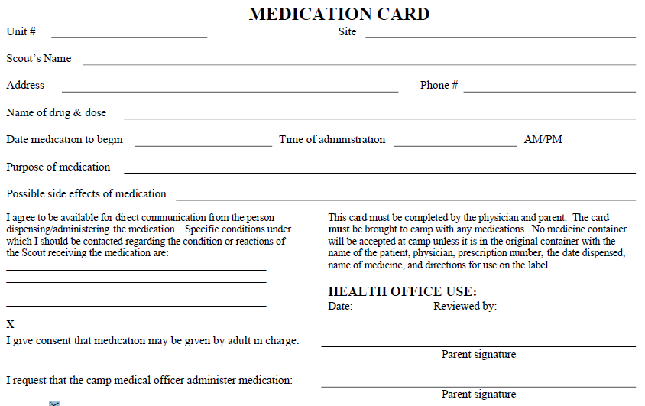

(CAMP USE ONLY!!!)
Medication Card – Side 2 Scout’s Name ______________________________

Fill in date, time and initial whenever medication is administered.

Date | Time | Initial | Date | Time | Initial | Date | Time | Initial

Full name of person(s) responsible for administering medication:

____________________________ ___________________________ ________________________

