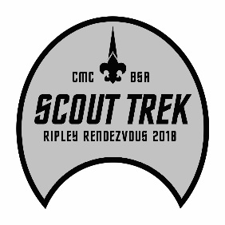

2018 Ripley Rendezvous Schedule

Friday Night
- Check in
- Welcome event 9 p.m.
- Leader Meeting 10 p.m. (or following Welcome event)

Saturday
- Breakfast
- Adventure program shooting sports/Trek Challenge
- Scout Ops/Scout Trek Challenge
- Lunch mid-day
- Dinner
- Religious Services
- Order of the Arrow Call Out
- Camp Fire Program

Sunday
- Breakfast
- Good Turn
- Check out

