Camper and Adult Fees 2019
Paid in full by May 15, | 2019 | Paid on or after May 16, 2019
1. Camper | $150.00 | $158.00
2. Adult Leader | $150.00 | $158.00

ALL CUBS AND LEADERS ATTENDING ROTA-KIWAN SCOUT RESERVATION WILL RECEIVE A PATCH.
Insurance
Your annual registration fee pays for insurance that covers accident and sickness insurance on
every registered Cub and adult leader. Insurance does not cover additional unregistered adults and siblings who may attend camp. Therefore, every Cub and Leader in camp should be registered and on your unit charter.
Summer Camp Fee Payment Schedule

Please note and read the fee payment schedule below. Also, your check-in at camp will go
much faster if your entire fees are paid ahead of time. If you have questions regarding the fee payment schedule, please visit www.michigan.scouting.org Thank you!
Discount Registration Period (Dec 1, 2018 - May 15, 2019)

For Packs that register during this period a $20 non-refundable deposit per registrant is due at time of registration. Final payment is due by May 15th to receive discount. Individual names and contact information needs to be submitted at this time.
If final payment is not made by May 15th the regular camp fee will apply. Any reservations made after May 15th, full payment is due. Packs can go online and update their registration up until 2 weeks prior to the camp you registered for. Only additions or substitutions can be made online. Other requests please contact us at 517-816-7755 or email us at camp.michigan@scouting.org.

Registration Period (May 15, 2019 – 2 weeks prior to start of camp)

Packs that register during this period will have to pay the full camp fee balance and provide names and contact information for each registrant to finalize registration. There is no deposit. Other requests please contact us at 517-816-7755 or email us at camp.michigan@scouting.org
Sleeping Arrangements
All people that attend camp will be bunking in a canvas tent with a platform bottom. All tents
come with two cots and two mattresses. We will have three sites that will be bring your own tent sites and two that will be camp provided tents. Please contact Aaron to make proper arrangements. He can be contacted through email at aaron.collins@scouting.org or 734-807-0201 Webelos will be sleeping in a campsite to prepare them for their first experience in a Scouts BSA camping. Each campsite will have a fire pit, wash station, picnic tables and a dining fly for playing games or resting. A restroom/showering facility is located with 65 yards of the campsite for your use anytime during the day. As always if you would like to bring your own tent that is welcome, but please remember to have a no flame in tent sign. If you have health concerns and cannot sleep in a tent, please reach out to the camp director so other accommodations can be made. As always if you would like to bring your own tent you are more than welcome to do so.

Program Opportunities
Webelos Resident Camp’s program is designed to incorporate requirements that will help the Scout
complete adventures for the Webelos rank only. The age appropriate programming is designed for the
Webelos to help them along their path to earn requirements that may not be easily achieved in the
regular den/ pack meeting setting. We highly encourage only scouts working on their Webelos badge to
come to camp. Please know that if a Wolf or Bear Scout wishes to come to camp, the requirements for
that rank will not be developed into the program. Lions are excluded from activities such as shooting
sports, climbing, camping, aquatics and many other activities that are appropriate for Cub Scouts.
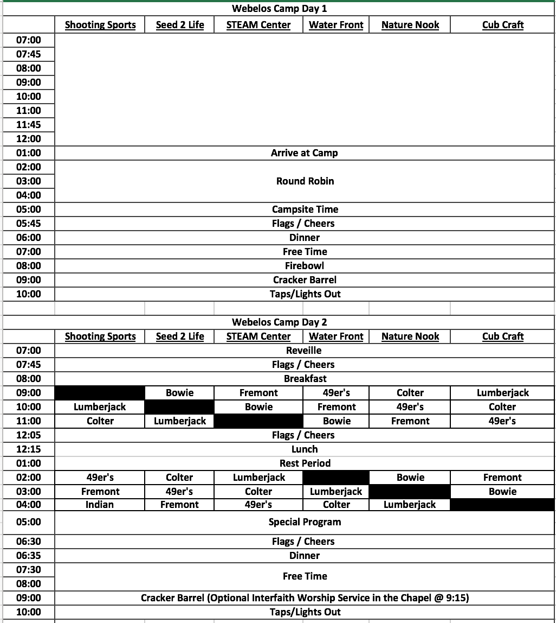
Program Schedule

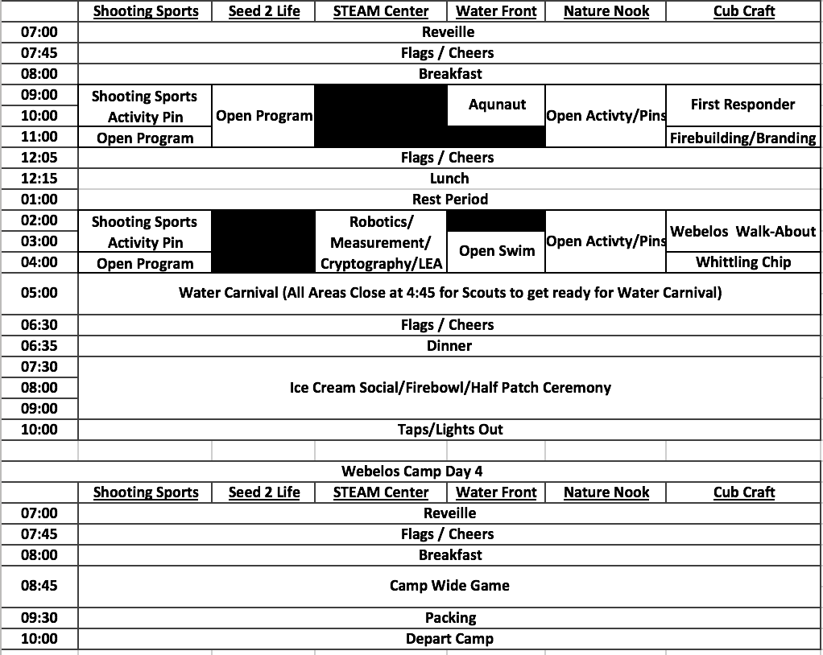
***ALL ACTIVITIES ARE SUBJECT TO CHANGE AT ANY POINT FOR THE BETTERMENT OF PROGRAM OR FOR THE SAFTEY OF CAMPERS*

