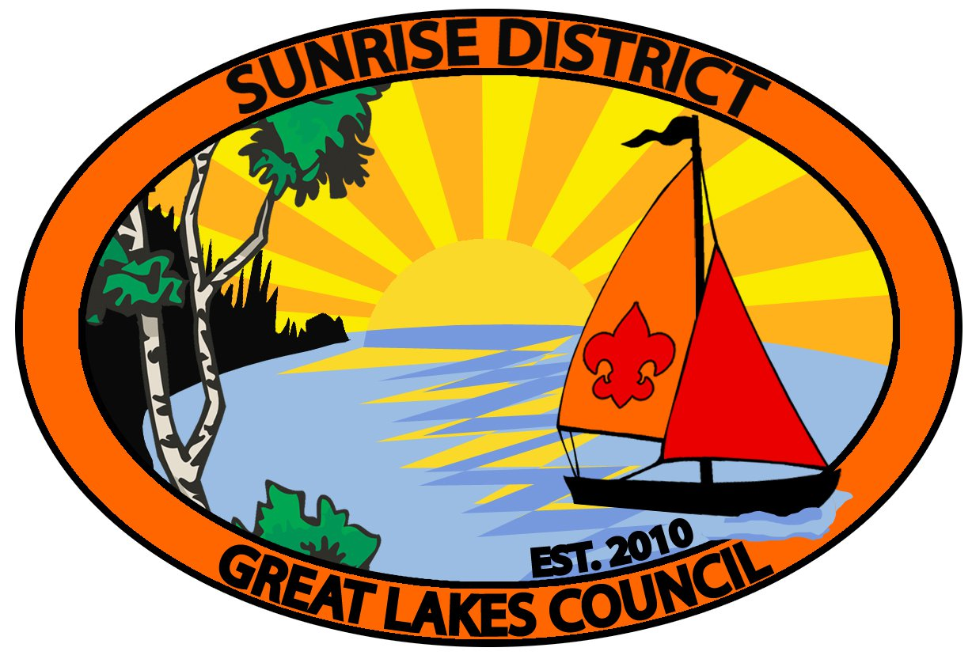

Sunrise District
2019
District Award of Merit
And
Ray of Light Award

The District Award of Merit is a council award presented by districts to Scouters who render service of an outstanding nature at the district level.

The Sunrise District “Ray of Light” Award honors registered scouters who have provided meritorious service to youth while serving at the Unit level. One award is available annually for each Unit within the District.

Applications for both awards are available from and must be submitted by March 31, 2019 to kdnewman@comcast.net or summer.robinson@scouting.org or kevin.lauro@scouting.org. Applications will also be available at roundtable.

District Award of Merit and Ray of Light recipients will be presented their awards at the Sunrise District Recognition Banquet.

