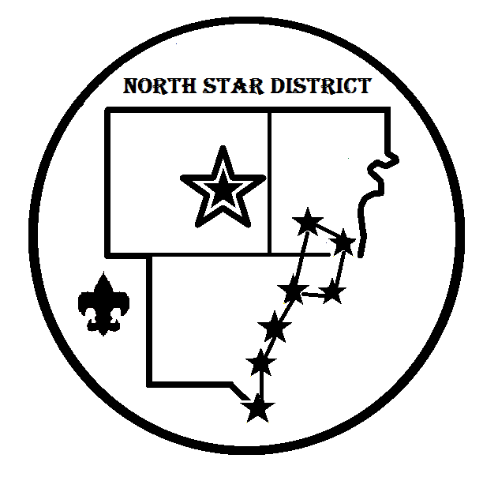

2019 North Star District
Award Nomination Form

Unit Type: ____________ Number: ____________
Recipients Name: __________________________________________
Position in Unit: ___________________________________________
Award Being Nominated for (list on reverse side):

What makes this candidate worthy of this honor? :
______________________________________________________________________________________________________________________________________________________________________________________________________________________________________________________________________________________________________________________________________________________________________________________________________________________________________________________________________________________________________________________________________________________________________________________________________________________________________________________________

Nominated by: _____________________________________________
Position: ______________________ Phone Number: ______________
Email Address: _____________________________________________

Return this form via email to Jon Miller at jonathan.miller@scouting.org
- Or return by mail to 1776 West Warren Ave. Detroit, MI 48208 (Attn: North Star)
Awards List

Outstanding Unit Leader Awards
(Open to any leaders who were registered at least in 2018)
- Outstanding Pack Leader
- Outstanding Troop Leader
- Outstanding Crew Leader

Outstanding New Leader Awards
(Open to anyone who’s first full year in their role was 2018)
- Outstanding New Pack Leader
- Outstanding New Troop Leader
- Outstanding New Crew Leader

Other District Awards
- Den Leader of the Year Award
- Commissioner of the Year Award – (for Commissioners active in 2018)
- Pointing the Way Award – (a District Volunteer award)

