Kaposia District
2020 Merit Badge BLAST
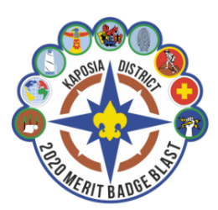

Saturday, February 22, 2020
Check-In starts at 7:45 am; Flags at 8:15 a.m.
Merit Badges from 8:30 am to 3:30 pm

Park High School
8040 80th Street S, Cottage Grove, MN 55116

$16 per Scout / $8 per Adult
(Includes lunch)
Please note: Some merit badges have an additional fee
Registration Deadline is Friday, February 14, 2020.
If registering late, please contact Coordinator.
Registration link is _ coming soon

Early registration is highly encouraged, so that Scouts can get their Merit Badge(s) confirmed, get and start to read the merit badge book and begin work on any prerequisites. (List will be available soon)
All merit badge prerequisites MUST BE COMPLETED BEFORE ATTENDING.
Cost Center 313
District Coordinator: Margaret White (651) 295-2871 magswraps@gmail.com

