2019 Webelos Experience in the Woods
For Webelos, AOL, Parents and Den Leaders
November 01 - 03, 2019
Stearns Scout Camp
3303 Co Rd 44, South Haven, MN 55382

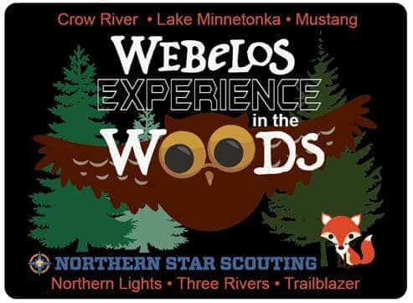

Just some of the Cool Activities

- Patrol Cooking
- Campfire Building
- Archery
- BB Gun
- Ultimate Frisbee
- Patrol Competitions
- Patrol Team Building Activities

Aquila Team – Crow River, Lake Minnetonka, Mustang, Northern
Lights, Three Rivers & Trailblazer Districts
Aquila Team – Crow River, Lake Minnetonka, Mustang, Northern Lights, Three Rivers & Trailblazer Districts
Aquila Team – Crow River, Lake Minnetonka, Mustang, Northern
Lights, Three Rivers & Trailblazer Districts
Aquila Team – Crow River, Lake Minnetonka, Mustang, Northern
Lights, Three Rivers & Trailblazer Districts

Registration Information
Online Registration link: Coming soon to the Three Rivers District website
https://scoutingevent.com/250-WWAquila19
Registration and fee payment Deadline is Thursday October 24,2019, 11:59PM
$30 - Webelos Registration Fee
$20 - Parent/Leader Registration Fee
$20 - Adult Staff Registration Fee
$0 - Youth Staff are Free

Required Equipment and Materials to Bring
- Water Bottle
- Camp Cup (needed for meals)
- Mess Kit (needed for meals)
- Silverware (needed for meals)
- Health Forms for each Scout and Adult
- Tents, Sleeping gear, Rain Gear, Warm Outdoor clothes
- Skit and song Ideas
- Tent
- Sleeping bag
- Sleeping pad or cot
- Appropriate attire (warm clothes, underwear, socks)
- Tennis shoes/Boots
- Fall/winter coat, hat, gloves
- Personal hygiene products (toothbrush, toothpaste, comb, etc.)
- Bug spray
- Flashlight
- Rain gear
- Propane Heaters Are Never Allowed In Tents. If this rule is not followed, you will be asked to leave camp.
Dress for the weather, it could be raining, snowing or sunny. Weather can be unpredictable so plan ahead. BSA policies for camping & sleeping arrangements must be followed at this event. This means that no scout can share a tent with an adult other than their parent. This means that two scouts & their dads cannot share a tent.

Cooking Equipment and Meals Provided !!

Tentative Schedule for the Weekend
Friday
6pm Check in and meet troop guide and staff
8pm Cracker Barrel
10pm lights out

Saturday
7am Breakfast
8:30 am opening ceremony
8:45-9:45 Patrol meeting (name, flag and yell)
10am activity stations
11am-12:30 Lunch
12:30-1:30 activity stations
13:30-4p, activity stations
4-5pm firem’n chit
5-6:30 Dinner in campsite
6:30-7:30 Free time
7:30-9pm campfire program
10pm lights out

Sunday
7am-8:30 Breakfast
8:30-9am Scouts own
9-10 Pack up & thorns and roses
10am check out
Webelos Experience in the Woods Evaluation - Youth
District________________ Unit # __________________Troop Guide________________________

What did we do well?

What could we have done better?

Which activity did you like best?
Why?

Which Activity did you like least?
Why?
Number of Events (circle one) Too Many Right Number Not Enough

Please rate each of the following, with 1 being the lowest and 5 being the highest
Campfire 1 2 3 4 5
Activities 1 2 3 4 5
Opening Ceremony 1 2 3 4 5
Closing Ceremony 1 2 3 4 5

Any Additional Comments

Webelos Experience in the Woods Evaluation - Adults

District________________ Unit # __________________Troop Guide________________________
What did we do well?

What could we have done better?

Were you given enough advance information to be prepared for this event? YES NO

What additional information should have been included?

Did you think the facilities were adequate for this particular event?

How well did this event prepare you for Scouts BSA?

Please rate each of the following, with 1 being the lowest and 5 being the highest

Campfire 1 2 3 4 5
Activities 1 2 3 4 5
Opening Ceremony 1 2 3 4 5
Closing Ceremony 1 2 3 4 5

Any Additional Comments:

