Kaposia District 2019 Merit Badge Day

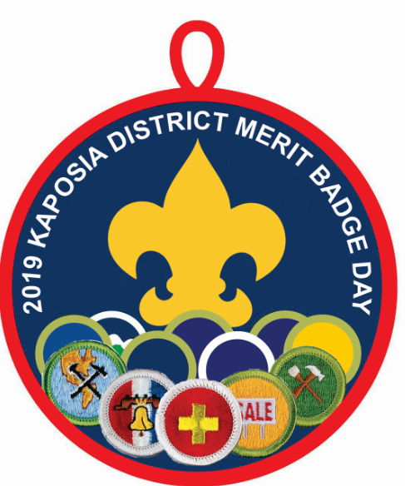

Saturday, February, 23 2019
Check-In starts at 7:45 am; Flags at 8:15 a.m.
Merit Badges from 8:30 am to 3:30 pm

Park High School
8040 80th Street S, Cottage Grove, MN 55116

$18 per Scout / $6 per Adult
(Includes lunch)
Some merit badges have an additional fee
Registration Deadline is Friday, February 15, 2019
Registration link is https://www.scoutingevent.com/250-kambd2019

Early registration is highly encouraged, so that Scouts can get their Merit Badge(s) confirmed, get and start to read the merit badge book and begin work on any prerequisites.
0All merit badge prerequisites MUST BE COMPLETED BEFORE ATTENDING.
Cost Center 313
District Coordinator: Margaret White (651) 295-2871 magswraps@gmail.com

