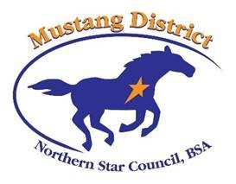

Mustang District Picnic & Awards
May 31, 2018

Lakeside Shelter, Lone Lake Park
(5624 Shady Oak Road, Hopkins)

Cost: $10 for adults -- $5 for children

Bring a dish to share (enough for 4 people) and eating utensils – Meat will be provided

Celebrate with those who will receive special recognition for outstanding service in the District

Use your Mustang Bucks for 2017 to 2018 to bid on Scout auction items

