KLONDIKE SAM’S GOLD RUSH – EAGLE RIVER DISTRICT 2017 KLONDIKE INFORMATION
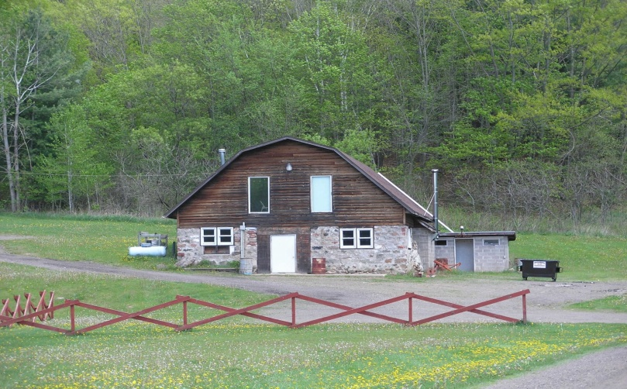
Where: The Chalet – Clear Lake WI.
Directions: Highway 63 to 30th Avenue on south end of town. From North, turn right on 30th Ave. From South, turn left. Right on 60th St (about 200 yards). About 1.5 miles, right to Chalet/ Clear Lake Ballpark. Watch for signs.
Dates : Friday February 3rd through Sunday, February 5th, 2016. Klondike is Saturday, February 6, 2016.
Camping: Yes – there will be camping. No charge. Registration will be required. Please call Dave Heiss (Scoutmaster Troop 146: 715.338-9359 / davick@frontier.com. Arrive after 5:00pm. .
Registration starts at 8:00AM Flag Ceremony at 9:315AM Judged events and competitions continue until 3:45PM Closing Ceremony by 4:00PM
Who: All Boy Scout Troops, Venture Crews and 5th grade Webelos. Visitors: The Klondike is open to all Scouting families and friends.
Cost: $10.00 per Scout, $6.00 per Adult. Registration: www.eagleriver.nbsa.org. All participants will receive the 2016 Klondike Patch.
**** CAMPING!!! CAMPING!!! CAMPING!!! **** All Units are invited to participate in some winter camping, no charge. Just bring your cold weather gear, and some shovels. See who builds the best 2017 KLONDIKE QUINZY!!! Contact Dave Heiss (Scoutmaster Troop 146 to reserve your units spot!- davick@frontier.com CAMPING!!!!! CAMPING!!!! CAMPING!!!!
SCHEDULE:
FRIDAY (February 3, 2017): Troops and Crews are invited to camp both Friday and Saturday evening if desired. You can begin building shelters at 6:00pm, Friday, February 13. Cracker Barrel at the Chalet – 9:00pm for those units staying over Friday night. Please let us know if you intend to stay, and which night(s).
SATURDAY (February 4, 2016):
8:00 am –Open Registration
9:00 am – Sled Judging
9:30 am – Flags
10:00 am – Events begin
12:00 pm – Lunch
- Lunch:
  - Lunch will be prepared by your Patrols on the trail.
  - Scouts should bring their own trail lunch they can cook w/ small fire at event site.
  - Scouts will need mess kits, tinder/ kindling, their food and water bottle for clean up.
  - We will also have some concessions. Coffee, cocoa and cold drinks available.
1:00 pm – Events
4:00 pm – Retire Colors
4:30 pm – Awards
6:00 pm - General Camping activities. Campfire will be held as well as Unit provided Cracker Barrel
SUNDAY (February 5, 2016)
Please join Troop 146 at the Chalet as we sponsor an 8:00am Pancake breakfast and Klondike Fellowship for all remaining campers….. We hope there are a lot of us!!!!
Check-In:
Check-in will be at the Chalet.
• Please have a completed roster and signed health forms for each participant. We ask that Health Forms be in a single unit binder and remain with the Unit Leader during the event.
Trash:
All Trash must be carried out. Nothing may be left except footprints!
Phones:
Cell phones may experience poor reception at this location
Dress Code:
- Leaders make sure that your scouts are dressed for winter conditions. Common Sense Winter Dress! Scouts will be outside throughout the day and should be wearing the following gear:
  - Clothing in layers
  - Parka type outer jacket with a hood if possible
  - Insulated pants (snow pants)
  - Snow boots
  - Heavy socks (wool if possible)
  - Warm headgear
  - Long johns
  - Insulated gloves, mitten or choppers
- No scout will be allowed in wearing tennis shoes/sneakers or blue jeans (with no snow pants). We will have campfires at most activity sites, but there is no shelter except the Chalet.
Klondike Sled Supplies:
- This is the minimum equipment list; as usual you can add anything you wish to make life easier! One set per patrol:
  - Sled
  - One Scout Handbook
  - Notebook and pencil
  - First aid kit
  - Blanket
  - Rope
  - Tarp
  - Patrol Flag
  - One or two compasses
  - Material for fire building o Flint & steel or hot spark
  - Tinder & kindling (paper, lint, steel wool) there is wood on site
  - Trash bag to haul out any garbage you generate

- For each participant:
  - Mess kit
  - Filled water bottle
  - Fanny pack or knapsack for personal items (extra gloves, socks etc.)

WEBELOS
5th grade Webelos will participate in all the activities and will be judged against other Webelos. Webelos IIs can camp with a host Troop.
Webelos Klondike Sled
5th grade Webelos are welcome to bring what you have! A big plastic sled with a large Tupperware tub secured to it (to hold your gear listed under Klondike sled supplies above) is OK. Make sure the pulling rope is long enough for all the boys to pull. Or – go for it and build one with your host Troop!! We do encourage your unit to make a sled.
Complete packets and information will be coming at January Round Table.
Activities:
**** Units are welcome to bring their ice fishing gear. Any open times can be filled with ice fishing as well as any Klondike oriented activities. ****

Contacts:
Greg Scheder – District Activity Chair
651.336.4881
Greg.Scheder@ThomsonReuters.com

Dave Heiss – Scoutmaster, Troop 146
715.338.9359
davick@frontier.com
KLONDIKE SLED
Sleds should meet the following specifications:
1. The sled must be at least six (6) feet long and 18 inches wide.
• Keep the sled narrow - 18 to 24 inches for best results.
2. Sleds must be strong enough to finish the course in one piece.
3. No commercially built sled may be used (except skis for runners).
4. Display troop number on sled. (Optional: display patrol flag on a pole attached to sled.)
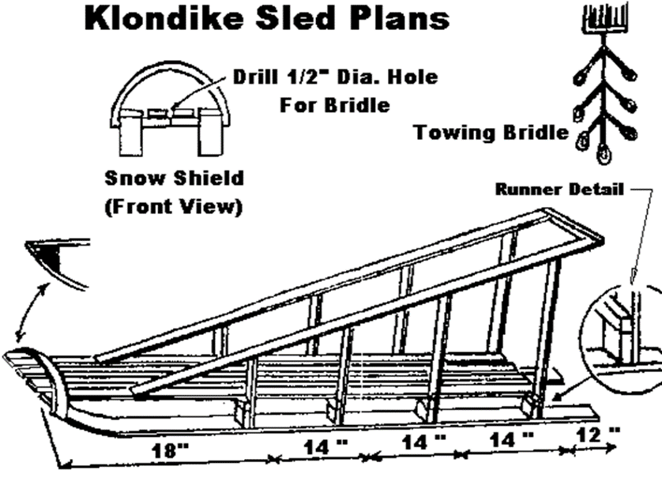
Here are some ideas to get you started...
• Be creative with your sled design.
• Make your sled strong, but light!
• Paint your sled bright colors.
• Varnish the bottom of the runners --
then wax before use.
Or an old set of downhill skis or pvc
pipe works well as runners.
• Use screws instead of nails and pre-drill
pilot holes to prevent splitting. Use glue in addition to screws.
• A snow guard curtain on the front and sides will help keep equipment dry.
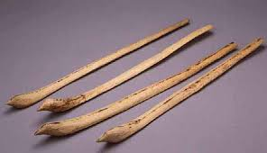
Snow snake

