River Walk Trail Rules and Information – SATURDAY MARCH 30th 2019

The River Walk Trail is a 4.8-mile trail one way, 9.3-mile loop with two trailheads. The trail winds along the Republican River, between the outlet tubes of Milford Lake to the Washington Street entrance of Ft. Riley. Dogs are able to use the trail but must be kept on a leash.

There is a small parking lot at the Washington Street entrance, however due to the number of participants and vehicles anticipated for the hike we will register and park at the Milford Lake Dam trailhead and start at that point. The Army Corps of Engineers will allow us to park vehicles in the grass along the street at the Dam side trailhead.

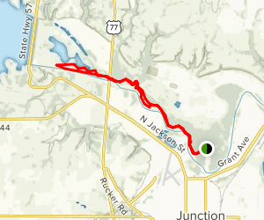

The black/green dot shown is the small parking lot at the Washington Street entrance.

We will plan to start at the other side of the trail; Dam side where there is more parking.

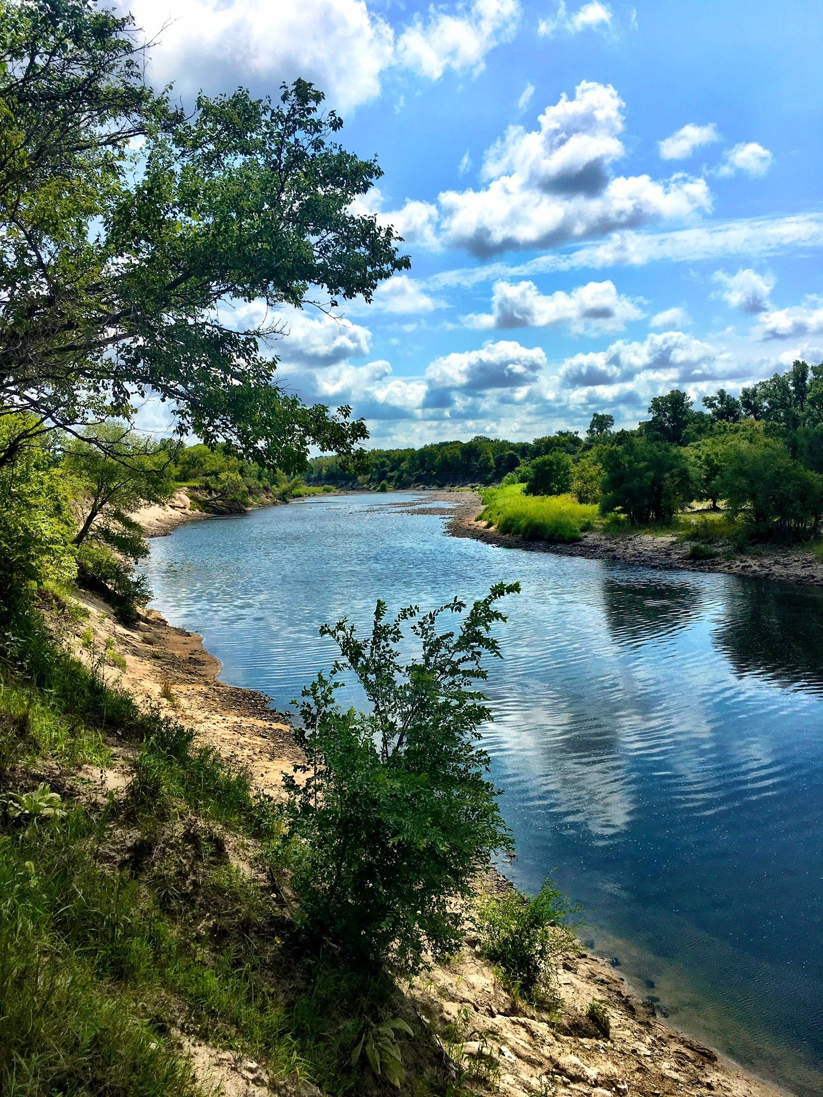
MILFORD LAKE,
US ARMY CORPS OF ENGINEERS

5203 N Highway K-57
Junction City, Kansas 66441
785-238-5714
