Algonkian District
MERIT BADGE UNIVERSITY

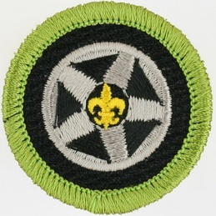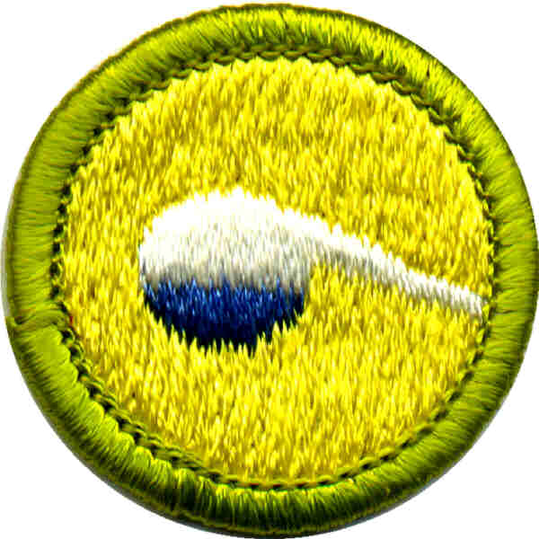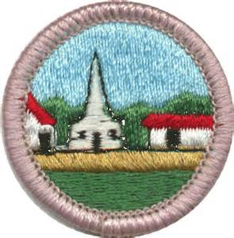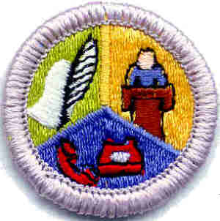
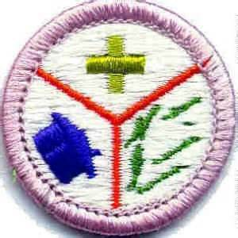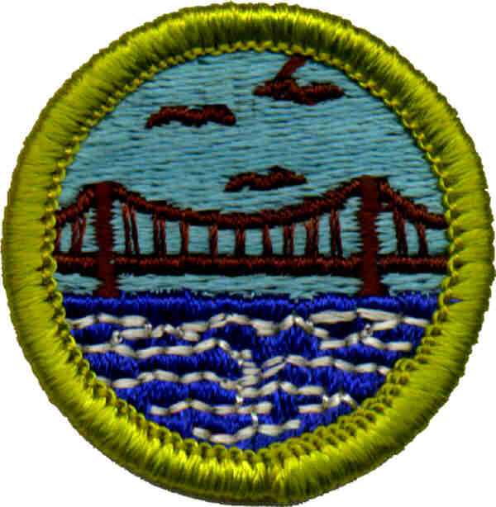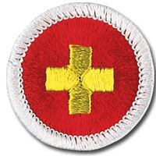
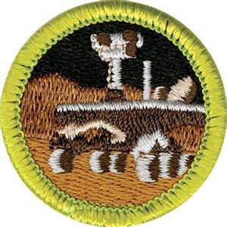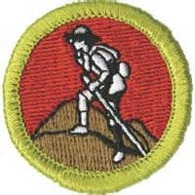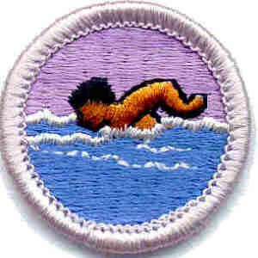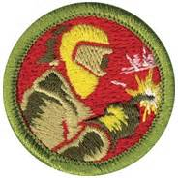

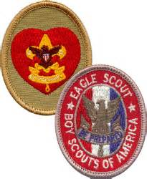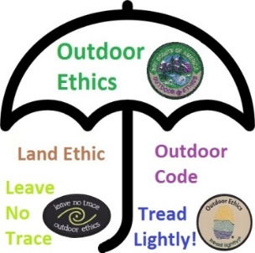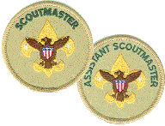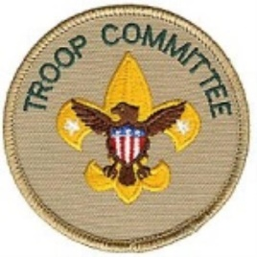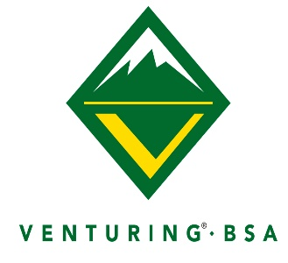January 18, 2020
Merit Badge Seminar/Adult Leader Training
Saturday, January 18, 2020
Vincennes University – Vincennes Campus

All Times Listed are Central Time Zone
6:45am------------------------------------------------ Registration at Shircliff Theater
7:15am------------------------------------------------ Opening and Announcements
7:45am------------------------------------------------ Merit Badge Sessions
10:45pm------------------------------------------------ Lunch and Tours
12:30pm------------------------------------------------ Merit Badge Sessions
3:30pm------------------------------------------------ Clean Up
4:00pm------------------------------------------------ Dismissal

Merit Badges / Trainings |  | Capacity
Automotive Maintenance | See registration for all pre requisites | 24
Citizenship in the Community* | All classes must have a | 20
Citizenship in the Nation* | Minimum of 5 scouts | 20
Communication* |  | 12
Emergency Preparedness* |  | 20
Engineering |  | 20
First Aid* |  | 15
Chemistry |  | 20
Game Design |  | 20
Programming |  | 15
Robotics |  | 24
Welding |  | 20
Swimming* |  | 20
Photography
Sports and Theater |  | 20
Crime Prevention |  | 20
Disability Awareness |  | 30
Textile |  | 10
Scouting Heritage
* = Eagle Required

Any requirements for individual merit badges that should be completed prior to the event will be sent out ahead of the event. Registration fee for seminar is $12.00 per person and includes lunch in the Tecumseh Dining Center on campus and a custom designed patch. All fees must be paid at the time of registration. Fees are lower than costs because VU is subsidizing part of the cost of lunch in exchange for youth participants taking a tour of the campus.
Warning!!!!!! New 2020 policy for Algonkian Merit Badge University
Your merit badge selections are not secure without a paid registration. You will be dropped off a merit badge in favor of paid registrants if the merit badge fills up.
PLEASE BRING BLUE MERIT BADGE CARD SIGNED BY SCOUTMASTER
Units MUST Pre-register to attend
Register Online from the Buffalo Trace Council Website
NO LATER THAN: January 11, 2019

Rules for Merit Badge Seminar
- Sessions will begin promptly at 7:45am, and will dismiss at 4:00pm. Arrive for registration between 6:45 and 7:15am. Announcements at 7:15am. Scouts must be in classrooms by 7:45am.
- Registration fee is $12 per person and will be available electronically on the Buffalo Trace Council Website. The Chemistry and Swimming merit badges will require additional fees for materials and facility rental respectively.
- Registrations will be accepted until classes are full. No walk-ins or substitutions. Scouts must be registered in a Troop prior to January 1, 2019 to participate.
- Check-in at the registration table in the Shircliff Theater building. Signs will be posted to direct you to parking and the building. Building and room assignments will be provided in the building upon arrival and check-in.
- Scouts are asked to wear their Class A uniforms.
- Merit badges will require the full day. Scouts should list both their primary choice as well as alternates.
- Scouts are expected to be on their best behavior. We are invited guests at Vincennes University, and we must respect the facilities and equipment. Scouts are expected to dispose of trash and behave appropriately at all times.
- Once Scouts arrive, they may not leave the campus until they have been released at the end of the day. Please stay in designated area, no wandering around the campus.
- Each participating unit MUST have at least one adult in attendance during the entire day. Adult leader training is taking place during the day; you can be in training and qualify as an adult leader in attendance, but we ask that each unit provide one adult who can sit in on one merit badge in the classrooms to assist the merit badge counselor.
- Each Scout is also responsible for paper, pencils, merit badge pamphlets, and any expenses that need to be paid that day as well as a merit badge “blue card” signed by the Scoutmaster.
- Not all requirements for each merit badge will be covered at the seminar. Some requirements must be completed either before or after attending the session. Each Scout will benefit by reading the merit badge pamphlet and be familiar with the requirements. Having all of the prerequisite requirements completed before that day is a MUST, to complete the Merit Badge the day of the event.
- Worksheets are available- http://meritbadge.org/wiki/index.php/Merit_Badge_Worksheets

Lunch
Lunch will be provided on campus in the Tecumseh Dining Center. No eating/drinking in classrooms
Cleanup
At the end of class, we must clean up all areas we have used. Please leave the University better than you found it, while you are participating in your activities for the day.

