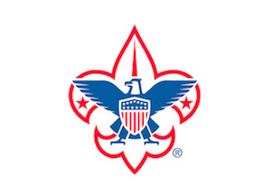  April 29, 2018  Scouting for tolerance: a walk of faith  Join other Scouts and families to learn about the similarities and differences between three faiths  Registration: $7 includes special patch  Type of Registrants: Scout, Guest, Adult  Check In: 11-11:30, Islamic Cultural Center, Northbrook  Location: Event starts at Islamic Cultural Center and includes Congregation Beth Shalom and St. Giles Episcopal Church  Event Concludes: Northbrook Leisure Center, 3:30  BRING: Sack lunch, class A uniform and water bottle  Questions: Andrew.vass@scouting.org or hprager@gmail.com  Organized by the Northeast Illinois Council BSA Interfaith Committee including the Catholic Committee on Scouting and Jewish Committee on Scouting. Special thanks to the Northbrook Park District for the use of their facilities. | 11 AM Registration  Conclude by 3:30  Learn about other faiths!  ────  Travel to and visit three houses of worship  ────  Sample food from different religions  Earn a special patch for participating  Event limited to first 100 people  nORTHEAST iLLINOIS COUNCL  www.neic.org/walkoffaith  Uniform event  $7 registration

