The specifications below will be strictly adhered to for the Fox Valley District Pinewood Derby.
These rules supersede the rules that were provided in the Pinewood Derby kit. Special attention should be paid to axle location and wheels (especially tread indicators). A car may be entered in either the speed competition or the design competition at the District race, not both.

- Cars are to be made from the Official Boy Scout Pinewood Derby Kit. Replacement kits are available at the Scout Shop. The front of the car must not have a notch more than 1/8th of an inch as pictured, will run backward on the track if possible. Pointed nose cars are hard to start. The race starter will do their best.

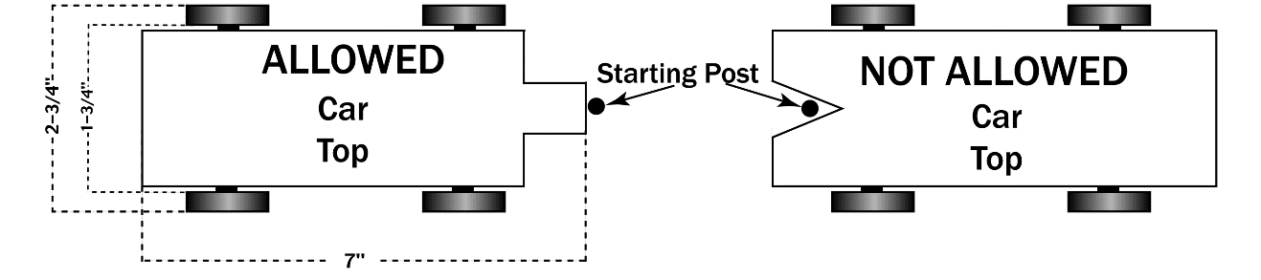
- Any replacement parts shall be Official Cub Scout Pinewood Derby parts.

- Clearance: Minimum ground clearance must be 3/8 inch as measured between the car and the track. Weights may need to be recessed into the body to maintain this clearance.

- Length: The length of the car shall not exceed 7 inches.

- Width: The width of the car shall not exceed 2-3/4 inches. Minimum width between wheels shall not be less than 1-3/4 inches. Car body can be narrower than 1-3/4 inches, but the wheels must be a minimum of 1-3/4 inches wide so the car will straddle the track.

- Height: The height of the car should not exceed 3 inches.

- Axle Location: All cars must use slots in original block for axle placement. No changes in axle distance will be allowed. Axle distance is 4 3/8 inches from the center of the front axle to the center of the back axle.

- Weight: The weight of the car shall not exceed 5 ounces. No loose or liquid materials of any kind are permitted in or on the car. The car may be hollowed out and built up to the maximum weight provided the weight is secured to the body.

- Wheel Bearing: Washers, bearings, and bushings are prohibited.

- Springs: The car shall not ride on any type of springs.

- Detailing: Details such as steering wheel, driver, decals, painting, and interior detail are permissible a long as these details do not exceed the maximum length, width, height, or weight. All details must be permanently attached.

- No solid axles (PineCar brand) will be allowed. Only axles as provided with the Official Pinewood derby kit will be allowed (4 nails, 1 per wheel). No wheel covers or hubcaps are allowed. Pointed ends of the nails must be visible for inspection.

- Wheels. Cars must be run with official BSA wheels from the kit of the car to be raced. Colored wheels available from the Scout Shop are acceptable as well. The wheels may not be altered with holes drilled in the side or tread width narrowed. Tread (indicators) marks on the outside edge of the wheel must be clearly visible on all 4 wheels. Only light sanding and polishing of the mold imperfections on the outside of the wheel will be allowed. A wheel can NOT be tapered to a sharp edge or radius (See picture). Alterations to the inside of the wheel are not permitted.

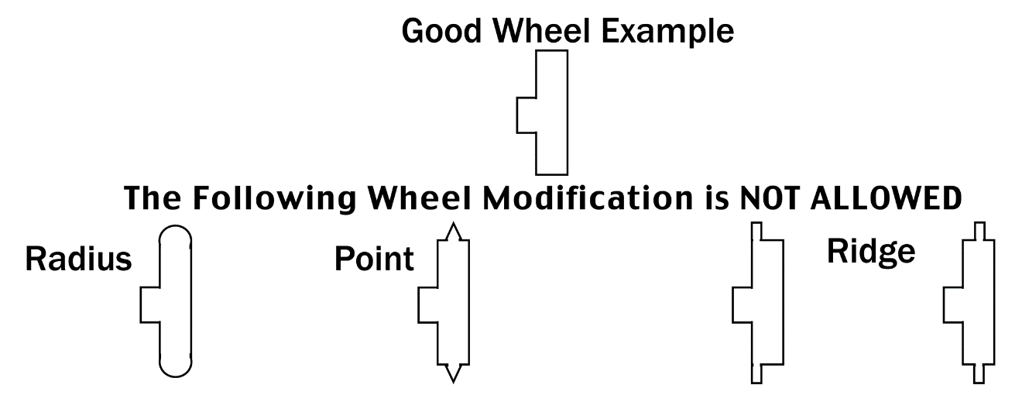
- Each car must be free-wheeling with no starting device.

- Inspection: Each car must pass inspection by the Official Inspectors before it may compete. The Inspectors have the right to disqualify cars which do not meet these specifications.

- Lubrication: Graphite or other dry type lubricants will be the only lubricants allowed. No other types will be permitted. Lubrication must be done prior to official inspection only. PLEASE LUBRICATE THE FRICTION POINTS, NOT THE OUTSIDE OF THE WHEEL. Graphite coated wheels will NOT be allowed as they will foul a wooden track.

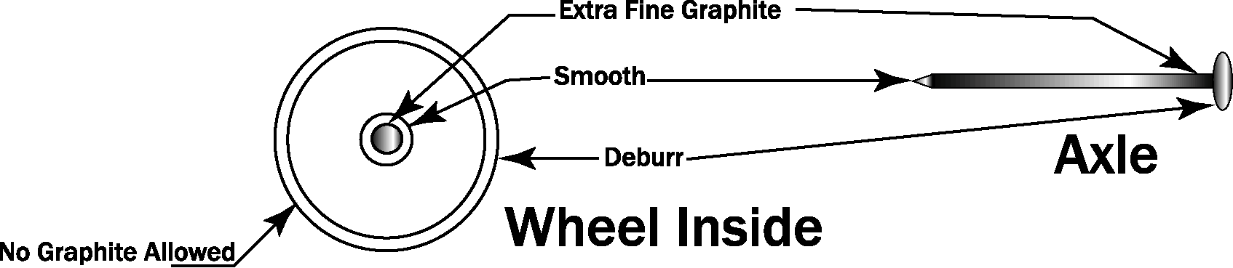
- No electrical or mechanical device that spins in order to propel or stabilize the car is permitted.

- Cars may not be handled after they receive official inspection approval.

- Cars raced in previous years are not allowed.

- It is intended that the winning cars from each Pack are the cars entered in the District PWD.

- Judges’ determinations as to race winners are final.

- Scoring: Every car will run one time on each lane. The finishing positions for each rank will be awarded based on the lowest total time for the car down the track. In the highly unlikely event that there is a tie, (we measure to the .001), all cars that are tied for a position will draw a lane and make one pass down that lane. Their finish will be used to break the tie.

- Webelos Scouts that recently crossed over to Boy Scouts will race in the same race as the Webelos.

- The Grand Champion race will be run with the first place car from each rank (Webelos combined). Every car will run one time on each lane. The finishing position will be awarded based on the lowest total time for the car down the track.

- Your car must meet these district specifications or it will NOT be permitted to run at the District Race. The fact that a car met your Pack’s rules is irrelevant. Do not disappoint a Scout by showing up with a car that cannot and will not be run.

GOOD LUCK AND GOOD RACING!!!!
DESIGN CONTEST JUDGING CRITERIA

A car may be entered in either the speed competition or the design competition at the District race.

The Design Contest will be scored in each of the following categories:

- Originality (0-50 points) (50% of total score)
This area will evaluate the conceptual thinking the Scout gave to his work as well as his attention to meeting all official derby specifications. Example: A car looking like a unique object such as a pencil, arrow, or modernistic sports car

- Craftsmanship (0-20 points) (20% of total score)
The section will consider the effort that was put into the fit and finish of the vehicle by the Cub Scout. Example: The smoothness of the surface, fit of the parts, gloss of the paint, etc. are checked

- Color Usage (0-10 points) (10% of total score)
Here the usage of color is judged. Example: How and where different colors are used

- Detailing (0-10 points) (10% of total score)
This is the area where the blending of all the parts that make up the car are evaluated. Example: How does the usage and placement of all parts contribute to the overall appearance?

- Graphics (0-10 points) (10% of total score)
The utilization of numbers, decals, painted symbols, etc. are judged as they relate to the car. Example: The judges rate the contributions these items make toward the overall appearance of the car in the same way icing decorates a cake.

Judges’ determinations as to Design winners are final.

Cars that reflect appropriate skill for the age level of the entrant will receive higher scores.

There is no limit to the number of cars a Pack may enter in the design contest.

GOOD LUCK AND BE CREATIVE!!!!

