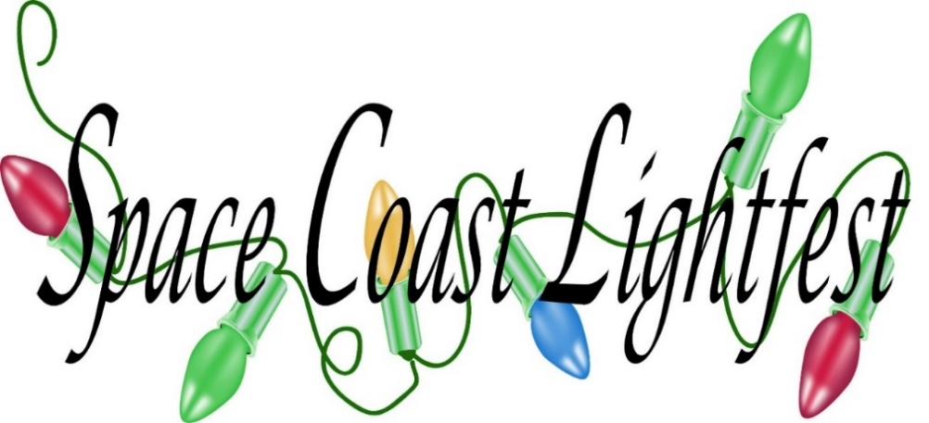
This Photo by Unknown Author is licensed under CC BY-SA
Lightfest is opened nightly from Nov 18th thru Jan 1st from 630 pm to 1000 pm at Wickham Park in Melbourne Florida. Enter off Wickham road onto Leisure Way. It is a drive through event except on Dec 7, & 8 when we will be walking only. Private Hayrides by reservation only Monday thru Thursday. Public Hayrides Friday thru Sunday (except Dec 7,8,21 and 22) Questions contact Sally at 321-720-4109 or Fnnayllas@aol.com Spacecoastlightfest.com
SPECIAL EVENT CALENDAR
11/17 5K Run
11/18 First day
11/30 Story Time With Santa
12/3 Park and Recreation Appreciation
12/4 Pet Night with Santa
12/5 Lite Rock 99.3 Night
12/5 Responders and Medical Appreciation night
12/6 Girl Scout Discount Night
12/6-8 Scout Campout
12/ 7-8 Stroll Weekend—NO CARS
12/10 WMMB News Talk
12/10 Military Appreciation night
12/11 Teacher Appreciation
12/13-14 Live Nativity
12/14 kiss 95.1
12/14 FIT Night show your FIT ID and get a discount.
12/15 Horse night Step off 600 pm

Event online sign up links
5K Run
https://www.runningzone.com/events/space-coast-lightfest-5k-run-among-the-lights-2/
Private Hayrides- https://scoutingevent.com/083-28375
Private Parties- https://scoutingevent.com/083-28381
Stroll Vendor sign up https://scoutingevent.com/083-28367
Campout- https://scoutingevent.com/083-28369
Horse Night- https://scoutingevent.com/083-28395
Stroll-
https://scoutingevent.com/083-28398
Drive through tickets
https://scoutingevent.com/083-27616

