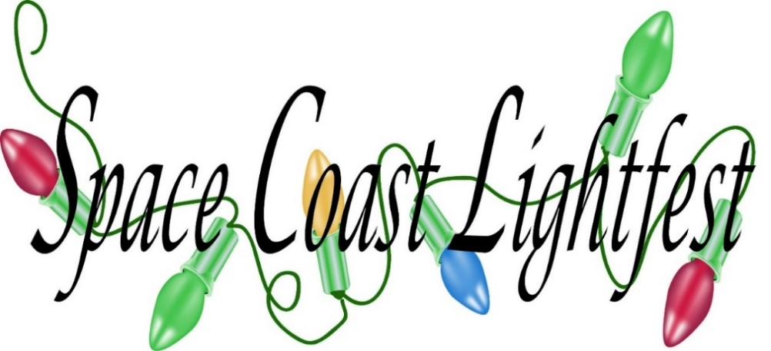



[This Photo](https://commons.wikimedia.org/wiki/File:F_icon.svg) by Unknown Author is licensed under [CC BY-SA](https://creativecommons.org/licenses/by-sa/3.0/)

Lightfest is opened nightly from Nov 18th thru Jan 1st from 630 pm to 1000 pm at Wickham Park in Melbourne Florida. Enter off Wickham road onto Leisure Way. It is a drive through event except on Dec 7, & 8 when we will be walking only. Private Hayrides by reservation only Monday thru Thursday. Public Hayrides Friday thru Sunday (except Dec 7,8,21 and 22) Questions contact Sally at 321-720-4109 or Fnnayllas@aol.com Spacecoastlightfest.com

**Event online sign up links**

Private Hayrides- [**https://scoutingevent.com/083-28375**](https://scoutingevent.com/083-28375)

Private Parties- [**https://scoutingevent.com/083-28381**](https://scoutingevent.com/083-28381)

Stroll Vendor sign up[**https://scoutingevent.com/083-28367**](https://scoutingevent.com/083-28367)

Campout**-** [**https://scoutingevent.com/083-28369**](https://scoutingevent.com/083-28369)

Horse Night-[**https://scoutingevent.com/083-28395**](https://scoutingevent.com/083-28395)

Stroll-

[**https://scoutingevent.com/083-28398**](https://scoutingevent.com/083-28398)

Drive through tickets

[**https://scoutingevent.com/083-27616**](https://scoutingevent.com/083-27616)

**SPECIAL EVENT CALENDAR**

11/17 5K Run

11/18 First day

12/3 Park and Recreation Appreciation

12/5 Lite Rock 99.3 Night

12/5 Responders and Medical Appreciation night

12/6 Girl Scout Discount Night

12/6-8 Scout Campout

12/ 7-8 Stroll Weekend—NO CARS

12/10 Kiss 95.1 Night

12/10 Military Appreciation night

12/11 Teacher Appreciation

12/14 FIT Night show your FIT ID and get a discount.

12/15 Horse night Step off 600 pm