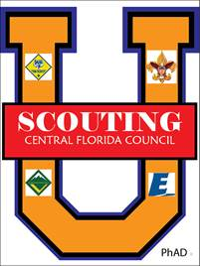
University of Scouting 2019
Success for US is being able to leave the school the way found it!
Classroom Usage Rules

You may use the smart boards in the classrooms.
- Do not use any other classroom equipment or supplies. Only use what you brought.
- Do not move anything unless you have too. If you move something, be sure to put it back before you leave.
- When you enter, take a photo from each corner so you know how the classroom was set up.
- After your class, make sure the room looks like the photos!

Some notes:
★ Try to start and end on time. (Classes are 50 minutes.)
★ Plan to arrive 10 minutes early! Please don’t disrupt the current class if they haven’t broken yet.
★ Check the sign on the door to make sure your class is listed correctly and at the right time.
★ Have students check-in on your roster sheet and ask walk-ins to add their name and email.
★ Have your name and contact information available in your presentation.
★ Encourage students to complete an evaluation form at the end of the day.

