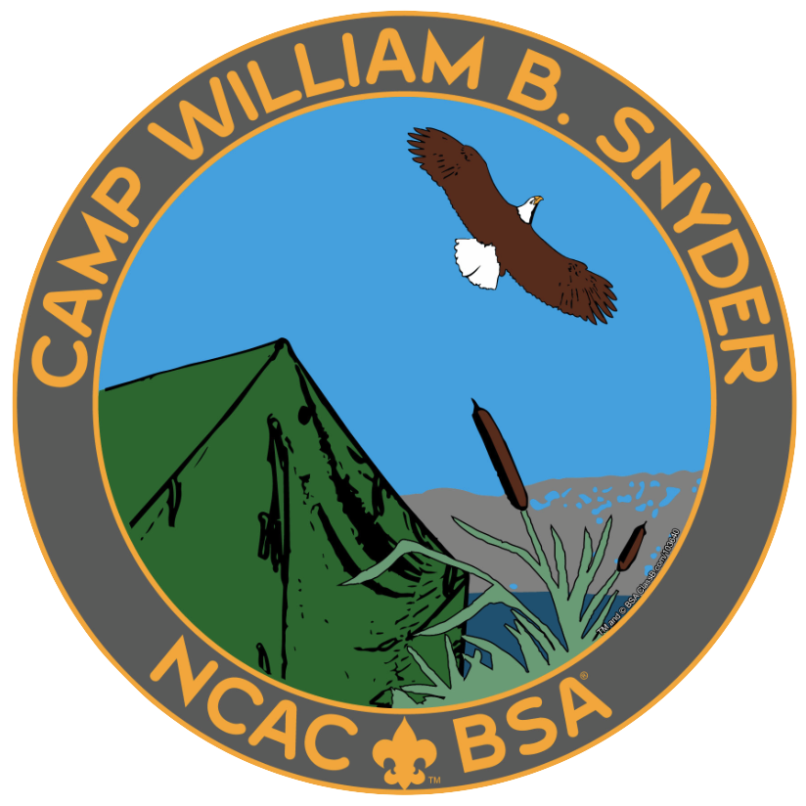

2019
Camp William B. Snyder
Leader & Parent Guide

Camp William B. Snyder | 6100 Antioch Rd., Haymarket, VA 20169 571.248.4904 Camp.Snyder@Scouting.org

Greetings Leaders and Parents,

On behalf of the volunteers and staff of the National Capital Area Council and Camp William B. Snyder, thank you for choosing Camp William B. Snyder as your summer destination for 2019. This year’s theme at camp is “Cub Scout Investigators”, so put on your thinking caps, dust off those magnifying glasses, and let’s solve some mysteries.

Throughout the course of their stay, Scouts will be given the opportunity to complete requirements for various achievements and electives for their current rank. While some Adventure / Elective Requirements will be met for each rank do not expect to completely fulfill an Adventure or Elective for any rank. These advancement opportunities will be mixed in with the day-to-day fun activities that are a tradition at Camp Snyder.

If you have any questions that cannot be answered in this guide, please contact our staff at 571-248-4904 or Camp.Snyder@Scouting.org

We look forward to seeing you and your scout for what will be a great camp experience!

Camp William B. Snyder

PLANNING FOR CAMP
Health Forms
All Scouts and Adults must have a properly completed and signed health form in order to participate in camp programs.

The official BSA Annual Health & Medical Record form is required for all participants. Fillable PDF forms can be downloaded from the camp website. Health Form Parts A and B are required for all campers (youth and adult) attending for any part of any session. Part C is required for the Webelos Advancement and Resident Camp weeks.
TIP: Arriving at camp with a completed Health Form is necessary for the check-in process.

Information on the Health and Medical Record from www.Scouting.org: (Valid for 12 calendar months)
Policy on Use of the Annual Health and Medical Record
In order to provide better care for its members and to assist them in better understanding their own physical capabilities, the Boy Scouts of America recommends that everyone who participates in a Scouting event have an annual medical evaluation by a certified and licensed health-care provider—a physician (MD or DO), nurse practitioner, or physician assistant. Providing your medical information on this four-part form will help ensure you meet the minimum standards for participation in various activities. Note that unit leaders must always protect the privacy of unit participants by protecting their medical information.

Parts A and B are to be completed annually by participants in all Scouting events. This health history, parental/ guardian informed consent and release agreement, and talent release statement are to be completed by the participant and parents/guardians.

Part C is the physical exam that is required for participants in any event that exceeds 72 consecutive hours, for all high-adventure base participants, or when the nature of the activity is strenuous and demanding. Service projects or work weekends may fit this description. Part C is to be completed and signed by a certified and licensed health-care provider—physician (MD or DO), nurse practitioner, or physician assistant. It is important to note that the height/weight limits must be strictly adhered to when the event will take the unit more than 30 minutes away from an emergency vehicle, accessible roadway, or when the program requires it, such as backpacking trips, high-adventure activities, and conservation projects in remote areas. See the FAQs for when this does not apply.

Part D is required to be reviewed by all participants of a high-adventure program at one of the national high-adventure bases and shared with the examining health-care provider before completing Part C.

Medication
All prescription medications are the responsibility of the adult leader in charge of the Pack. It is expected that
medications such as inhalers, epi-pens, and other medicines that must be held on the person at all times. Packs should bring a lockable box to keep medications in while not in use. Medications that require refrigeration may be stored at the first aid station.

Special Dietary Needs for Allergic or Religious Reasons
If an individual is allergic to some food products or requires a special diet, it is the individual’s responsibility to notify the camp a minimum of 2 weeks prior to arrival. Special dietary need forms are available on the Camp’s registration site. For severe allergic cases it is strongly recommended that the individuals bring food with them that they can use to supplement a meal or as an alternative to the meals provided by camp.

Meals/Food can be placed in a labeled cooler to be stored in the camp refrigerator/freezer. All food must be stored properly and sealed. Upon arrival at camp, give the food to the Kitchen Manager. There is no fee reduction for individuals who bring their own food. Food substitutions should be for medical or religious reasons only. Camp menus will be available for review on the camp website but are subject to change.

WHAT TO BRING TO CAM P
Who to Bring to Camp
Registered Male or Female Cub Scouts may attend camp. Youth who are Cub Scout aged but not registered Cub Scouts may not attend Summer Camp.

Adults — Two Deep Adult Leadership is required at camp. The minimum leadership requirements for any Cub Scout unit attending camp is a ratio of two adults for up to eight boys, and one additional adult for each additional four boys. Best practice is for the unit to provide for three adult leaders at all times; just in case an adult is called away or must accompany Cub Scouts to a location other than the rest of the den. Units who are bringing female campers to overnight programs must provide a Female leader with youth protection.
Camp Staff are not responsible for the day-to-day supervision of Campers. Each Camper is required to attend camp supervised by an adult.
What to Bring to Camp
With both day and overnight programs being offered at Camp Snyder, the equipment needed by our campers can vary slightly. Below is a list of general recommendations to get you moving in the right direction. The quantity of items needed should be adjusted based on how many nights/days you will be attending. There are probably other things your pack likes to bring on outings so feel free to add or subtract from this list. Remember that there may be a short hike to your campsite upon arrival so please do not over pack.

Cub Scout Day Camp

Individual Equipment
Medical Form w/Sections A and B filled out
(required for all youth and adults in attendance)
Swimsuit & Beach Towel Medications (if needed)
Sunscreen Change of Clothes
Bug Repellent Hat
Water Bottle-filled before arriving each day Cub Scout Handbook/Pen/Paper Rain Coat or Poncho Trading Post Money

Resident Camp Programs

Individual Equipment Pack Equipment (Optional)

Health Forms with sections A, & B File System for all camper records & paperwork (Section C for Webelos / Resident Week Camp) Pack/Den Flags
Swimsuit & Beach Towel Clipboard
Sunscreen Games & Sporting Equipment (Used for Den Time)
Bug Repellent Lanterns & Coolers
Backpack Lockable Storage Container for money
Sneakers or Hiking Boots Clothes Line
Scout Uniform Footlocker or Chuck Box
Underwear & Socks Camera
Water Shoes Pocket Knives (for Adults Only)
T-Shirts Sewing Kit
Sweat Shirt Cub Scout Handbook
Shorts & at least 1 Pair of Long Pants Laundry Soap (in case of an accident, we have laundry facilities) Rain Coat or Poncho
Spending Money (Trading Post) Flashlight/Extra Batteries
Toiletries (showers available)
Sleeping Pad & Sleeping Bag with Pillow

Do Not Bring to Camp:
BB guns, archery equipment, axes/hatchets, sheath knives, bicycles, electronic toys, game systems (DS, PSP, etc.), mobile phones (youth), pets or animals of any kind, alcohol, fireworks, cigarettes (including e-cigarettes), things you do not want to lose, and things easily damaged by moisture & weather.

Checking-In to Day and/or Resident Camp
The check in process begins in the main parking lot pavilion. Packs and Families arriving earlier than check in time are asked to remain in the main parking lot. All paperwork is due at check-in.
The simplest method of checking in your Pack, is for the entire pack to arrive at one time. We suggest meeting in the main parking lot together, then sending one representative to check everyone in.
Cub Scout Resident Camp Specifics
One vehicle per Pack may drive to the campsite to unload. After unloading, all vehicles must be returned to the main parking lot. By order of the Prince William County Fire Marshall and in accordance with our land use permit no vehicles are to remain in the campsite area. No commercial or home-made campers are allowed in campsites.
Cub Scout Day Camp Specifics
Packs should plan to have a group meeting area/parent drop off area in the field adjacent to the parking lot or next to the Hylton training center for the remaining days of camp.

Medications
All prescription medications are the responsibility of the adult leader in charge of the Pack. It is expected that
medications such as inhalers, epi-pens, and other medicines that must be held on the person at all times. Packs should bring a lockable box to keep medications in while not in use. Medications that require refrigeration may be stored either at the dining hall or first aid station depending on the time they should be distributed. Parents’ written permission to administer medicines must accompany all prescription drugs.

Swim Checks
All Scouts and adults must be given a swim check by the camp aquatic staff before they are permitted in any aquatic
area. Swim tests must be completed annually and will be administered the first time the campers visit the pool.
The swim test consists of the following:
Swimmer: Jump feet first into water over your head. Swim 75 yards utilizing any strong stoke. Swim 25 yards using the elementary backstroke. Float motionless.
Beginner: Jump feet first into water over your head. Swim 50 feet. (Swimmer must make one turn within the 50 feet.)
Non-swimmer: No swimming required. Limited use of Boating and Swimming activities. Anyone who declines to participate in the swim test will be categorized as a non-swimmer and limited to the shallow end of the pool. These restrictions will impact the boating area as well.
Please carefully consider you units swim check certified adults when planning your week as this can have a major impact on the ability of your scouts to participate in boating.
Leaders Orientation Meeting

Resident Camp
On the first morning there will be a meeting for an adult from each Pack. Information concerning the camp, its policies, emergency procedures, and alarm system are covered. It’s imperative that one Pack leader attend this meeting.

Cub Day Camp If any news needs to be shared with adult leaders an announcement will be made at lunch with a leaders meeting following lunch dismissal.

Resident Camp Opening & Closing Campfires
All Packs and individuals are encouraged to have skits, songs, and/or run-ons to present at the closing campfires at camp.

YOUR WEEK AT CAMP
Conduct Policy
We are all members of the Boy Scouts of America. As such, the basic rules of conduct at Camp Snyder are the Scout Oath and Scout Law. The conduct and discipline of Scouts are the parents’ and leaders’ responsibility. The camp staff is not responsible for the discipline of any Scout (unless it is a case of imminent bodily harm or property damage). Any Scout found intentionally damaging camp property will be asked to leave camp.
Restitution for damages will be billed to the Scout’s parents or Scout unit.

Buddy System
Camp Snyder operates under the “Buddy-System.” All Scouts and parents are encouraged to move about camp with a “buddy.” ALL YOUTH MUST BE ESCORTED AROUND THE PROPERTY BY AN ADULT.

Campsites and Tents at Camp Snyder
Each campsite at Camp Snyder has nine 4-person platform tents. Each tent is equipped with military style cots for participants to use. Each campsite can sleep up to 36 people. In some cases, a 5th cot may be added to a tent if necessary. For this reason, adults and youth should plan on sharing tents with other members from their Pack or in some cases, another Pack. In order to allow maximum participation, we cannot promise that individual registrations (one youth and one adult) will have their own tent. Families are welcome to bring their own tents if they would like. We do ask that you notify the camp if you plan to bring your own tent. Additionally, we have limited campsite access to power for campers that use CPAP. Please notify the camp as soon as possible if this is a need for your unit.

Shower Facilities & Youth Protection Issues
BSA youth protection policy stipulates that youth ages 6 to 17 years of age and adults 18 years of age and older may not share shower or sleeping facilities. Scouts are only allowed to utilize facilities that are clearly marked for youth. Adults, male and female, may use facilities labeled for adults only use. Camp Snyder has separate facilities for male and female youth as well as male and female adults.

The shower houses are conveniently located throughout camp. Electricity is available for your convenience.
Please encourage your Cub Scouts to shower. Per our Youth Protection policy, adults must ensure youth members’ privacy and may not be in the immediate shower area while youth are showering. Private shower stalls are provided in all camp shower-houses. Also, during your stay at camp, your den or Pack may be asked to sweep and hose down the shower house.

Trading Post
The main entrance to the Trading Post in on the Back Porch of the Administration Building. The camp provides a well-stocked trading post of Scouting materials and snacks. Hours of operation will be posted. Scouts and adults are encouraged to monitor the trash generated by the trading post snack bar to ensure it makes it to the proper receptacles. It is everyone’s responsibility to Keep Camp Snyder Clean.

Campsite Fires
Every campsite at Camp Snyder has an established fire ring. We require that fires be attended at all times. Sites are
provided with a “Fireguard Plan,” which should be filled out by the unit. The cutting of trees (dead or alive) is not
permitted without the permission of the camp staff. Units may burn any wood they find already cut or laying on the ground.

Quiet Hours
All Scouts are to remain in their campsites from 10pm—7am unless they are participating in an official camp function. An adult leader must accompany Scouts outside their campsite area during quiet hours. All program areas are off-limits during non-program, and non-activity times.

YOUR SAFETY AT CAMP

Intrusion of Unauthorized Persons on Camp Property
The intrusion of any suspected unauthorized person on camp property should be reported immediately to the Camp Director, Camp Ranger, Camp Commissioner, or the Camp Business Manager. At no time should a Staff Member, Camper, or Scout Leader confront a suspected unauthorized intruder. Authorized attendees are identified by either a camp wrist band or camp visitors pass. Visitor passes/bands are available at the camp business office & trading post.

Medical Services
Camp William B. Snyder has a trained Medic available during Camp operating hours. The Medic responds to first aid issues throughout the camp and can be located in the Medics office at the Hylton Training Center when campers are onsite overnight. Camp William B. Snyder has arrangements with the Prince William County Hospitals in Haymarket and Manassas to handle any major emergencies. In addition, the Prince William County Fire Dept. has a station located directly across the street from the main entrance of the camp.
Liquid & LP Fuels
In accordance with camp policy, the use of liquid fuels (i.e.: kerosene, gasoline, liquid Coleman fuel) in camp is allowed, but discouraged. Under no circumstances shall flames of any kind be carried in or used near tents. The only acceptable lighting for tents is flashlights or battery powered lanterns. LP gas lanterns and camp stoves may be used in the campsite area with adult supervision. All empty containers are to be carried home with the unit.

Electrical Power & Extension Cords
The use of external electrical power (generators) or extension cords is prohibited in campsites. The only exception is the approved use for medical purposes such as CPAP machines. Contact the Camp Director for approval

Cleanliness and Sanitation in Camp
Trash bags are provided for campsite use. To avoid insect issues, trash must be taken to the dumpsters on a daily basis. Please do not place campsite trash bags in the shower houses. Campers are asked to assist with keeping the shower areas clean.

Shoes in Camp
For safety reasons it is imperative that Scouts and adults wear proper footgear at all times. Scouts and adults are encouraged to bring an extra pair of “old” shoes, or aqua socks/shoes to wear at the lake. Open-toed shoes or sandals are prohibited. A shower shoe (flip-flop) is recommended for use in the showers only.

Parking & Vehicles in Camp
The main parking lot is located near the camp entrance. For the safety of our Scouts and visitors, no privately owned motorized vehicle (car or truck) will be allowed on camp service roads at any time. The camp is not responsible for any damage to privately owned vehicles.

Alcohol & Illegal Drugs
All drug and alcohol laws of the Commonwealth of Virginia are strictly enforced. Alcoholic beverages are not permitted on BSA property. Anyone found in possession of, or under the influence of either will be asked to leave the property immediately.

Fireworks
In accordance with BSA policy, fireworks of any kind are prohibited for unit use.

Tobacco Use
In accordance with BSA recommendations, the use of tobacco products is undesirable. Adults are requested not to use tobacco products in the presence of Scouts. The use of tobacco products in any camp building or campsite is strictly prohibited. The on camp designated smoking location is at the rear of the dining hall.

Product Sales
No camper or staff member is authorized to sell any form of merchandise on camp property.

Pets in Camp
Dogs, cats or other pets are not allowed in camp.

Firearms & Knives
No personal firearms, ammunition, or archery equipment is to be brought to camp. Sheath knives are not permitted in camp.

Bicycles in Camp
For safety purposes, Scouts and adults are asked to leave their bikes at home.
GENERAL CAMP INFORMA TION - DIRECTIONS

From the East
(Capital Beltway - Route I-495):
- Take Interstate 66 west to exit #40 (Route 15).
- Travel south on Route 15 to the second traffic light and turn right onto Route 55 (John Marshall Hwy).
- Travel west about 1 mile to Antioch Road.
Turn right onto Antioch Road, and Camp Snyder is on your left about ½ mile down the road

From the South:

- Travel north on Route 15 (Warrenton), Route 7100 (Fairfax County Pkwy) or Route 28 (Manassas) to Interstate 66.
- Travel west on Interstate 66 to exit #40 (Haymarket, VA).
- Travel south on Route 15 to the second traffic light and turn right onto Route 55 (John Marshall Hwy).
- Travel west about 1 mile to Antioch Road.
Turn right onto Antioch Road. and Camp Snyder is on your left about ½ mile down the road

From the North:

- Travel south on Route 15 (Leesburg), Route 28 (Sterling) or Route 123 (McLean) to Interstate 66.
- Travel west on Interstate 66 to exit #40 (Haymarket, VA).
- Travel south on Route 15 to the second traffic light and turn right onto Route 55 (John Marshall Hwy).
- Travel west about 1 mile to Antioch Road.
Turn right onto Antioch Road, and Camp Snyder is on your left about ½ mile down the road

Emergency Procedures

- There are five primary emergencies in camp for which we have procedures to follow to ensure everyone’s safety. On your first day in camp at the Leader’s Roundtable, each of the procedures will be reviewed.
The 5 primary emergency situations are: Severe Weather, Fire, Lost Camper, Lost Swimmer, and Intrusion by Unwelcome Person.

Important Phone Numbers:

Camp Office 571-248-4904
- Heathcote Medical Center 571-284-1000 or 571-284-1200 (Emergency Room)
- Prince William County Hospital 703-369-8000 or 703-369-8337 (Emergency Room)
- Prince William County Police 703-792-6500 National Capital Area Council Office 301-214-9100

Heathcote Health Center & ER Prince William Hospital & ER
(2.22 Miles from Camp) (11.56 Miles from Camp)
15195 Heathcote Blvd. 8700 Sudley Road
Haymarket, VA 20169 Manassas, VA 20110-4418

GENERAL CAMP INFORMA TION

Uniforms In Camp
The camp uniform is the official BSA uniform. It is requested that all Scouts and adults wear their uniform shirt to Morning Flags, evening meals and campfires. Scouts and adults may wear a camp or BSA tee shirt during the day and during activity periods. *We understand that all Cub Scouts may not have official pants, just the shirt will be ok. Please understand that you will not be turned away because you are not in a BSA Uniform, it is formality that will help prepare your youth for crossing over into Boy Scouts.

Camp Disclaimer Policy
Neither Camp Snyder, National Capital Area Council, BSA nor its agents will be held responsible for the loss of or damage to personal or unit property and/or equipment.

Two-Way Radio’s or other communications devices
Units are discouraged from using two-way radios on camp. Camp personnel use two-way radios for emergency and business communications. Campers who utilize two-way radios will have them confiscated and returned to their unit leaders. It is recommended that Scouts not bring cell phones to camp.

Lost & Found
All items found at camp should be turned into the Administration Building or at the Dining Hall. Leaders are asked to please check for lost items before departing camp. Items remaining at camp after the camp session will be donated to charity.

Visitors at Camp
All visitors must check-in and out at the camp office. A visitor is defined as anyone not registered for the Session and not on the Pack roster or camp staff. All visitors are asked to park in the main parking lot. No vehicles are allowed in the campsites. Visitors must display a “camp visitor’s pass/wrist band” at all times.

Leaving Camp
For your protection, every youth or adult who leaves camp must check out at the camp office.

Youth members who leave camp property must be released to a parent or legal guardian. A designated individual may remove a youth member from the facility only when a letter of authorization and approval from the parent or legal guardian and proper identification is provided. A copy of the Scout Release form will be kept in the camp office. Leaders are responsible for recognizing and approving any early departure of any unit youth member.

Tents & Campsite Equipment
Leaders should check all campsite equipment during check in and report any damages found to their campsite guide. Units will be held responsible for damages when checking out. Each site is equipped with canvas BSA wall tents on wooden platforms. Military style cots are available for use with each tent. Units may elect to bring their own tents. Please inform the camp director two weeks in advance if bringing your own tents. There are “no” registration fee changes if using your personal tents.

Advancement Paperwork
A variety of Tiger, Wolf & Bear Adventures/Electives as well as Webelos Adventure Pins and electives will be available for Scouts to earn during their sessions at camp. The Camp will provide a summary of possible adventures earned to unit leaders and on the Camp website. This should assist both parents and Adult Leaders in transferring any requirements earned at Camp into Scouts personal handbooks when camp is over.

GENERAL CAMP INFORMA TION - THE DINING HALL

Meal Times
Dining hall procedures will be discussed during the orientation on the first day and at the first meal. The Dining Hall Steward coordinates all dining hall activities.

Waiter Responsibilities:
- Setting of all tables
- Wait on the table during the meal if needed
- Remove all materials when the meal is complete. Wash tables, clean floor (sweep & mop) around tables, return all unused items.
- Assist with cleaning the dining hall when everyone has departed
- Table waiters will be dismissed by the dining hall steward

Each table must select waiter teams for each meal. An adult must be present with all waiters before and after the meal. Adults should not leave Scouts unattended at the table. If you need help, ask the nearest staff member to assist you.

Meal Time Programs
After the meal, there will be a song or short program as well as some important announcements. Everyone in Camp should participate in the entertainment, including adults. Scouts are not allowed to leave the dining hall unaccompanied.

Table Manners
Adults are responsible for the behavior of the youth. Everyone should wash their hands before meals. Most meals are served cafeteria style. Adult leaders should encourage proper table manners, such as asking for things to be passed and for everyone to use serving utensils. This not only is polite but it helps decrease transmission of germs. It is a courtesy that people remove their hats when entering the dining hall.

Dining Hall Rest Rooms
Restrooms are at either end of the dining hall. The restrooms to the right of the kitchen are for youth only. The restrooms to the left of the kitchen are for adults only.

Lunch at Adventure Days Camp
Upon arrival to the Flag Assembly Area, instructions will be given regarding the dining hall procedures specific to the program you are attending.

Flag Assembly & Uniforms
Prior to breakfast, lunch and dinner, an assembly will occur where the flags are raised or lowered, or a short program is presented. It is important that your pack be present on time to hear announcements and participate in our flag ceremonies.

Uniform is not required at breakfast, as you will leave directly from the dining hall and head out to program for the day. The uniform is strongly encouraged, but not required for the lowering of colors and at dinner time. Units may leave uniform shirts on their chairs in the Dining Hall. Flag ceremonies are led by the camp staff. If your Pack would like to do participate in a flag ceremony before a meal, please contact the Program Director to reserve a meal upon your arrival.

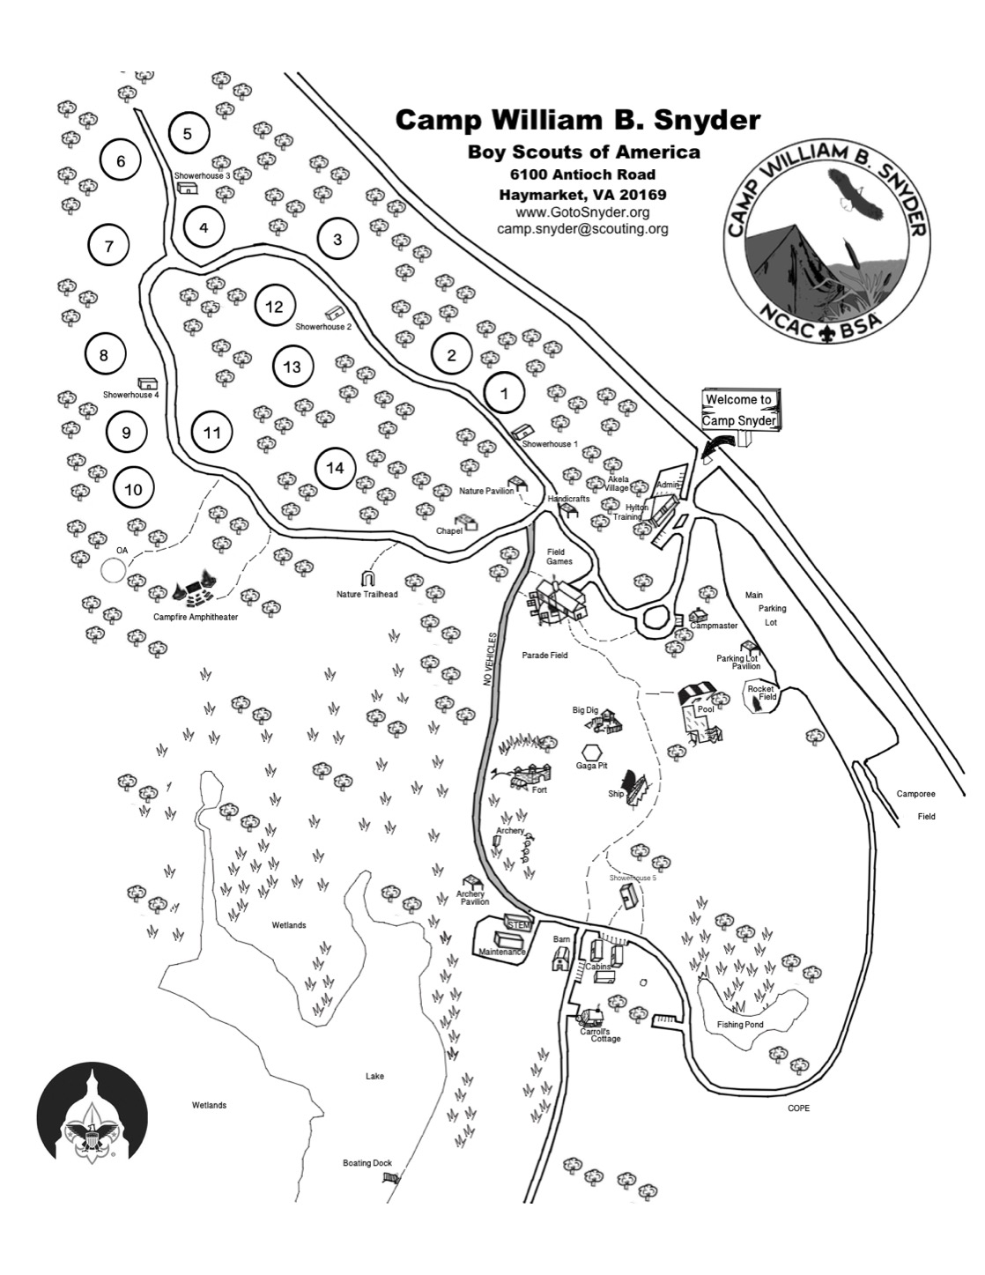

CAMP WILLIAM B. SNYDER
SPECIAL DIETARY NEEDS REQUEST
Submit to camp at least two weeks before arrival
Fax to 571-248-8241 or scan and email to camp.snyder@scouting.org Mail to: Camp William B. Snyder, 6100 Antioch Rd, Haymarket, VA 20169

(Please print or type)

Pack Number
Cub Resident Camp
Cub Adventure Days
Webelos Camp

Session Attending: (1,2,3 or 4) Date of Camp Attending:

Pack leader in camp Parents Name: Parents Phone # Parents Email
Request made for (Youth) (Adult) Medical Condition/Allergy: (Severe) (Mild)

Ingredients Participant CAN NOT Have:

Other pertinent information that our Food Service Manager should be aware of:

Special Dietary Requests should be made for medical or religious purposes only.

Part A: Informed Consent, Release Agreement, and Authorization A

Full name: DOB:
High-adventure base participants: Expedition/crew No.: or staff position:

Informed Consent, Release Agreement, and Authorization

I understand that participation in Scouting activities involves the risk of personal injury, including death, due to the physical, mental, and emotional challenges in the activities offered. Information about those activities may be obtained from the venue, activity coordinators, or your local council. I also understand that participation in these activities is entirely voluntary and requires participants to follow instructions and abide by all applicable rules and the standards of conduct.

In case of an emergency involving me or my child, I understand that efforts will be made to contact the individual listed as the emergency contact person by the medical provider and/or adult leader. In the event that this person cannot be
reached, permission is hereby given to the medical provider selected by the adult leader in charge to secure proper treatment, including hospitalization, anesthesia, surgery, or injections of medication for me or my child. Medical providers are authorized to disclose protected health information to the adult in charge, camp medical staff, camp management, and/or any physician or health-care provider involved in providing medical care to the participant. Protected Health Information/ Confidential Health Information (PHI/CHI) under the Standards for Privacy of Individually Identifiable Health Information, 45 C.F.R. §§160.103, 164.501, etc. seq., as amended from time to time, includes examination findings, test results, and treatment provided for purposes of medical evaluation of the participant, follow-up and communication with the participant’s parents or guardian, and/or determination of the participant’s ability to continue in the program activities.

(If applicable) I have carefully considered the risk involved and hereby give my informed consent for my child to participate in all activities offered in the program.
I further authorize the sharing of the information on this form with any BSA volunteers or professionals who need to know of medical conditions that may require special consideration in conducting Scouting activities.
With appreciation of the dangers and risks associated with programs and activities, on my own behalf and/or on behalf of my child, I hereby fully and completely release and waive any and all claims for personal injury, death, or loss that may arise against the Boy Scouts of America, the local council, the activity coordinators, and all employees, volunteers, related parties, or other organizations associated with any program or activity.

I also hereby assign and grant to the local council and the Boy Scouts of America, as well as their authorized representatives, the right and permission to use and publish the photographs/film/videotapes/electronic representations and/or sound recordings made of me or my child at all Scouting activities, and I hereby release the Boy Scouts of America, the local council, the activity coordinators, and all employees, volunteers, related parties, or other organizations associated with
the activity from any and all liability from such use and publication. I further authorize the reproduction, sale, copyright, exhibit, broadcast, electronic storage, and/or distribution of said photographs/film/videotapes/electronic representations and/or sound recordings without limitation at the discretion of the BSA, and I
specifically waive any right to any compensation I may have for any of the foregoing.
!
!

NOTE: Due to the nature of programs and activities, the Boy Scouts of America and local councils cannot continually monitor compliance of program participants or any limitations imposed upon them by parents or medical providers. However, so that leaders can be as familiar as possible with any limitations, list any restrictions imposed on a child participant in connection with programs or activities below.
List participant restrictions, if any: None

I understand that, if any information I/we have provided is found to be inaccurate, it may limit and/or eliminate the opportunity for participation in any event or activity. If I am participating at Philmont, Philmont Training Center, Northern Tier, Florida Sea Base, or the Summit Bechtel Reserve, I have also read and understand the supplemental risk advisories, including height and weight requirements and restrictions, and understand that the participant will not be allowed to participate in applicable high-adventure programs if those requirements are not met. The participant has permission to engage in all high-adventure activities described, except as specifically noted by me or the health-care provider. If the participant is under the age of 18, a parent or guardian’s signature is required.

Participant’s signature: Date:

Parent/guardian signature for youth: Date:
(If participant is under the age of 18)

Second parent/guardian signature for youth: Date:
(If required; for example, California)
Complete this section for youth participants only:
Adults Authorized to Take to and From Events:

You must designate at least one adult. Please include a telephone number. Name:

Telephone:

Name: Telephone:

Adults NOT Authorized to Take Youth To and From Events:

Name: Telephone:

Name: Telephone:

680-001
2014 Printing

Part B: General Information/Health History B

Full name: DOB:
High-adventure base participants: Expedition/crew No.: or staff position:
Age: Gender: Height (inches): Weight (lbs.): Address:
City: State: ZIP code: Telephone:

Unit leader: Mobile phone: Council Name/No.: Unit No.: Health/Accident Insurance Company: Policy No.:
Please attach a photocopy of both sides of the insurance card. If you do not have medical insurance, enter “none” above.
!
!
In case of emergency, notify the person below:
Name: Relationship: Address: Home phone: Other phone: Alternate contact name: Alternate’s phone:

Health History
Do you currently have or have you ever been treated for any of the following?

Yes | No | Condition | Explain
 |  | Diabetes | Last HbA1c percentage and date:
 |  | Hypertension (high blood pressure)
 |  | Adult or congenital heart disease/heart attack/chest pain (angina)/heart murmur/coronary artery disease. Any heart surgery or procedure. Explain all “yes” answers.
 |  | Family history of heart disease or any sudden heart- related death of a family member before age 50.
 |  | Stroke/TIA
 |  | Asthma | Last attack date:
 |  | Lung/respiratory disease
 |  | COPD
 |  | Ear/eyes/nose/sinus problems
 |  | Muscular/skeletal condition/muscle or bone issues
 |  | Head injury/concussion
 |  | Altitude sickness
 |  | Psychiatric/psychological or emotional difficulties
 |  | Behavioral/neurological disorders
 |  | Blood disorders/sickle cell disease
 |  | Fainting spells and dizziness
 |  | Kidney disease
 |  | Seizures | Last seizure date:
 |  | Abdominal/stomach/digestive problems
 |  | Thyroid disease
 |  | Excessive fatigue
 |  | Obstructive sleep apnea/sleep disorders | CPAP: Yes £ No £
 |  | List all surgeries and hospitalizations | Last surgery date:
 |  | List any other medical conditions not covered above
680-001
2014 Printing

Part B: General Information/Health History B

Full name: DOB:
High-adventure base participants: Expedition/crew No.: or staff position:
Allergies/Medications
Are you allergic to or do you have any adverse reaction to any of the following?

Yes | No | Allergies or Reactions | Explain | Yes | No | Allergies or Reactions | Explain
 |  | Medication |  |  |  | Plants
 |  | Food |  |  |  | Insect bites/stings
List all medications currently used, including any over-the-counter medications.
CHECK HERE IF NO MEDICATIONS ARE ROUTINELY TAKEN. IF ADDITIONAL SPACE IS NEEDED, PLEASE
INDICATE ON A SEPARATE SHEET AND ATTACH.

Medication | Dose | Frequency | Reason
YES NO Non-prescription medication administration is authorized with these exceptions:

Administration of the above medications is approved for youth by:
/
Parent/guardian signature MD/DO, NP, or PA signature (if your state requires signature)

Bring enough medications in sufficient quantities and in the original containers. Make sure that they
!
!
are NOT expired, including inhalers and EpiPens. You SHOULD NOT STOP taking any maintenance medication unless instructed to do so by your doctor.

Immunization
The following immunizations are recommended by the BSA. Tetanus immunization is required and must have been received within the last 10 years. If you had the disease, check the disease column and list the date. If immunized, check yes and provide the year received.
Yes | No | Had Disease | Immunization | Date(s)
 |  |  | Tetanus
 |  |  | Pertussis
 |  |  | Diphtheria
 |  |  | Measles/mumps/rubella
 |  |  | Polio
 |  |  | Chicken Pox
 |  |  | Hepatitis A
 |  |  | Hepatitis B
 |  |  | Meningitis
 |  |  | Influenza
 |  |  | Other (i.e., HIB)
 |  |  | Exemption to immunizations (form required)

Reason:

Approved by:

Date:
No
Further approval required: Yes
DO NOT WRITE IN THIS BOX
Review for camp or special activity.
Reviewed by: Date:
Please list any additional information
about your medical history:
_____________________________________________

_____________________________________________

_____________________________________________

_____________________________________________

680-001
2014 Printing

Part C: Pre-Participation Physical C
This part must be completed by certified and licensed physicians (MD, DO), nurse practitioners, or physician assistants.

Full name: DOB:
High-adventure base participants: Expedition/crew No.: or staff position:
You are being asked to certify that this individual has no contraindication for participation inside a
!
!
Scouting experience. For individuals who will be attending a high-adventure program, including one of the national high-adventure bases, please refer to the supplemental information on the following pages or the form provided by your patient.

Examiner: Please fill in the following information:
 |  |  | Yes | No | Explain
Medical restrictions to participate
Yes | No | Allergies or Reactions |  | Explain |  | Yes | No | Allergies or Reactions | Explain
 |  | Medication |  |  |  |  |  | Plants
 |  | Food |  |  |  |  |  | Insect bites/stings
Height (inches): Weight (lbs.): BMI: Blood Pressure: / Pulse:

Examiner’s Certification
 | Normal | Abnormal | Explain Abnormalities
Eyes
Ears/nose/ throat
Lungs
Heart
Abdomen
Genitalia/hernia
Musculoskeletal
Neurological
Other

I certify that I have reviewed the health history and examined this person and find no contraindications for participation in a Scouting experience. This participant (with noted restrictions):

True | False | Explain
 |  | Meets height/weight requirements.
 |  | Does not have uncontrolled heart disease, asthma, or hypertension.
 |  | Has not had an orthopedic injury, musculoskeletal problems, or orthopedic surgery in the last six months or possesses a letter of clearance from his or her orthopedic surgeon or treating physician.
 |  | Has no uncontrolled psychiatric disorders.
 |  | Has had no seizures in the last year.
 |  | Does not have poorly controlled diabetes.
 |  | If less than 18 years of age and planning to scuba dive, does not have diabetes, asthma, or seizures.
 |  | For high-adventure participants, I have reviewed with them the important supplemental risk advisory provided.
Examiner’s Signature: Date: Provider printed name: Address: City: State: ZIP code:
Office phone:
Height/Weight Restrictions
If you exceed the maximum weight for height as explained in the following chart and your planned high-adventure activity will take you more than 30 minutes away from an emergency vehicle/accessible roadway, you may not be allowed to participate.
Maximum weight for height:
Height (inches) | Max. Weight
60 | 166
61 | 172
62 | 178
63 | 183
64 | 189

Height (inches) | Max. Weight
70 | 226
71 | 233
72 | 239
73 | 246
74 | 252

Height (inches) | Max. Weight
65 | 195
66 | 201
67 | 207
68 | 214
69 | 220

Height (inches) | Max. Weight
75 | 260
76 | 267
77 | 274
78 | 281
79 and over | 295

680-001
2014 Printing

NCAC Scout Camp Risk Factors Certification

This form is intended for Camp Sessions where Form C is not

required but where a camp participant may have a pre-existing

medical condition requiring doctor’s guidance.

I, , _,
Adult Participant Parent/Guardian of Youth Participant
certify I have shown Parts A, B, and C of the BSA Annual Health & Medical Record (AMHR), the Scout Camp risk factors, including the swim classification test, described below, and discussed my/my son’s/daughter’s medical risk factors:

(List Factors)
with my health care provider in connection with the BSA Annual Health & Medical Record (AMHR) and this NCAC Risk Factors Certification form.

I, ,
Name of Health Care Provider
have reviewed Parts A, B, and C of participant’s BSA Annual Health & Medical Record (AMHR), the Scout Camp risk factors, including the swim classification test, described below, and discussed and reviewed Participant’s medical risk factors with Participant . Participant is

cleared for all camp activities, including the above-referenced swim test.

cleared for all camp activities except the above-referenced swim test.

cleared for all activities, but is subject to the following restrictions for swimming (describe):

is subject to the following restrictions for camp activities (describe):

and
is subject to the following restrictions for swimming (describe):

signature of participant/parent/guardian date

signature of health care provider date

Get Fit for Camp

Scout Camp can be physically and mentally demanding, and involves strenuous activities. Parents new to Scouting may not appreciate the level of outdoor physical activity involved in summer camp. Simply a day of extensive walking around camp involving varied and often hilly terrain, swimming, canoeing, and other activities may be more strenuous activity than many adults and scouts undertake in a week. Poor health and/or lack of awareness of risk factors can lead to disabling injuries, illnesses, and even fatalities. Participants should understand potential health risks inherent in camping while being exposed to occasional severe weather conditions such as lightning, high heat & humidity (Camp is not air conditioned.); and other potential problems, including injuries from tripping and falling. Mosquitoes, ticks, bees, and poison ivy may be encountered. Goshen Scout Reservation is located in the Allegheny Mountains in Virginia. The closest hospital is in Lexington, a little more than 30 minutes away. In light of this, we suggest more than one injector for use to counteract anaplylactic shock at Goshen. Camp Snyder is located in Haymarket, VA with the nearest hospital less than 10 minutes away. Both Camps have medical facilities and personnel for routine and emergency care.
When seeing your health care provider for your camp physical take Parts A, B, & C of the BSA Annual Health & Medical Record (AMHR) and this entire NCAC Risk Factors Certification form. Participants should discuss with your health care provider your risk factors, including, but not limited to:
Cardiac or Cardiovascular condition (Chest pain, myocardial infarction (heart attack) or family history of heart disease in any person before age 50, heart surgery, including angioplasty (balloon dilation), to treat blocked blood vessels or place stents, Stroke or transient ischemic attacks (TIAS));
Hypertension (participants with significant hypertension should be under treatment and their condition should be under control);
Excessive weight (see chart on health form Part C), or smoking (Note the BSA Policy on Smoking in the camp leaders’ guide re restrictions on smoking at camp);
Diabetes (bring enough medication, testing supplies, and equipment for the entire week, including batteries):
Seizure disorder or epilepsy (Should be well-controlled by medications. Participants with a history of seizures need to limit high-adventure activities (e.g., climbing or rappelling).);
Asthma (Should be well controlled. Participants must carry a rescue inhaler at all times during any Scouting event.);
Sleep Apnea (all required equipment (e.g., CPAP machine, batteries) must be provided by the Scout or Scouter;
Allergies or Anaphylaxis (see note above re having more than one injector for camp);
Ingrown Toenails, Recent Musculoskeletal Injuries, and Orthopedic Surgery (Ingrown toenails should be treated within a month prior to camp. Scouts and Scouters who have had orthopedic surgery, including arthroscopic surgery, or

significant musculoskeletal injuries, should have a release from their treating physician to participate);
Psychiatric/Psychological and Emotional Difficulties (Any condition must be well controlled without the services of a mental health practitioner. Scouts and Scouters are required to bring an appropriate supply of medication for the duration of camp, including travel to and from camp.);
Other Risk Factors (e.g., sickle-cell anemia, hemophilia, leukemia, severe blood dyscrasia, and HIV infection provide special challenges. Participants should review these with their health care provider during their physical exam for camp). The physical exertion at camp may precipitate either a heart attack or stroke in susceptible people. Participants with a history of any risk factors for these should have a physician-supervised stress test. If the test results are abnormal, the individual should not to participate.
Take your physical exam seriously and take responsibility for your own health and safety. All participants, if you are not engaging in a weekly program of sustained physical activity, please consult your doctor and safely begin one.

SWIM RISK ADVISORY FOR SUMMER CAMPS

This swim classification test is very physically demanding, particularly for adults.

Participants (both youth and adults) attending a NCAC summer camp will, on first day check-in day, have the opportunity to participate in a swim ability evaluation in cool lake water at the waterfront (Goshen), or cool pool water (Snyder). We recommend spending practice time in a pool prior to camp as beneficial, especially for participants who do not swim regularly.

Successful completion of this evaluation, consisting of a 100-yard swim consisting of the requirements of the BSA swim test, enables the participant to fully participate in all aquatic activities during the week. Participants who are not able to meet the swimmer requirements may be classified at a lower level, e.g., beginner or non-swimmer, which will result in more limited aquatics activities. If an adult, after consultation with your doctor, is not deemed sufficiently fit for the swim classification test, or has no interest in using the aquatic facilities, the adult can opt out of the swim test.

Camp Medical Staff reserve the right to deny the participation of any individual on the basis of a physical examination and/or medical history. Each participant is subject to a medical recheck at Camp

