Communication Req 2A Form

First & Last Name:_______________________________
Troop #:_______________________________________
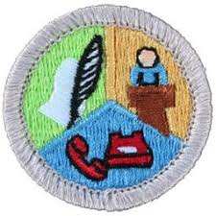

USE THIS FORM FOR REQUIREMENT 2a: (Each Scout MUST complete this form separately to receive credit.)
2. Do ONE of the following:
- Think of a creative way to describe yourself, using, for example, a collage, short story, autobiography, drawings, or use photographs. Using the aid you created, make a presentation to your counselor about yourself.
Top of Form

(Type, draw, or attach photographs as needed; you may use additional pages as well)

*d. Make a list of safe practices and safety devices currently used by your family, such as safety practices used at home, while working, and while *d. Make a list of safe practices and safety devices currently used by your family, such as safety practices used at home, while working, and while *d. Make a list of safe practices and safety devices currently used by your family, such as safety practices used at home, while working, and while *d. Make a list of safe practices and safety devices currently used by your family, such as safety practices used at home, while working, and while *d. Make a list of safe practices and safety devices currently used by your family, such as safety practices used at home, while working, and while Bottom of Form

