Communication Req 5 Form

First & Last Name:_______________________________
Troop #:_______________________________________
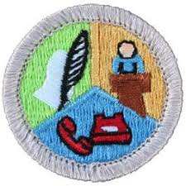

USE THIS FORM FOR REQUIREMENT 5: (Each Scout MUST complete this form separately to receive credit.)
5. Attend a public meeting (city council, school board, debate) approved by your counselor where several points of view are given on a single issue. Practice active listening skills and take careful notes of each point of view. Prepare an objective report that includes all points of view that were expressed, and share this with your counselor.
- Briefly describe the meeting
- What was the agenda
- Did you talk or ask questions?
- What were the key points and issues?
5. Attend a public meeting (city council, school board, debate) approved by your counselor where several points of view are given on a single issue. Practice active listening skills and take careful notes of each point of view. Prepare an objective report that includes all points of view that were expressed, and share this with your counselor.3. Write a five-minute speech. Give it at a meeting of a group.Top of Form

Type of public meeting:_____________________ Date Attended:_____________________
(Type below; may use additional pages)

*d. Make a list of safe practices and safety devices currently used by your family, such as safety practices used at home, while working, and while *d. Make a list of safe practices and safety devices currently used by your family, such as safety practices used at home, while working, and while *d. Make a list of safe practices and safety devices currently used by your family, such as safety practices used at home, while working, and while *d. Make a list of safe practices and safety devices currently used by your family, such as safety practices used at home, while working, and while *d. Make a list of safe practices and safety devices currently used by your family, such as safety practices used at home, while working, and while Bottom of Form

