08
Fall
CAMP WOLFEBORO
WEBELOS RESIDENT CAMP
LEADER’S GUIDE
2019

Nationally Accredited Camp (NCAP)
Mt. Diablo Silverado Council, BSA
800 Ellinwood Way
Pleasant Hill, CA 94523
Phone: 925-674-6126; Fax: 925-674-6190
Website: http://www.mdscbsa.org

Table of Contents
Camp Wolfeboro 3-4
Registration and Camp Fees 5-6
Registration Requirement 7
General Camp Information 8-12
Early Arrival 12
Health & Safety Information 13-15
Camp Programs 16-23
Merit Badge Info 24
ACE Program 25-26
Provisional Camper Program 27
S.T.E.M. / NOVA Awards (NEW FOR 2018/2019) 28
Special Programs 29-30
Unit Expeditions 30
Merit Badges Offered 32-33
Merit Badge Schedule 34
Camp Wolfeboro Weekly Schedule 2019 35
Sample Camp Menu 36
Packing List 37
Rocker Requirements 38-42
Appendix 43
Camp Unit Roster 44-45
Parental Firearm Permission Form 44
Dietary Allergies / Preferences 47
Provisional Camper Application 48
Wilderness Trek Registration 49
Early Arrival Request 50
Adult Leader Training 51
Campership Info & Application 52-53
MDSC Refund Policy 54
Camp Wolfeboro 2018 Fee Summary 55
Staff Information 56
Mountaineer Program 57
Camp Wolfeboro Map 59
Driving Directions to Camp 60
Unit Leader’s Meeting Info 61

Camp Wolfeboro

Camp Wolfeboro is one of the longest and running scout camps in the Western United States. Founded in 1928, Wolfeboro has continually become a special place to all its Scouts and Scouters.

It is the mission of the Wolfeboro staff to facilitate an environment where scouts will be engaged in unique, evolving programs, while building character through the values and methods of scouting in a safe outdoor environment.
It is the aim of the Camp Wolfeboro staff to promote a profound reverence for the outdoors. We establish, maintain and improve a rustic and traditional camping environment that can be enjoyed by all ages for many years to follow.
The Scout Oath and Scout Law are the core of Camp Wolfeboro. As your scouts participate in the camp programs, we help your units utilize the “patrol method” so the scouts can learn leadership skills. Additionally, we expect your scouts to use the “buddy system” at ALL times.

The best aspect of program at Camp is that is YOUR program and the Wolfeboro staff is here to assist you in providing that program so, BE PREPARED!

On my honor I will do my best
To do my duty to God and my country and to obey the Scout Law;
To help other people at all times;
To keep myself physically strong, mentally awake, and morally straight.

A Scout is:
TRUSTWORTHY, LOYAL, HELPFUL, FRIENDLY, COURTEOUS, KIND, OBEDIENT, CHEERFUL, THRIFTY, BRAVE, CLEAN and REVERENT.

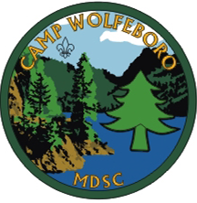
CAMP WOLFEBORO
Bear Valley, California

Dear Scouter:
We are delighted to have you and your Scouts with us at our Inaugural Webelos Resident Camp!. Camp Wolfeboro provides a safe and challenging High Sierra wilderness experience. We strive to provide the best program and staff possible to assist you and your scout in your first Resident Camp experience.
This leader’s guide has been designed to help you prepare for your visit to camp and make your time with us enjoyable. If you need any assistance, please do not hesitate to contact our Director of Support Service, Joe Barton at joe.barton@scouting.org or (925) 674-6172. Visit our website at https://campwolfeboro.mdscbsa.org/ to obtain forms and learn more about our offerings for 2019. You may also check your reservation status and make camp payments at https://scoutingevent.com/023-WRC2019
This program has been designed with your Scout in mind to help them learn more about camp and prepare them for their first full week Scouts BSA camp in 2020.
Thank you for what you do for your scouts and their families. For more than a century, scouting has a special place in America as the premier youth leadership development program. They say being a scout leader only takes “an hour a week”. I know it takes so much more. From all of us on the Wolfeboro Staff we offer a heartfelt THANK YOU!
We look forward to the opportunity to serving you at camp.
Yours in Scouting,
John Reich
Camp Director

Registration and Camp Fees

Go online https://scoutingevent.com/023-WRC2019 to make a reservation and pay for you and your Scout.

Both Scouts and Adults are $250 for the camp experience. Your fee covers your program materials and all meals while at camp. Scouts and parents may bring money for the Trading Post to purchase snacks or other souvenirs.

You May also mail in your fees to:

Mt. Diablo Silverado Council
c/o Webelos Resident Camp
800 Ellinwood Way
Pleasant Hill, CA 94523

Please make sure to include your Pack number and Scouts name on either a separate piece of paper or on the memo line of your check.

Adult Leader Fees are as follows:
You will receive one free adult leader for every four Scouts from your Pack who attend Camp. Additional adults will be required to pay $250 each.

FINAL CAMP FEES MUST BE RECEIVED TWO WEEKS BEFORE ARRIVAL AT CAMP so we can order proper food quantities. You will be charged full fees for additional reservations within the two weeks before camp!

The Camp Kitchen Staff cannot guarantee that there will be any space to keep refrigerated or frozen food for individual units, but we will try to make room to store them.

Food Allergy Notice
If ANY scout or leader has food allergies, they must complete a dietary allergy form and note it in our online system (See page 42, also online). If not completed online, forms must be sent or faxed to the council service center with final fee payment.

Camperships
The Mt. Diablo Silverado Council has a limited amount of funding available for “Camperships” to assist disadvantaged Scouts to attend summer camp and are available ONLY to Scouts who are registered in MDSC. (See appendix for more details)

Refund Policy
Mt. Diablo Silverado Council Refund Policy
Effective June 26, 2018 The Mt. Diablo Silverado Council has developed a refund policy to ensure our Scouts receive high quality programs and activities. Many of the costs associated with activities rely upon an outlay of funds many weeks and months prior to events. In order to maintain the most cost effective and positive program impact activity, camping and event refunds of 100% cannot be given. Refunds will now be considered based upon the following criteria and timeline.
Time until event | Percentage refund
Up to 14 days prior | 80% refund
Up to 7 days prior | 60% refund
7 days or less | No refund*

*Participants who cancel from an event within 7 days will be considered for up to a 60% refund if the refund request is accompanied by a Doctor’s note. Refund requests under these circumstances will not be considered if not received at the Council Service Center more than 14 days after the start of the event.

Registration Requirement

There has been a BSA Change to Adult Registration Requirement for Summer Camping
The BSA's adult registration requirements mandate that all adults accompanying a Scouts BSA troop to a resident camp or other Scouting activity lasting 72 hours or more must be registered as a leader, including completion of a criminal background check (CBC) and Youth Protection Training (YPT
Requiring registration, background checks, and YPT for adults on Scouts BSA extended activities adds another dimension of protection for Scouts BSA.
- The requirement applies to any adult accompanying a Scouts BSA group on a single Scouting activity where they are present for three or more nights (not necessarily consecutive)
- These adults must be registered as leaders, including the completion of a criminal background check and Youth Protection Training before the activity (CBCs cannot be expedited) Please note that under normal circumstances it can take up to 3 weeks for a CBC to be completed – with many new adult registrations all across the country at that time, it will take longer - BE PREPARED by registering and completing your YPT and CBC early so as not to be told you cannot attend camp because it did not come back yet.

Why is this happening?

- This is meant to enhance the "safe space" for overnight Scouts BSA activities.
- While incidents are rare, this will serve as an added layer of protection for our highest risk activities.

Please inform your troop’s leaders and parents of this change to allow time for everyone attending summer camp to be in compliance with these new requirements.

General Camp Information

Check In & Out
Scout Check in is scheduled for 12:00 noon on Monday. The camp truck will be at the top of the hill to assist in transporting gear into camp. Units should plan on arriving at camp between 10:30 AM and 11:00 AM in order to permit sufficient time to hike the two miles in and set up camp.

Your assigned Camp Buddies will be awaiting your arrival and meet your unit at the front gate, and then assist you in settling into your campsite and starting your program.

Departure time is Thursday morning after completing check-out procedures including picking up medical forms, medication, and patches and AFTER a campsite inspection by your camp commissioner. The camp truck leaves at about 9:30am on Thursday to take gear to the top of the hill.

Transportation to Camp
Each unit committee plans and provides its own transportation to and from camp. The Check In & Out sections of this guide should be used in planning your trip.

The Wolfeboro access road is accessible using 4X4 or high clearance vehicles ONLY. If you bring your personal vehicles down the road you are doing so at your own risk.

Parking
There is very limited parking at the bottom of the hill. Vehicles brought into camp are to be backed into designated parking areas in case evacuation is necessary.

Tents
Units are to provide their own tents and transfer them to and from camp. Each unit is responsible for providing adequate sleeping space for all members in attendance; remember Camp Wolfeboro does not provide platforms. The entrance to each tent must be clearly marked “No Flames in Tent” and have full dirt and water buckets nearby (provided to you), per BSA regulations.

Dining Hall
The first meal at camp is Monday lunch and the last is Thursday breakfast. All meals will be served in the dining hall using serving-line style serving. Your unit must provide one host per table for each table (max eight people) assigned to your unit to set up and clean up their table. These hosts should report to the dining hall 15 minutes before each meal.

If anyone in your unit has food allergies, please see page 42 regarding the Food Allergy Notice. If they are severe, contact the Council Service Center to find out if your needs can be accommodated.

NOTE: NOBODY is allowed in the Kitchen areas without permission from the Kitchen supervisor.

Visitors

There are no facilities at camp to allow parents or children not enrolled in the Boy Scouts of America to stay overnight.

Camping facilities located on Sand Flats near the camp are great for family camping. Please check with the Hathaway Pines Forest Ranger District office of the National Forest Service at 209-795-1381 for information. The link: http://activities.wildernet.com/pages/activity.cfm?actid=051601IO*53808cg gives some details about the campground, as does the Stanislaus National Forest website.

NOTE: Camp vehicles are NOT available to provide transportation up and down the camp road for parents and guests.

Trading Post
Our Trading Post is well stocked with Scouting literature, advancement supplies, souvenirs, and refreshments.

On average a Scout spends $100 during their week at camp. We suggest sending your Scouts with small bills when possible to aid in change. For $100 we recommend 2-$20, 3-$10, 4-$5 and 10- $1. We also do take credit cards and allow Adult Leaders to run a tab in the trading post on their credit cards. Adults who do not sign off on their tab by 7:00pm on Wednesday evening will be charged a $25 additional fee.

Uniforms
Field uniforms (a.k.a. “Class A”) are worn at flag ceremonies and at the morning and evening meals. During the day and evening, Scouts should wear attire appropriate to the program area in which they are participating, “Class B’s” are highly recommended. There are NO laundry facilities available to campers.

Den / Pack Flags
Baden-Powell said, “The patrol method is not a way to operate a Scouts BSA troop, it is the only way.” To help provide recognition of patrol spirit, we encourage your Dens to bring their flags to camp along with your unit’s flag.

Mail
There is NO direct mail service to camp so, mail delivery to camp is infrequent. There is a deposit box for outgoing mail near the Program Office. Incoming mail is distributed as soon as possible after receipt at the local P.O. in Bear Valley. The camp is not responsible for lost or stolen mail. The Trading Post stocks postcards, writing paper, envelopes and stamps. Every Scout should be encouraged to write to the scout’s family about summer camp. All mail to camp should be addressed in the format below. Please allow about 5 business days for mail to arrive at camp. Parents may want to send a letter to camp the Thursday before the youth’s week at Wolfeboro.

All mail is returned to sender at the end of the summer if received after the individual has left camp, so please provide a return address. All mail must be sent by the United States Postal Service only! Other carriers do not deliver packages to camp.

Scout Name
Troop # & Name of Campsite
Camp Wolfeboro
Bear Valley, CA 95223

Telephone
Wolfeboro uses a radiotelephone system. In case of an emergency, contact the Council Service Center at (925) 674-6126 to get a message to camp.

Personal Projectile Throwers
Please leave all personal bows, firearms and ammunition at home! For the safety of Camp Wolfeboro participants and to be in line with Camp Standards, our Shooting Sports Director must secure ALL designed Firearms on property.
If personal bows or firearms find their way to camp, they must be checked in with the Field Sports Director who will safely store them until checkout.

Liquid Fuels
All liquid fuels for stoves present a potential safety and fire hazard. Only adults, or older youth under the supervision of an adult, may use liquid fuels in camp.

Knives in Camp
Scouts will not need their knives to complete any of the activities in camp. If a scout brings his or her knife it is up to the Pack Leadership to ensure the Scout is being safe. It is strongly encouraged for your Scout to leave their knife at home.

Under NO CIRCUMSTANCES are SHEATH KNIVES NEEDED or ALLOWED for participation in the camp programs. Knives of that type will be confiscated for the duration of the week.

Pets
Pets MUST be left at home. Camp abounds with wildlife. Please do NOT take home any wildlife (like squirrels, snakes or lizards). They will not survive!

Valuables
The Camp is NOT responsible for the safety of campers’ valuables. Leave unnecessary valuables at home. Scouts should not take certain items (jewelry, money, etc.) to the aquatics or high adventure program areas. Many troops bring a “lock box” to store valuables for scouts at camp, but they need to be secured.

Items like television sets, “boom boxes”, generators, etc. should not be brought to camp by units. Cell service is very limited in the valley, so cell phones should be left in a leader’s vehicle.

Damaged Equipment Charge
Each unit is responsible for taking care of camp equipment that has been issued for their use. If this equipment is damaged, the individual or unit is responsible for cost of repairs or replacement at the discretion of the Camp Director.

Drugs, Alcohol, & Tobacco
Prescription drugs must be checked in to the Camp Medic. Non-prescription drugs (aspirin, cough syrup, etc.) may be used only with the approval of the Camp Medic. Local authorities will deal with those using illegal substances. Alcoholic beverages are not allowed in camp! Anyone in possession of, or under the influence of, alcohol will be escorted from camp immediately.

Smoking Policy— all buildings and facilities are designated as nonsmoking facilities. Smoking outside entrances and exit doors is not permitted anywhere. All activities will be conducted in a smoke-free environment.

If any adult must use tobacco, they may do so ONLY in the designated smoking area — it is located beyond the green gate at the entrance to camp.

Early Arrival
Camp Wolfeboro is CLOSED and the staff is off duty until 11am on Monday.

Health & Safety Information

Health Facility
A Medical Lodge is located at Camp Wolfeboro and has a medic trained to handle minor accidents and illnesses.

Arrangements for treatment of more serious cases have been made with medical clinics and hospitals in the towns of Arnold and Sonora, CA. If such treatment is required, attempts will be made to notify the camper’s parents. Their desires concerning further treatment will be accommodated wherever possible.

1. It is the responsibility of the unit leadership to provide transportation for unit member(s) requiring services from a doctor or hospital. The camp will provide transportation only when a unit has inadequate transportation, or if an injury requires medical personnel with emergency transportation.

2. One adult leader from the unit must accompany the unit member(s) requiring services to the doctor or hospital. The adult leader must obtain the Scout’s health record and any insurance forms from the Camp Medic before going to the doctor or hospital. Also, two deep leadership still applies.

3. Since parent(s) or guardian(s) will be notified of any serious illness or injury, they should provide information about where they can be located if they will not be at home during the week of camp.

4. The Camp Medic must clear all cases requiring outside medical care. This is an agreement with the local health services facility and usually required by insurance companies for claim procedures.

5. Those leaving camp for any medical reasons should check out with the Camp Medic. Upon returning to camp, they must check in with the Camp Medic and show documentation of release and any medical restrictions and care.

If not returning to camp, someone from the unit must contact the MDSC service center at (925) 674-6126 and leave a message with contact info.

Medications at Camp
The Camp Standard on medication states: “All prescription drugs (including those needing refrigeration) are to be kept in locked storage and in compliance with local and state laws. An exception may be made for a limited amount of medication to be carried by a camper, leader, parent, or staff member for life-threatening conditions, including bee sting or heart medication, and inhalers, or for a limited amount of medication approved for use in a first aid kit.”
This means individuals may only carry prescription medication needed for life-threatening situations, otherwise all other medications MUST be kept in lockers at the Medical Lodge.

A locker in the medical lodge will be provided to each unit during its stay at camp. An adult in each unit will need to be responsible for the administration of prescription drugs for their unit. They will be provided a lock to place on the locker. He or she will log the Scout’s name, age, day, time and medication each time it is given. At the conclusion of camp the containers and medications will be returned to the unit leader. All other medical needs will be taken care of by the Camp Medic.

Prescription medications are for the named patient only! Leaders along with medical personnel are responsible to oversee the administration of medications. It is essential that each medication is in its own original labeled container. Each Scout needing prescription medications should have their own individual supply.

At the time any medication is dispensed from the pharmacy a sheet of information pertaining to each drug is also given to the patient. It would be appropriate for a Scout to attach that information to the scout’s medical form.

For individuals with severe allergic reactions or other life-threatening conditions who may urgently need medication, they may, and should, be held by the individual. For example: Epipens, Glucagon for diabetics, asthma rescue inhalers, and nitroglycerin for cardiac events.

While there are many emergency supplies available in the Medic’s Lodge, scouts and leaders should bring their own critical supplies. Emergency items will be given under the direction of the Camp Medic OR any physician or emergency rescue personnel.

Many non-prescription, over-the-counter, medications will be available in the Medic’s Lodge. These include Tylenol, adult and junior strength, ibuprofen, Benadryl, aspirin, simple cough and cold medications, etc. These medications are dispensed at the Camp Medic’s discretion. Dressings for simple abrasions and burns as well as topical antibiotics and antiseptic solutions will also be available.

Medical Exams
Each Youth who attends camp must have a health history, signed by parents or guardians, supported by an exam done by someone licensed to practice medicine and completed within the last 12 months. An Annual Health and Medical Record (#680-001 2014) is to be used for summer camp by youth members. Parts A, B, and C must be completed. Please send up copies and not the originals.

Each Adult who attends camp must have a current health history supported by an exam done by someone licensed to practice medicine and completed within 12 months before arrival at camp. This includes any adult rotating into camp. An Annual Health and Medical Record (#680-001 2014) is to be used for summer camp by adult members. Parts A, B, and C must be completed.

Copies can be found at: http://www.scouting.org/filestore/HealthSafety/pdf/680-001_ABC.pdf

“Medical examinations for camp attendance are required of all campers for the protection of the entire camp group. The immunization requirement is waived for persons with religious beliefs against immunization.”

If immunizations are in conflict with a religious belief, please make a note in the immunization part of the Annual Health and Medical Record portion of the form and fill out the Exemption from Immunizations form.

ALL Scouts and leaders will receive a health re-check from the Camp Medic upon arrival at camp. Any Scout or Scouter arriving in camp without the completed Annual Health and Medical Record, including the prior medical examination, will be restricted from all camp activities until an examination is done. There is NO provision for the required examination to be done at camp.

Camp Wolfeboro leadership reserves the right to refuse admittance to anyone who, in the opinion of the Camp Medic and the Camp Director, has any physical or medical condition which could present a hazard to the individual or others. This includes individuals with a fever over 101˚F upon arrival in camp.

Insurance Note
The Annual Health and Medical Record form requests personal health & accident insurance carrier and policy number. This information is needed in case someone has a life-threatening condition and is taken to the hospital and the emergency contact person cannot be reached. Doing so meets requirements set by BSA insurance provider.

All Troops attending camp must be covered by accident insurance.

Camp Programs

The staff at Camp Wolfeboro is proud of its location in the heart of the Sierra Nevada mountain range on the shores of the Stanislaus River. This location allows each individual to fully experience the “Outing” in Scouting. Along with its ideal setting, Camp Wolfeboro’s program offers a wide range of activities.

Aquatics
The Wolfeboro Waterfront is positioned along an improved section of the North Fork of the Stanislaus River. Scouts will have an opportunity to swim or wade in the river and play some games to help get them acclimated to swimming in a natural river.
Ecology and Conservation
One of the most exciting areas in camp is the Ecology area because it is always changing, just like nature around us. The top-notch staff will help the youth work on activity pins. We have a unique opportunity to learn about all that nature has to offer here on the beautiful shores of the Stanislaus River.

Handicraft
The Handicraft area is an excellent place for your Scouts! They will work on their handyman pin and have a fun project to bring home!

Scoutcraft
Scouts will learn the patrol method and the basics of becoming a member of Scouts BSA by practicing all the requirements to earn their Scout rank.

Shooting Sports
Under the guidance of an excellent staff, Webelos will have the opportunity to work on their Shooting sports award and pins for Archery, BB guns and sling shots.
All youth who wish to shoot at the firearm’s range must have a signed “Firearm Use Permission Slip”.

Summit

Scouts will get to visit the special granite rock wall at Camp Wolfeboro for a special program.

Special Programs

Camp Wolfeboro offers special programs throughout the week. Your unit’s camp experience would not be complete without participating in several of these. The times and events are listed on the Camp Weekly Schedule.

Monday and Wednesday Night Campfires
There will be a campfire on Monday and Wednesday. The staff will run the opening campfire on Monday. The closing campfire will be put on by the units with the assistance of the staff.

Camp-wide Game
These activities will be held on Tuesday after dinner. Youth unit leadership and camp staff develops activities for patrol and troop and individual competitions. This can be a great team building activity!

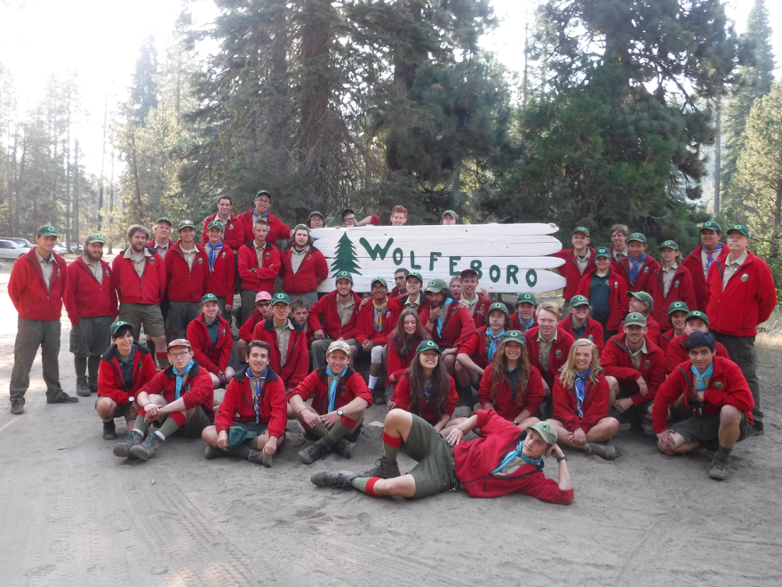

Webelos Resident Camp 2019 Camp Schedule
Time | Monday | Tuesday | Wednesday | Thursday
6:15 |  |  | Polar Bear Swim
7:15 |  | Breakfast A | Breakfast | Breakfast A
8:00 |  | Flags | Flags | Flags
8:15 |  | Breakfast B | Breakfast B | Breakfast B
9:00 |  | Station A | Station A | Campsite Clean-Up
10:00 |  | Station B | Station B | Campsite Clean-Up
11:00 | Scouts Arrive | Station C | Station C | Campers Depart
12:00 | Lunch A | Lunch A | Lunch A
12:15 | Campsite Set-Up | Campsite Time | Campsite Time
12:45 | Campsite Set- Up | Campsite Time | Campsite Time
1:00 | Lunch B | Lunch B | Lunch B
2:00 | Camp Tour | Station D | Station D
3:00 | Camp Tour | Station E | Station E
4:00 | Camp Tour | Station F | Station F
5:00 | Change into Class A | Change into Class A | Change into Class A
5:15 | Dinner A | Dinner A | Dinner A
6:00 | Flags | Flags | Flags
6:15 | Dinner B | Dinner B | Dinner B
7:00 | Open Program | Campwide Games | Open Program
8:00 | Monday Night Campfire | Den Campfires | Closing Campfire
9:00 | Lights Out | Lights Out | Lights Out

2019 | Monday |  | Tuesday | Wednesday | Thursday
Breakfast |  |  | French Toast  Turkey & Veggie Sausage Links  Fruit Bar  Cereal Bar  Cocoa/Juice | Breakfast Burrito  (Egg, & Sausage)  Oakmeal  Cocoa / Juice | Pancakes  Bacon  Butter & Syrup  Fruit Bar  Cereal Bar  Cocoa/Juice
Lunch | Turkey Burgers  Chips  Cookies  Salad Bar  P.B.& J.  Punch |  | Sloppy Joes  Cheese Crackers  Cookies  Salad Bar  P.B.& J.  Punch | Cold Cuts  Chips  Cookies  Punch
Dinner | Lasagna  Garlic Bread  Corn  Brownies  Salad Bar  Punch |  | Meatloaf  Broccoli  Applesauce  Ice Cream Bars  Salad Bar  Punch | Spaghetti  Meatballs  Garlic Bread  Green Beans  Pudding Cups  Punch
**Coffee, creamer, and sugar for adults and staff only**
**Menu is subject to change**

Packing List
What to bring to Camp and what to leave at home

Very Important
_____ Signed Annual Health and Medical Record (See page 12)
_____ Signed permission slips (especially firearms)

Suggested Personal gear
____ Pack ____Sleeping bag
____ Jacket ____Raincoat /poncho
____Foam Pad ____ Full Uniform
____T-shirts, several ____Sweater
____Pants ____Hiking shorts
____ Undershorts ____Several pairs socks
____ Pajamas ____Hiking boots
____Light shoes ____Hat
____ Gloves ____Swimsuit or cutoffs
____Large towel ____Chapstick
____Water ____Scout Handbook
____Knife, fork, & spoon ____Plate, cup, & bowl
____Pocket knife ____Flashlight
____ Matches ____Personal first aid kit
____Washcloth ____Toothbrush
____Toothpaste ____Soap
____ Pencils ____Note pad
____Envelopes & stamps ____Day pack
____Watch ____Tent

Optional
____ Compass ____ Laundry bag
____ Rubber boots ____ Pillow
____ Sunglasses ____ Insect repellent
____ Sewing kit ____ Fishing gear
____ Camera & film ____ Sharpening stone
____ Harmonica or Guitar ____ Clothespins
____ Twine or light rope ____ Spending money
____ OA sash ____ Money for activities

Items to Leave at Home!
Pets Music devices Firearms Tobacco
Electronic games Radios Hatchets Ammunition
Sheath knifes Fireworks Alcohol & Cell phones

Appendix

Camp Unit Roster

Parental Firearm Permission Form

Dietary Allergies / Preferences

Campership Info & Application

MDSC Refund Policy

Staff Information

Mountaineer Program

Camp Wolfeboro Map

CAMP UNIT ROSTER
Unit Leader |  |  | Unit |  |  | Council
Unit Leader |  |  | Unit |  |  | District
Camp | Wolfeboro |  |  |  |  | Campsite

Adult Leaders | Emergency Contact |  | Emergency Phone | Days at Camp  (circle) |  | Leadership Training Needs |  |  |  |  |  | Check In |  |  | Check Out |  |  |  |  |  |  |  |  |  | Allergy Form
 |  |  | 000-000-0000 | S M T W Th F S |  | YPT | LST |  | IOS | CPR |  |  |  |  |  |  | 18-20 |  |  |  | 21-99 |  |  | Y or N
 |  |  |  | S M T W Th F S
 |  |  |  | S M T W Th F S
 |  |  |  | S M T W Th F S
 |  |  |  | S M T W Th F S
 |  |  |  | S M T W Th F S
 |  |  |  | S M T W Th F S
Youth (full name) |  | Emergency |  |  | Emergency  Phone |  |  | Relationship |  |  |  |  | Check |  |  | Check |  |  |  | D-O-B |  |  | Allergy  Form
 |  | Contact |  |  | 000-000-0000 |  |  |  |  |  |  |  | In |  |  | Out |  |  |  | 00-00-00 |  |  | Y or N

Parental Firearm Permission Form

Consent for Minor to Use Firearms & Live Ammunition
Mt. Diablo Silverado Council

4 Copies are required at Camp

The State of California has enacted legislation that prohibits any person from furnishing, loaning, or otherwise providing a minor any firearm or live ammunition without the express permission of his or her parent or legal guardian. Your son/daughter will not be allowed on any shooting range without this signed release. It is necessary for you to give consent for your child to participate in the shooting sports activities. For the purpose of this camp, this permission includes archery.

By signing this consent form I do hereby give the minor named below permission as required by California Penal Code Sections 12552, 12070, 12072, 12078, et. Seq. to the Mt. Diablo Silverado Council, Boy Scouts of America, and to instructors established by the Boy Scouts of America (National), to furnish a firearm, BB Gun, .22 rifle, 20-gauge shotgun, 12-guage shotgun, .22 handgun (Venturers only), bow and ammunition and/or arrows to said minor for the purposes of instructing him/her in the safe handling of firearms, safe shooting, and marksmanship. Instructors include Certified Instructors and Range Safety Officers of the National Rifle Association and BSA certified archery instructors and Council adult volunteers.

I do further agree to indemnify and hold harmless the Mt. Diablo Silverado Council, Boy Scouts of America, and all officers, members, employees, and volunteers thereof, from all suits or actions brought for, or on account of, any injuries or damages received or sustained by any person or persons by or from the consequences of any negligence or any act or omission of the above named minor occurring during the course of said instruction.

Participant's printed name: _________________________________________ Unit #____________

Date(s) of camp:______________________

Parent/Guardian's Name:___________________________________________ Date: ____________
Signature:___________________________________________________________________________

Primary Phone # (______) ________ - __________________

Alternate Phone # (______) ________ - __________________

DIETARY ALLERGIES / PREFERENCES

Name: _____________________________________ Unit No. ______ Week # _______

Dietary Allergies: eat drink breathe mild severe
Peanuts ( ) ( ) ( ) ( ) ( )
Tree nuts (walnuts, pecans, etc.) ( ) ( ) ( ) ( ) ( )
Eggs ( ) ( ) ( ) ( ) ( )
Milk (Dairy) ( ) ( ) ( ) ( ) ( )
Wheat (Gluten) ( ) ( ) ( ) ( ) ( )
Soy ( ) ( ) ( ) ( ) ( )
Fish ( ) ( ) ( ) ( ) ( )
Shellfish ( ) ( ) ( ) ( ) ( )
Other ( ) ( ) ( ) ( ) ( )
What are the signs and symptoms of your allergic reaction? (Be specific)
_____________________________________________________________________________________________________
How quickly do symptoms appear after exposure to the allergen?
_____________________________________________________________________________________________________
Do you have a food allergy or intolerance diagnosis from a healthcare provider? ( ) No ( ) Yes
Has your healthcare provider recommended treatment for any allergic reaction? ( ) No ( ) Yes
Has your healthcare provider given you a prescription for medication? ( ) No ( ) Yes
Have you used the epinephrine auto-injector (Epi Pen) ( ) No ( ) Yes
Can you eat foods "processed in the same facility" as your allergen? ( ) No ( ) Yes
Will you supply your own food (and/or food related items) for meals? ( ) No ( ) Yes
Do you require any other special conditions like a "safe" table for meals? ( ) No ( ) Yes
explain: _______________________________________________
Are you able to monitor and prevent your own exposures...
Do you know:
What foods to avoid? ( ) No ( ) Yes
To ask about food ingredients? ( ) No ( ) Yes
How to read and understand food labels? ( ) No ( ) Yes
To tell someone immediately after an exposure? ( ) No ( ) Yes
How to get and use emergency medication? ( ) No ( ) Yes
Do you:
Firmly refuse a problem food? ( ) No ( ) Yes
Wear a medical alert bracelet, necklace, watchband? ( ) No ( ) Yes
Administer your own emergency medication? ( ) No ( ) Yes
Dietary Preferences (NOT allergies):
Vegan ( )
Vegetarian ( )
Gluten Free ( )
Other ( )
Other _________________________ ( )

CAMPERSHIP APPLICATION
Please note that camperships will only be awarded to Scouts registered with the Mt. Diablo Silverado Council.
Applications with missing information will be not be considered! Please read back side carefully before proceeding. Must be returned to the Council Service Center before final payment is made for the camp you are applying for. (Please Print Information Clearly)
( ) Pack ( ) Troop ( ) Crew Unit #____________________
Scout’s Name (Last)__________________________ (First)____________________________(Middle Initial)_____________
Rank _______________________________ Gender_________________ Scout’s age at time of camp_____________
Birth date______/_______/_______ Is this Scout a foster child? __________ Is this Scout a first-year camper? _________
OPTIONAL: What is the primary language spoken at home? ________________ What is the Scouts Ethnicity? ___________

Parent/Guardian’s Name_______________________________________________________________________________
Address________________________________ City______________________________ Zip_________________________
Home Phone____________________ Business Phone_______________ Email ____________________________________
Event/Camp Attending______________________ Camp Dates_______________________ Camp Fee $________________
Income Information:
Gross Monthly Income or Assistance Program Eligibility (school lunch, welfare, AFDC, support, etc.) $___________________
Number of persons in your household? _________________
Our family will contribute $___________ Our unit will contribute $___________ Others will contribute $________________
We would like to request financial assistance in the amount of $_______________.
(Keep in mind that camperships are not approved for amounts more than one-half of the MDSC early camp fee.)
Scout has participated in the following money-earning projects: ____________________________________________________________
A few words describing the Scout and his/her background? _____________________________________________________________________________________________________
By completing this application, I hereby request financial assistance from the Mt. Diablo Silverado Council, BSA Campership Fund. I certify that this information is true and correct to the best of my knowledge.
__________________________________ __________________________________________
Signed by Parent/Guardian Signed by Unit Leader
Print Name _________________________________ Email _____________________________________
(Parent/ Guardian) (Unit Leader)

APPLICATION FOR CAMPERSHIP
Each year the Mt. Diablo Silverado Council grants a limited number of camperships. They are awarded upon proper application and certification to worthy Scouts, who for financial reasons are unable to enjoy a summer camp experience. These camperships are available for Mt. Diablo Silverado Council camps only. Camperships are designed to assist Scouting units and families by insuring that no Scout is deprived of the camp experience because the scout’s family lacks necessary funds. Camperships are awarded on a "matching funds" basis; the Scout, parents or guardian, and troop, ship, crew or pack contributes supplementary dollars. Please note that the amount of the campership to be awarded is subject to review each year.
Campership applications MUST be received at the Council Service Center prior to the early discount day of the year you will attend camp. Please provide all required information. Incomplete applications will be discarded.
To apply for a Campership, the following steps must be completed. All information will be held confidential.
- The family completes the Campership Application.
- The unit leader meets with the parents or guardian and determines the amount of the family's contribution.
- On advice of the unit leader, in consultation with the Chartered Organization, the Unit Committee determines the extent to which the Unit/Chartered Organization can support the camp fee. Opportunities for money-earning projects to offset the difference should not be overlooked. The Scout must have participated in unit, district and council fund raising opportunities within the past year.
- The Cubmaster/Scoutmaster/Advisor endorses the application and a letter explaining the unit position and any other information that would help in making a decision on this application should be mailed to the Council Service Center, 800 Ellinwood Way, Pleasant Hill, CA 94523.
- After a committee reviews the application, the Scout's family or the unit will be notified of the amount of financial assistance the council will provide. This notification will act as the official confirmation of the amount of the campership. You must present this verification when making final camp fee payments.
- Camperships are good only in the Mt. Diablo Silverado Council camps.
- USE ONLY ONE FORM PER YOUTH. More forms can be obtained at the Council Service Center or by calling 925-674-6100 or you can photocopy this one. Forms are also available on the council web site at www.mdscbsa.org Please note that camperships are non-transferrable.
- You must answer every question on the form and the youth, the parent/guardian, and Cubmaster/Scoutmaster/Advisor must sign the form.
- Campership applications are NOT registration forms for camp; they are applications for financial aid: For Cub Day Camp, Cub Scout Family Camp, Camp Wolfeboro. You must sign up for camp through your pack, troop, ship or crew.
- You must include the camp and date your youth is attending. If you do not know, ask the Cubmaster, Scoutmaster, Advisor, or
Coach.
- A thank you letter from the youth who have benefited from these funds is appropriate. Thank you letters may be addressed to the Mt. Diablo Silverado Council, 800 Ellinwood Way, Pleasant Hill, CA 94523.
INCOMPLETE APPLICATIONS WILL BE DISCARDED. ALL BLANKS MUST BE COMPLETED AND PROPER SIGNATURES OBTAINED.
RULES FOR ACCEPTANCE AND PARTICIPATION IN THE CAMPING PROGRAM ARE THE SAME FOR EVERYONE WITHOUT REGARD TO RACE, COLOR, OR NATIONAL ORIGIN.
Mt. Diablo Silverado Council Refund Policy
Effective January 1, 2019 The Mt. Diablo Silverado Council will implement a refund policy to ensure our Scouts receive high quality programs and activities. Many of the costs associated with activities rely upon an outlay of funds many weeks and months prior to events. In order to maintain the most cost effective and positive program impact; activity, camping and event refunds of 100% cannot be given. Refunds will now be considered based upon the following criteria and timeline.
Time until event | Percentage refund
Up to 14 days prior | 80% refund
Up to 7 days prior | 60% refund
7 days or less | No refund*

*Participants who cancel from an event within 7 days will be considered for up to a 60% refund if the refund request is accompanied by a Doctor’s note. Refund requests under these circumstances will not be considered if not received at the Council Service Center more than 14 days after the start of the event.

Staff Information
Dear Adult and Youth Unit Leaders and other Adult Volunteers!
Would you, or someone you know, like the opportunity to be a part of the Wolfeboro Camp Staff that has led and created the program that you and your Scouts have so enjoyed in the past? Would you like to be a part of a dynamic and energetic team committed to bringing their love of Camp Wolfeboro and Scouting to Scouts and campers? If you are interested, we are too!

Apply now to join the 2019 Camp Staff at Wolfeboro!
Apply at:
https://docs.google.com/forms/d/e/1FAIpQLScIrSPFB5y899zdqBf3EGlQS7Shuuk9sdYU0i-lPN03-4ZcCw/viewform?usp=sf_link
Or contact Joe Barton at joe.barton@scouting.org

Why apply for a camp staff job? Here are a few of the countless reasons that are frequently expressed:

- To make lots of new friends in your area, other states, and even other countries.
- To spend a summer in the great outdoors where nature prevails.
- To acquire experiential education (learning by doing) and new skills that will last a lifetime.
- To be part of an effective team and to cooperate with others to get things done.
- To learn how to lead others and to apply leadership skills.
- To undertake and fulfill meaningful challenges and earn the satisfaction of doing a job well.
- To work with youth and adults of all ages.
- To serve others (the most noble and fulfilling pursuit of all).
- To give something back for the opportunities you have received.
- To live in a wholesome environment based on the Scout Oath and Law.
- To have meaningful spiritual experiences.
- To have advice, counsel, and support of senior staff dedicated to helping you succeed.
- To be paid and receive food and lodging in return for something challenging and fun.
- To be considered for jobs of greater responsibility and to receive recommendation for other pursuits.

Why work at a fast food or retail establishment that focuses on sales when you can have opportunities like these that will prepare you for more meaningful endeavors?

We all recall the thrill and prospect of camping as youth. The opportunity to sleep out under the stars away from home, it didn't matter how far away from home, just camping. That adventure is still the promise of Scouting and now is the time for you to be one of the many Scouters who are working to bring that thrill to the next generation of Scouts.

Mountaineer Program

Do you have a Scout or Venturer who wishes to be on staff? The Mountaineer program is the perfect opportunity for a youth to gain the training needed to be an effective Wolfeboro Staff member. They must be at least 14 years of age and must be able to commit to one of the three two week sessions held during the summer at Wolfeboro. They will be provided with room and board and loaned staff regalia for the duration of their stay.

The first week of the mountaineer session will be spent receiving the same training that the full time staff gets during the pre-camp staff meetings. The second week will be spent shadowing the staff as he or she counsels several merit badges and helps to run other Wolfeboro programs while gaining a greater understanding of the teaching process. The third week is when he or she is allowed to counsel their own merit badges in the program area of his or her choice. Throughout the mountaineer session, the staffer will have free time in which he or she is encouraged to enjoy all aspects of camp program, including earning merit badges or other advancement.

If they're interested in this program, they need to fill out the Mountaineer Application found at: http://www.mdscbsa.org/camping/wolfeboro-mountaineer-information/

Once the council office has received the application and the Mountaineer candidate has been accepted into the program, they and their parents are invited to a pre-camp orientation meeting.

MOUNTAINEER ORIENTATION
Please join the Wolfeboro Management for an orientation meeting to discuss the Mountaineer program with our new 2019 candidates.

WHEN: Saturday, May 11, 2019
1:00 pm -3:00 pm

WHERE: Mt. Diablo Silverado Council Office
800 Ellinwood Way
Pleasant Hill, CA

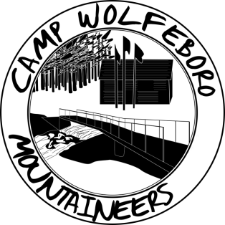

Map of Camp Wolfeboro
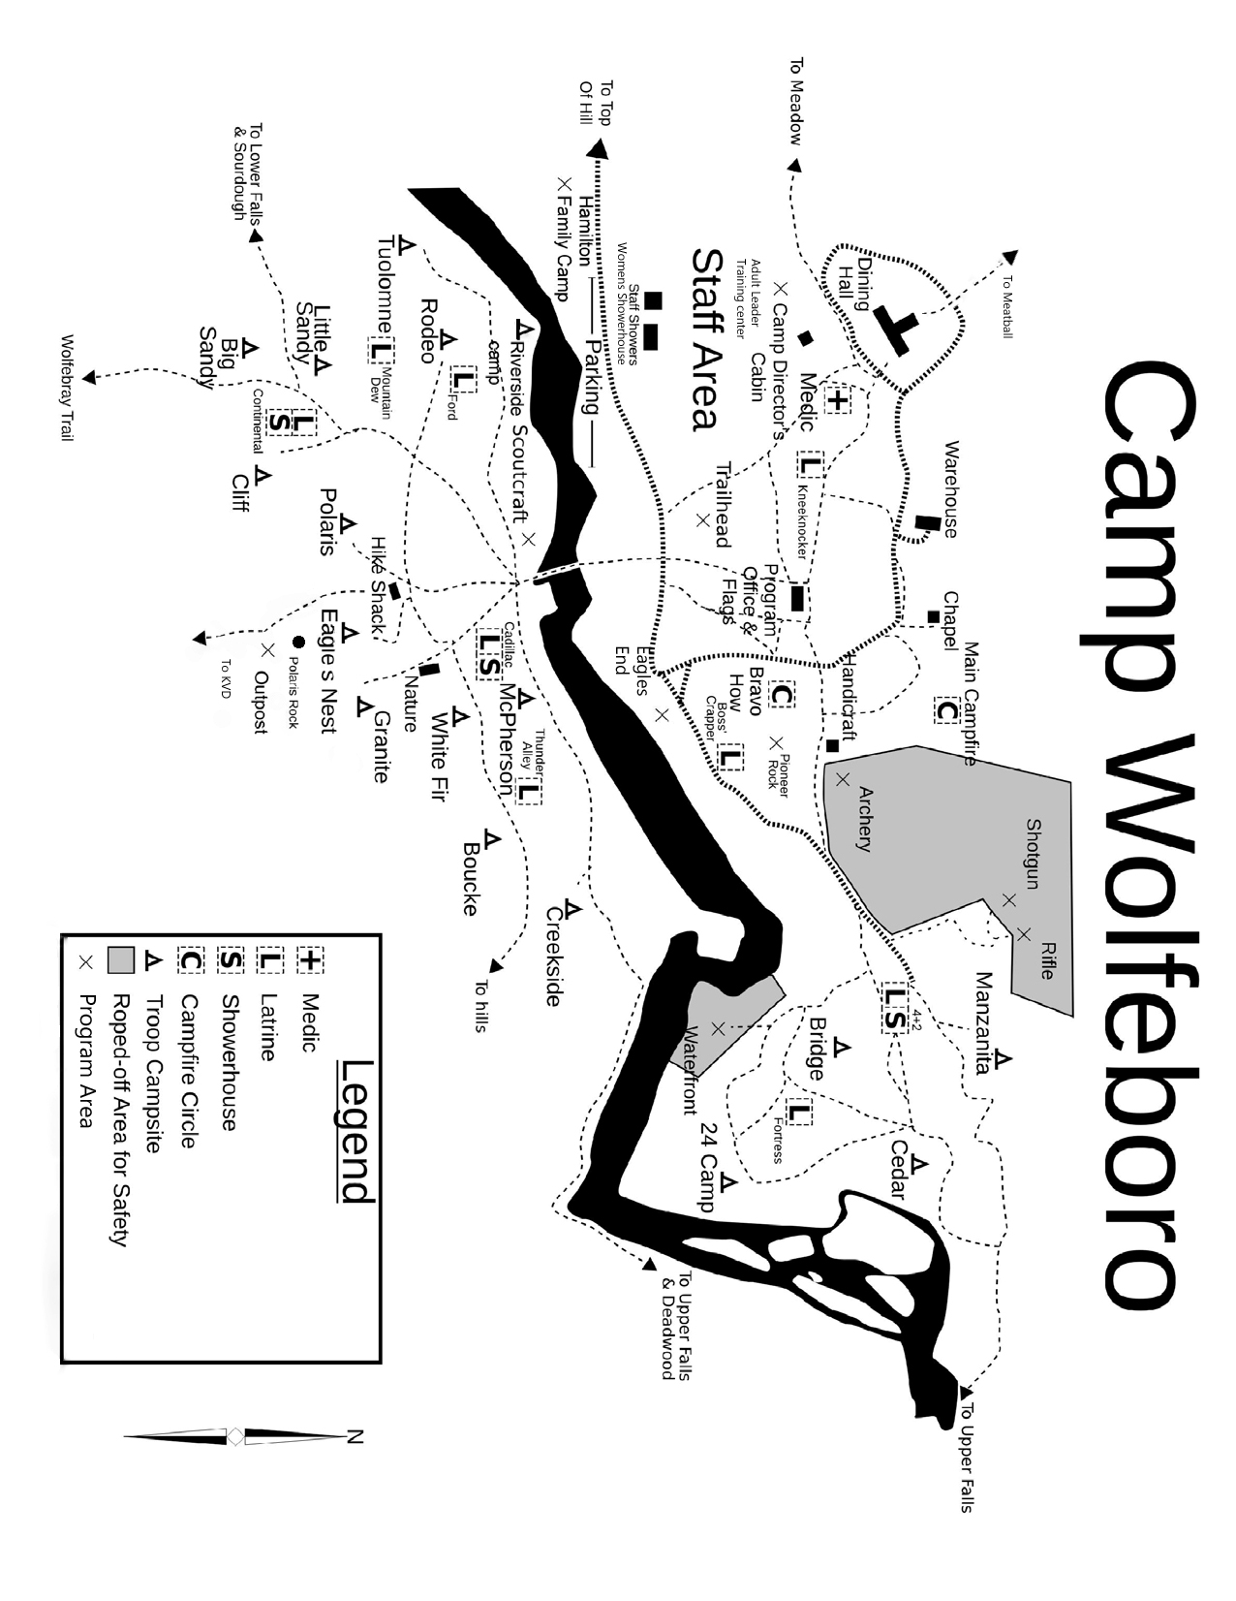

\

Directions to Camp Wolfeboro

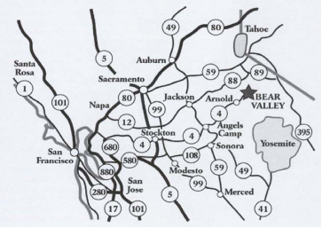
Camp Wolfeboro is located on Forest Service Road 7N02 off of Highway 4 about 0.2 miles east of Big Meadows Campground and 2 miles west of Tamarack.

If you coming from the East on Highway 4, you will pass Bear Valley Village and eventually the town of Tamarack. As you near Skyline Drive on your right, you will see Forest Service Road 7N02 on your left about 0.25 miles from there.

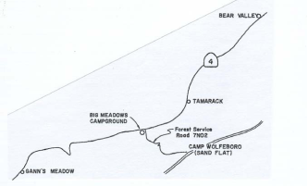

If you are coming from the West on Highway 4, as soon as you see Big Meadows Campground sign on your right you want to start slowing down as the turn off for Forest Service Road 7N02 is 0.2 miles ahead on the right and is easy to pass.

From the Bay Area, there are many ways to get to camp on Highway 4. Most routes will eventually take you through the intersection of Highways 49 and 4, which is located at Angels Camp and is about 40 miles from Wolfeboro.

You should consult some form of GPS service to determine the best route from your location.

Once you turn onto Forest Service Road 7N02, you will need to cross a small stream and continue about 100 yards to a dirt parking area unless you drive all the way down the VERY rough road into camp which is about 2 more miles.

Webelos Resident Camp Leaders’ Meeting

Please join the Wolfeboro Staff and Management for a meeting to hear about the Camp program and have your questions answered.

WHEN: Wednesday, June 26, 2019
7:00PM

WHERE: Mt. Diablo Silverado Council Office
800 Ellinwood Way
Pleasant Hill, CA

For more information contact:

Joe Barton joe.barton@scouting.org or (925) 674-6172

