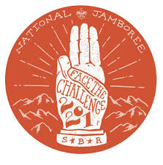
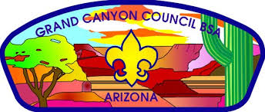
GRAND CANYON COUNCIL
2021 NATIONAL JAMBOREE
SCOUTMASTER – APPLICATION

Please FAX (480-240-979) completed application or email to ??? or mail to Council Office
PERSONAL INFORMATION
Name: ___________________________________
Home Address: ______________________________________________________________________________
Telephone (____) ____ - ___________ Email _____________________________@___________________

PRIOR NATIONAL JAMBOREE EXPERIENCE (Please list all prior National Jamboree experience)

SCOUTING EXPERIENCE (Please list all current and prior positions held in the Scouting organization with dates)

REASON FOR VOLUNTEERING FOR 2021 NATIONAL JAMBOREE

SCOUTING TRAINING (Please list ALL Scout Training completed with dates – including Wood Badge)

SCOUTING RECOGNITION (Please list ALL awards and Scouting Recognition with dates)

