18 Sep 2020

From: Asia Central District 2020 Fall Camporee Staff

To: 2020 Fall Camporee Participants

Subj: ASIA CENTRAL DISTRICT FALL CAMPOREE ABOARD JWTC, 9-12 OCTOBER 2020

Encls: 1. Unit Roster

2. Marine Corps Hold Harmless Agreement

3. Camporee Campsite Inspection Form

1. Situation: From 9-12 October 2020, Asia Central District will host the Fall Camporee aboard the Jungle Warfare Training Center (JWTC), Camp Gonzalves, Okinawa Japan to allow Scouts to learn and improve outdoor skills and patrol teamwork. This year’s Camporee has a Young Indiana Jones adventure theme (after all, he was a Life Scout in one of his movies!). Bring your Scout Spirit, and join Young Indy as he learns and competes in adventurous feats of outdoor skill and intellect throughout the Fall Camporee!

2. Concept of Operation: The Fall Camporee will be Scout-led and Scouter supervised. Each unit is responsible for ensuring each Scout is prepared with individual and patrol equipment and for transportation to and from JWTC. Units will arrive at Camp Gonsalves on Friday, October 9 at or around 1700 for check-in, and set up their campsites in Bivouac Area 3. At approximately 2000, JWTC staff will provide all Scouts with an orientation and safety brief of the facilities. The remainder of the evening is for Patrol Leaders and Senior Patrol Leaders to organize their patrols, eat meals, and prepare for the following day.

Scouts are expected to use the Patrol-Method throughout the Camporee’s main events on 10 and 11 October. The first day of events, on 10 October, will consist of 4 stations that patrols will rotate through with a focus on *learning* the skills taught at each station. These stations will be instructed by JWTC staff and Troop 110 leaders (air rifle). The next day, 11 October, will consist of the same stations, but patrols will now *compete* against each other (Scout Spirit and teamwork will be considered in grading). Webelos Scouts will only participate in Saturday’s events, and will integrate into older Scout patrols.

Following all activities, respective Senior Patrol Leaders are responsible for ensuring all organizational equipment is packed and the areas are clean. Scouters from each troop will arrange for transportation from JWTC.

3. Coordinating Instructions:

“Young Indy” Themed Character:

Should you choose to participate, you can compete in the contest for the best-themed Young Indy (or another character from one of the Indiana Jones movies) in camp. Costume contest will be judged during Saturday night’s campfire.

“Young Indy’s” Golden Spoon:

Scouts only, no adult help please. It’s widely known that Young Indy was an accomplished chef in camp culinary arts. Show off your own camp culinary skills during the “Young Indy” Golden Spoon judging contest. Patrols and individual Scouts wishing to participate should prepare a plated dinner or dessert for judging during Saturday's designated dinner period. Recognition will take place during Saturday’s campfire program.

Best Campsite Spirit:

During Campsite Inspections, units can be awarded spirit points for having the best Indiana Jones-themed campsites. Unit campsite inspections will take place on both Saturday and Sunday, with recognition during Sunday’s campfire program.

Scout Spirit:

Scout Spirit is judged based on adherence to the twelve points of the Scout Law, and participation in the Indiana Jones theme. Recognition will take place during Sunday’s campfire program.

COVID-19:

To reduce COVID-19 risk, all participants will exercise social distancing, wear face masks, exercise good hygiene, and sleep one person per tent (unless family).

The Asia Central District Fall Camporee will be cancelled if COVID-19 HPCON Charlie is in effect. If cancelled, refunds will be issued, minus the cost of the Fall Camporee patch (participants will still receive), and the nominal fee charged to the council by the website vendor.

Buddy System:

All participants are expected to be in the socially-distanced presence of a buddy at all times. This is mandatory outside of the designated bivouac area, and at night.

Wildlife:

All JWTC wildlife is truly wild. DO NOT attempt to approach or play with any animal.

1. Safety:

|  |  |  |
| --- | --- | --- |
|  | Day | Night |
| OIC | LtCol Sven Jensen | SSgt Andrew Laudun |
| RSO | SSgt Andrew Laudun | Maj Jeffrey Planteen and Maj Garrett Mulder |
| Medical Officer | CDR Peter Cole | CDR Peter Cole |
| Safety Vehicle | JWTC provided Ambulance | JWTC provided Ambulance |
| Cliff Safety Corpsman | JWTC provided | JWTC provided |

Adult Scout leaders can expect to be assigned to partner with JWTC staff in supervising Scouts during the 10 Oct Learning Day and 11 Oct Competition Day.

Basic first aid for minor cuts, scrapes or insect bites will be provided by each Patrol/Troop. For more acute care requiring medical attention, Dr. Cole will assess and recommend treatment. In the case Scouts must be non-emergency evacuated from JWTC for follow on care, each Troop will designate a care-giver and driver to provide transportation to a hospital or Military Treatment Facility.

Emergency medical care will be provided by JWTC on-call medical capabilities. JWTC staff will provide activity-specific medical coverage for higher risk activities such as the rappelling wall. JWTC staff will ensure backboard, C-Collars and other activity-specific medical requirements are available.

To reduce Leptospirosis risk, no JWTC water activities will be conducted. However, Leptospirosis remains a risk for Okinawa.

JEV vaccination is encouraged for all participants, along with the use of insect repellent to reduce mosquito exposure.

Risk Mitigation: JWTC is an isolated jungle area used for military training. There are no medical treatment facilities close to the area so continuous risk mitigation at all levels is critical to the safe conduct of the campout. The following risk factors and mitigation actions will be followed.

|  |  |  |  |
| --- | --- | --- | --- |
| **Risk** | **Description** | **Mitigation** | **Supervision** |
| Heat Casualty | Dehydration due to hot humid conditions and physical exertion | -Each participant will have water at all times  -Hats & sunscreen will be worn  -Loose cool clothing  -Adjust activity to conditions  -Maintain awareness of heat conditions (flags)  -Safety Brief to include heat injury signs and treatment | SPL  SM  RSO |
| Falling | During rappelling, the risk of losing control of descent or falling | -Safety brief  -Helmets and gloves  -Hair tied up when rappelling  -Pre-activity instruction and rehearsals  -Qualified belay with supervision | Scouter  JWTC staff |
| Snake Bite | As it becomes warmer, snakes, including Habu, will be more prevalent | -Safety brief  -Buddy System  -On site medical care | SPL  SM  RSO |

B. Schedule of Events / Timeline

|  |  |  |  |
| --- | --- | --- | --- |
| **Date/Time** | **Event** | **Location** | **Remarks** |
| **9 Oct** |  |  |  |
| 1700 | Arrive JWTC | Bivouac Area 3 |  |
| 1700-2000 | Camp Set Up | BA3 | SPLs lead |
| 2000-2100 | Scout Master Huddle/JWTC Orientation | BA3 | Scoutmasters, JWTC Staff, Camp Staff, SPLs |
| 2200 | Lights out | BA3 |  |
|  |  |  |  |
| **10 Oct** | **Learning Day** |  |  |
| 0600 | Reveille | BA3 | SPLs |
| 0600-0700 | Breakfast / Pack | BA3 | SPLs |
| 0600-0700 | Webelos Check-In | BA3 | Camp Staff and SPLs |
| 0700-0730 | Morning Flag Ceremony, Safety Brief, and Instruction | BA3 | Scouts/JWTC Staff, Camp Staff |
| 0730-0745 | Transition |  |  |
| 0745-0945 | 1st Round of Instruction  Group 1: Rappelling  Group 2: Pioneering/Jungle Survival  Group 3: First Aid/Air Rifles  Group 4: Orienteering/Obstacle Course |  | JWTC Staff |
| 0945-1000 | Transition |  |  |
| 1000-1200 | 2nd Round of Instruction  Group 1: Pioneering/Jungle Survival  Group 2: First Aid/Air Rifles  Group 3: Orienteering/Obstacle Course  Group 4: Rappelling |  | JWTC Staff |
| 1200-1215 | Transition |  |  |
| 1215-1415 | 3rd Round of Instruction  Group 1: First Aid/Air Rifles  Group 2: Orienteering/Obstacle Course  Group 3: Rappelling  Group 4: Pioneering/Jungle Survival |  | JWTC Staff |
| 1415-1430 | Transition |  |  |
| 1430-1630 | 4th Round of Instruction  Group 1: Orienteering/Obstacle Course  Group 2: Rappelling  Group 3: Pioneering/Jungle Survival  Group 4: First Aid/Air Rifles |  | JWTC Staff |
| 1630-1800 | Transition/Meal Prep |  |  |
| 1800-2000 | Dinner & Young Indy Golden Spoon judging |  |  |
| 2000-2200 | Camp Fire, Young Indy Golden Spoon recognition, Veteran Appreciation fireside chat |  | Camp Staff & designated units |
| 2200 | Lights Out |  |  |
|  |  |  |  |
| **11 Oct** | **Competition Day** |  |  |
| 0600 | Reveille | BA3 | SPLs |
| 0600-0700 | Breakfast / Pack | BA3 | SPLs |
| 0700-0730 | Scout’s Own church service | BA3 | Camp Staff |
| 0730-0800 | Morning Flag Ceremony, Safety Brief, and Instruction | BA3 | Scouts/JWTC Staff |
| 0800-0815 | Transition |  |  |
| 0815-1015 | 1st Round of Competition  Group 1: Rappelling  Group 2: Pioneering/Jungle Survival  Group 3: First Aid/Air Rifles  Group 4: Orienteering/Obstacle Course |  | JWTC Staff |
| 1015-1030 | Transition |  |  |
| 1030-1230 | 2nd Round of Competition  Group 1: Pioneering/Jungle Survival  Group 2: First Aid/Air Rifles  Group 3: Orienteering/Obstacle Course  Group 4: Rappelling |  | JWTC Staff |
| 1230-1245 | Transition |  |  |
| 1245-1445 | 3rd Round of Competition  Group 1: First Aid/Air Rifles  Group 2: Orienteering/Obstacle Course  Group 3: Rappelling  Group 4: Pioneering/Jungle Survival |  | JWTC Staff |
| 1445-1500 | Transition |  |  |
| 1500-1700 | 4th Round of Competition  Group 1: Orienteering/Obstacle Course  Group 2: Rappelling  Group 3: Pioneering/Jungle Survival  Group 4: First Aid/Air Rifles |  | JWTC Staff |
| 1700-1800 | Transition/Meal Prep |  |  |
| 1800-2000 | Dinner |  |  |
| 2000-2200 | Camp Fire, Patrol Competition, Scout Spirit, Campsite Spirit Recognition, Veteran Appreciation Fireside Chat & Closing Ceremony |  | Camp Staff & designated units |
| 2200 | Lights Out |  |  |
|  |  |  |  |
| **12 Oct** |  |  |  |
| 0600 | Reveille | BA3 | SPLs |
| 0600-0800 | Breakfast | BA3 | SPLs |
| 0800-1100 | Clean up/Pack out |  |  |

Locations:

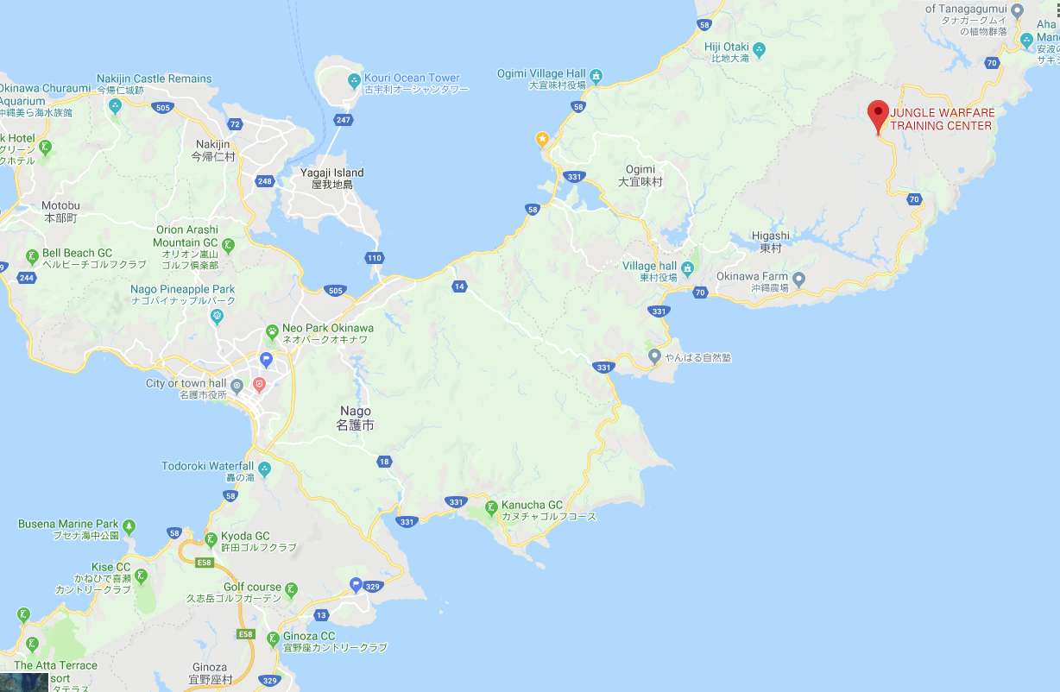

Jungle Warfare Training Center. Higashi, Kunigami

4. Administration and Logistics

A. Administration

1. Hold Harmless Agreement must be submitted to below POC NLT 24 Sept.
2. Check-in Procedures
   1. Regular check-in is at 1700 on Friday, 9 October at designated Bivouac Area parking. Webelos Scout units will follow the same process on Saturday morning between 0600-0700. After driving to the parking area, have your unit leader and senior Scout (SPL) check-in. Please wait until your unit has received its check-in packet before unloading and proceeding to your campsite.
   2. Check-in will include verifying the following information:
      1. Unit verification against the Asia Central District payment roster. Final payment must be made by the 23 Sept 2020 online registration deadline to be included on the District roster.
      2. Inspection of BSA Medical forms (Parts A and B) for each Scout and adult Scouter. (Unit leaders will keep these, in case of emergency.) Forms can be downloaded at <https://filestore.scouting.org/filestore/HealthSafety/pdf/680-001_AB.pdf>.
      3. Hard-copy submission of completed Unit Roster for personnel accountability and emergency use.
      4. Scout unit submission of completed Marine Corps Hold Harmless Agreement for each participant by 23 Sept 2020 to point of contact listed below.

B. Logistics

1. Chow: Patrols are responsible for their own meals.
2. Lunch: Scouts should pack their own lunch to eat while rotating through stations.
3. Water: Potable water will be located at BA3 and the cliff. Patrols will bring water jugs for group use. Individuals will bring not less than 1 X one-quart water bottle.
4. Facilities: Port-a-Johns will be available at the campsite area.
5. No open fires in campsites. Charcoal = OK.
6. Transportation: Units are responsible for providing transportation to and from JWTC for all participants. Parking is limited, so carpooling is encouraged.
7. Clothing: JWTC is a rugged back-country environment. All participants are required to wear close-toed shoes suitable for hiking, climbing and walking in the dense jungle. Open toed shoes are not permitted. All participants are also required to wear long pants, a hat, and sunscreen, and carry adequate drinking water. Long sleeve shirts are highly recommended. Long hair should be tied up.
8. Trash guidance: units welcome to discard refuse at JWTC only if, clear plastic bags are used, trash is sorted properly and plastic and metal is recycled.
9. Equipment:

**Unit:**

American, Unit & Patrol flags

Dining Fly

Tents

Cookware and clean up items

Unit First Aid Kit

Toilet paper & COVID hygiene gear

Poles and rope to equip the pioneering station

**Individual:**

|  |  |  |
| --- | --- | --- |
| * Class B activity uniform/Change of clothing | * Leather Gloves | * First Aid Kit |
| * Sun hat | * Sleeping bag | * Fire starting kit |
| * Close toe shoes & long pants | * Orienteering Compass | * Personal Hygiene (incl toilet paper) |
| * Rain gear | * Mess Kit | * Good Attitude |
| * Bug Spray | * Flashlight |  |
| * Sunscreen | * Scout Handbook |  |
| * Lip balm | * Note taking material |  |
| * COVID face mask & hand sanitizer | * Water bottles |  |

5. Communications:

POC: Garrett Mulder, 080 4093 4048, [garrettmulder@gmail.com](mailto:garrettmulder@gmail.com)

**Unit Roster**

Unit #: **______**

Total Scouts: **______**

Total Scouters (adults): **______**

Unit Leader (adult): **_____________**

Senior Patrol Leader/Crew President: **_____________**

|  |  |  |
| --- | --- | --- |
| Adults: | Scouts: | Scouts: |
|  |  |  |
|  |  |  |
|  |  |  |
|  |  |  |
|  |  |  |
|  |  |  |
|  |  |  |
|  |  |  |
|  |  |  |
|  |  |  |

Use multiple pages as needed

Encl (1)

BO 3500.1D

7 JAN 2013

APPENDIX I RELEASE FROM LIABILITY/HOLD HARMLESS AGREEMENT

ASSUMPTION OF RISK-USE OF RANGE/TRAINING AREA

This is a voluntary release of liability and complete assumption of risk. I,

(print parent/guardian name) , agree that I will release, indemnify, defend and hold harmless the United States Government, the United States Marine Corps, Marine Corps Base Camp Butler (here-in-after “MCBB”) and its officers, employees, agents, personnel, successors (here-inafter “the government”) and assigns from and against any and all claims,damages, liabilities, losses, injuries, death, and cost and expenses including attorney fees, costs of suits, and deductible amounts for claims made against my insurance, arising out of or claimed on account of my

involvement whatsoever resulting from my presence on MCBB, or my involvement

in activities aboard MCBB.

This release applies to myself, and to my parents, spouse, children,

guardian, executors, future heirs, assigns, creditors and administrators.

This release of liability includes, but is not limited to claims based on

negligence, both passive and active, of the government arising out of, or

relating to any loss, damage, illness, death, or injury that may be sustained

while on MCBB. This release also applies to all dangers inherently involved

in the activities in which I desire to participate. I understand that the

risks involved in these activities include, but are not limited to, risks

resulting from firearms, projectiles, other equipment, terrain, my personal

physical condition, vehicles, other participants and lack of hydration. I am

specifically entering MCBB to participate in a Range/Training Area Event, an

inherently dangerous activity for which I am aware of and understand the

associated risks.

Other known risks aboard military installations include, but are not limited

to: (1) Injuries or death resulting from strenuous activities. (2) Injuries

or death resulting from recreational activities. (3) High volumes of traffic

by civilian and military vehicles. (4) Interactions with animals, both wild

and domestic. (5) Significant distances from recreational areas to medical

treatment facilities or hospitals. (6) Potentially hazardous training

activities, including but not limited to, range firing, aircraft operations,

watercraft operations, and field maneuvers. and (7) Hazards inherent to

firing weapons, including but not limited to, being wounded by errant

projectiles, being injured by target apparatus, and exploding ammunition or

weapons.

I hereby authorize emergency medical treatment in the event of injury or

illness. I also authorize trained health care providers, including, but not

limited to physicians, nurses, nurse practitioners, emergency medical

technicians and hospital corpsmen, to administer routine and/or emergency

medicines and treatments, as needed.

This release shall remain in effect for one (1) year from the date of

signature, unless rescinded in formal writing by the government or the

releaser.

BO 3500.1D

7 JAN 2013

I further agree to give the government prompt written notice of any claim or

suit possibly coming within the scope of the indemnity provided for by this

agreement. Such notice will be promptly delivered to the Civil Law Section,

Joint Law Center, MCBB. Upon written request of an indemnitee, the

indemnitor will assume the defense of any such claim, demand, action, or

proceeding as soon as practicable. If the government declines to provide the

said support, this agreement shall be null and void. If any such support is

provided by the government, this agreement shall remain in full force and

effect.

I further state that I, (print parent/guardian name) , have carefully read the foregoing release, know the contents thereof, and sign this release as my own free act, on behalf of myself and/or my child or children for whom I am authorized to act as legal guardian.

Date (YYMMDD) Signature

Phone number:

Range Safety Officer: (print name) ___________________________

Range Safety Officer: (signature) ____________________________

Encl (2)

**Camporee Campsite Inspection**

Unit # ________ Score Total ________

|  |
| --- |
| **Common Area of Camp**  Campsite easily identified (Unit banner or sign) 15 ________  U.S./ Unit Flags properly displayed 10 ________  Camp entrance clearly visible 15 ________  Perimeter of camp clearly visible (rope or other buffer) 10 ________  Bulletin Board, Activity Schedule, Fire Warden Chart, & Roster  visibly posted. COVID-19 mitigation measures clearly displayed. 25 ________  Fire prevention – fire ring, water and shovel 10 ________  Camp equipment stored properly 10 ________  Camp area clean and trash free 15 ________  Designated litter control visible 10 ________  First Aid Kit stocked and visible 20 ________  Drinking Water available and visible 20 ________  “Wow Factor” (Indiana Jones-themed campsite; no weapons!) 25 ________  **Camping/Sleeping Area**  Tents set up in orderly fashion (1 camper per tent, unless family) 10 ________  Fire buckets filled and ready 15 ________ |

Inspected By: **_____________________**

Encl (3)