**Asia West District Korea Finals**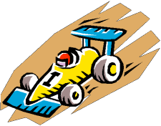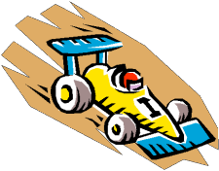

**Pinewood Derby Rules and Event Information**

**\*\*\*Race Track Info\*\*\***

* The Races will be run on two separate tracks simultaneously. Cars will be raced and placed by an electronic scoring system. Each race group has multiple heats, determined by the number of derby cars racing. Each car will race in each lane of the tract it is racing on.
* During a race heat, the derby car will race one time in a lane it has not raced before. The racing program will rotate the derby car, for the next race heat, to another lane. The derby car will have raced three or four times depending on the number lanes in the track.
* The finale race time is determined by taking the total time of the heats (based on track lane size) a derby car has completed, with the lowest time winning. (Fastest Overall Car).

**Derby Eligibility:**

1. The AWD Korea Finals are open to all registered Cub Scouts in AWD.
2. **Each Pack in Korea can send up to 18 cars to participate in the race, the first, second and third place winner from each Den in their Pack.** (3 Lions, 3 Tigers, 3 Wolves, 3 Bears, 3 WEBELOS, 3 AOL). Each Pack may also designate one alternate per division.
3. Scouts who raced with their Pack as AOL’s but crossed over to Scouts BSA prior to the AWD Finals are still eligible to participate.
4. **Pre-Registration must be completed on the District websites via BlackPug prior to the registration deadline of March 28th. Cars who do not register online will not be eligible to race.**
5. **All cars must pass inspection and weigh-in on race day.**

I**nspection:**

1. Each car must pass an official inspection before it may compete. The inspector(s) have the right to disqualify those cars which do not meet the rules and specifications outlined.
2. If a car does not pass inspection, the owner will be informed of the reason for failure and will be allowed to make adjustments in the remaining official registration time period.

**Impounding Car:**

1. Cars should be impounded by Pack leaders after the completion of the Pack level derby until registration at the District Derby.
2. At the registration event, after registration, inspection and weigh-in, the car will be impounded. Scouts and parents will not be allowed access to cars until the end of the event.
3. **EXCEPTION:** Race officials may authorize repairs when damage is caused by collision with another vehicle or object. Repairs must be completed within five (5) minutes. Only runners and race officials will touch the cars after they have been registered and impounded.

**Materials:**

1. **All cars must be built** from the **Official BSA Grand Prix Pinewood Derby Kit** (referred to

below as **the kit**) as issued or bought from the Pack, sold by the Far East Scout Shop, [www.scoutstuff.org,](http://www.scoutstuff.org/)  or purchased elsewhere as long as they are the exact same type.

1. **Absolutely NO premade cars will be permitted to race!** All registered cars MUST be made from the kits that have been provided. A Scout (and his Parent/Guardian) is Trustworthy. 
2. Only cars constructed for the 2024 Derby can be entered into the race, cars constructed in a previous year cannot be used.

**Added Items**

1. Details such as steering wheel, a driver, and decals are permissible, as long as these details do not exceed width, length, height, clearance, and weight specifications. All details must be securely attached to the car.

**Gravity Powered**

1. **All cars must be freewheeling with no starting devices**. Magnets and slip weights are prohibited.

**Weight:**

1. **Race cars may weigh no more than five (5) ounces (total weight)** as determined on the official scales during race day inspection. Depending on the official scale used by the District, will go to one or two (1 or 2) place(s) after the decimal point (example 5.0 or 5.00). This will be determined by the Head Racing Official on Race Day.
2. Weight may be added to the car. All weights must be securely fastened to the car.

**Wheels and Axels:**

1. **Only official current Cub Scout Grand Prix Pinewood Derby wheels and axles are permitted. (See Detail Pictures and Notes)** 
2. You may not change wheel dimensions. Wheels may not be rounded, pointed, concaved, shaved, beveled or otherwise modified. You may, however, sand/polish the tread or tire contact area of the wheel to smooth rough spots.
3. Wheel bearings, washers, and bushings are prohibited. The car will not ride on springs of any type. Wheel covers or hub caps are prohibited, the head of the nail axle must be viewable for inspection.
4. The axles (nails) maybe polished and stamping imperfections removed, but the shape and size of the head may not be altered.
5. The axel dimensions may not be changed.
6. The outside surface of the axel head may not be changed substantially.
7. The axel nails shall be firmly affixed to the body.
8. Modified or special wheels are prohibited
9. Wheels may not be glued in unless necessary for proper function of the car due to breaking of the wood.
10. **All 4 wheels must touch the track or be reasonably close as determined by the head judge.**

**Technical Standards:**

The inspection judges during check-in are responsible to evaluate each car's adherence to the technical standards. Their decision may be appealed to the inspection official, head race official and the Pinewood Derby Committee, who, after consultation with the inspection team, the Scout, and his parent/assistant, shall render a final, binding decision.

**Measurements**:

* Your racer must be no Longer than 7”.
* Your racer cannot be wider than 2 ¾”.
* Your racer must have 3/8” or more clearance between the race track surface and the bottom of the racer.
* All 4 Wheels must touch the track or reasonably close as determined by the head judge.
* **Nose Height -** The cars will rest against a starting pin; therefore it is advisable that they do not come to a sharp point in front. It is recommended the front end **should not be any higher than 3/4” (0.75) inch is recommended above the axle line.** This way the car will run on the racetrack and trigger the finish line electronics. (Adequate clearance is the responsibility of the race car builder.)
* **Wheel base-** You may drill new axel holes BUT you MAY NOT extend the wheel base. The wheel base distance between the front and rear axels may not be changed from 4 5/16inches.
* **Indented Front Ends:** Cars with indented front ends are **not allowed**. Cars like the one below will "stage" further down the track, and thus are not traversing the same course as other cars.



**Lubricants:**

1. Only dry powdered lubricants, such as graphite or white powder Pinewood Derby Car Lubricant, may be used. Oils and silicone sprays are prohibited.
2. Cars will be lubricated before the first race and before the Championship race, if the car qualifies.

**Staging:** The entire car must stage behind the starting pin.

**Body:** The car body may have no moving parts. These are parts that can affect the travel of the vehicle (moving weights to give the cars a boost).

**Conduct of the Races:**

The District Pinewood Derby Officials are responsible for proper conduct of the race. Decisions of the Officials regarding the rules interpretation and procedure may be appealed to the Head Racing Official and District Pinewood Derby Committee. Scouts **AND PARENTS** should also be familiar with the rules.

**Inspection Gauges:** All inspection will be conducted by one team at a special inspection area using scales and gauges approved by the District Pinewood Derby Committee. Any adjustments to the cars if necessary can be made at the pit area.

**Impounding:** Once the car has passed inspection and received its number, the car will be handed off to a runner who will place it on the table provided.

**Car Handling Responsibility:** Runners shall be responsible for staging the cars at the starting line, retrieving the cars at the finish line (after the race has been called) and returning the cars to the table area after each heat.

**Lane Assignment:** Lane assignment for each heat shall be determined by the racing program. Scouts will be grouped by the Hosting Pack racing program to assure the Scouts car will have one race in each of the lanes provided.

**Car Repair:** If, during the race, a wheel falls off or the car becomes otherwise damaged, the **SCOUT AND PARENT** may, to the best of their ability, perform repairs. The scout parent team may seek advice for repairing the car, but may receive no other assistance. The scout parent team will have 5 minutes to complete repairs. If a car is damaged due to track fault or due to fault of another car or scout, then the track official, at his sole discretion, may allow additional repair assistance.

**Car Interference:** If, during a race heat, a car leaves its lane and, in so doing, interferes with another racer, the cars will be reset and raced again. If a particular car jumps the track a second time without being interfered with, that car the car that leaves the lane will have the slowest time added to account for averaging done by the Hosting Pack racing program.

**Car Leaves Lane:** If, during a race heat, a car leaves its lane but proceeds down the track in a manner that does not interfere with its opponents, the car that leaves the lane will have the slowest time added to account for averaging done by the Hosting Pack racing program.

**Car Leaves Track:** If, during a race heat, a car leaves the track without interfering with its opponent, it shall be considered to have ended its heat at that point. The racers slowest time will be added to account for averaging done by the Hosting Pack racing program.

**Track Fault:** If a car leaves its lane, at his sole discretion, the track official may inspect the track and, if a track fault is found which probably caused the initial violation, the track official may order the race heat to be rerun after the track is repaired.

**No Finishers:** If, during a race heat, no car reaches the finish line on the track, the car which went the farthest in its lane shall be declared as the heat winner. The racers slowest time will be entered for that race to account for averaging by the Hosting Pack racing program.

**Call to Race:** Competitor cars will be called to race, as selected by the Hosting Pack racing program. The track officials will receive car numbers racing in the heat generated by the Hosting Pack racing program and will be verified by the track runners.

**Conduct:**Unsportsmanlike conduct by an adult or scout will result in immediate disqualification. Mask wear is required inside the facility at all times.

**COVID Guidelines**: Every person entering the building will be asked to sign in by scanning a QR code for contact tracing. Failure to adhere to USFK COVID guidelines will result in removal from the facility. Be prepared to follow additional COVID mitigation measures.

**Appeals / Disputes:** The Cub Scout, along with their parent / guardian, must pose all questions of rules interpretations, procedure and fact to the Track Official or Head Racing Official promptly. A station at the track area will be designated for this purpose.

**ALL DECISIONS BY THE RACE OFFICIALS ARE FINAL**

Questions: Email AW District Executive Amanda Nguyen at Amanda.nguyen@scouting.org

Or AW District Chairman Lorraine Horton AWDChair@gmail.com

Remember the Cub Scout Motto

DO YOUR BEST

PICTURES & NOTES

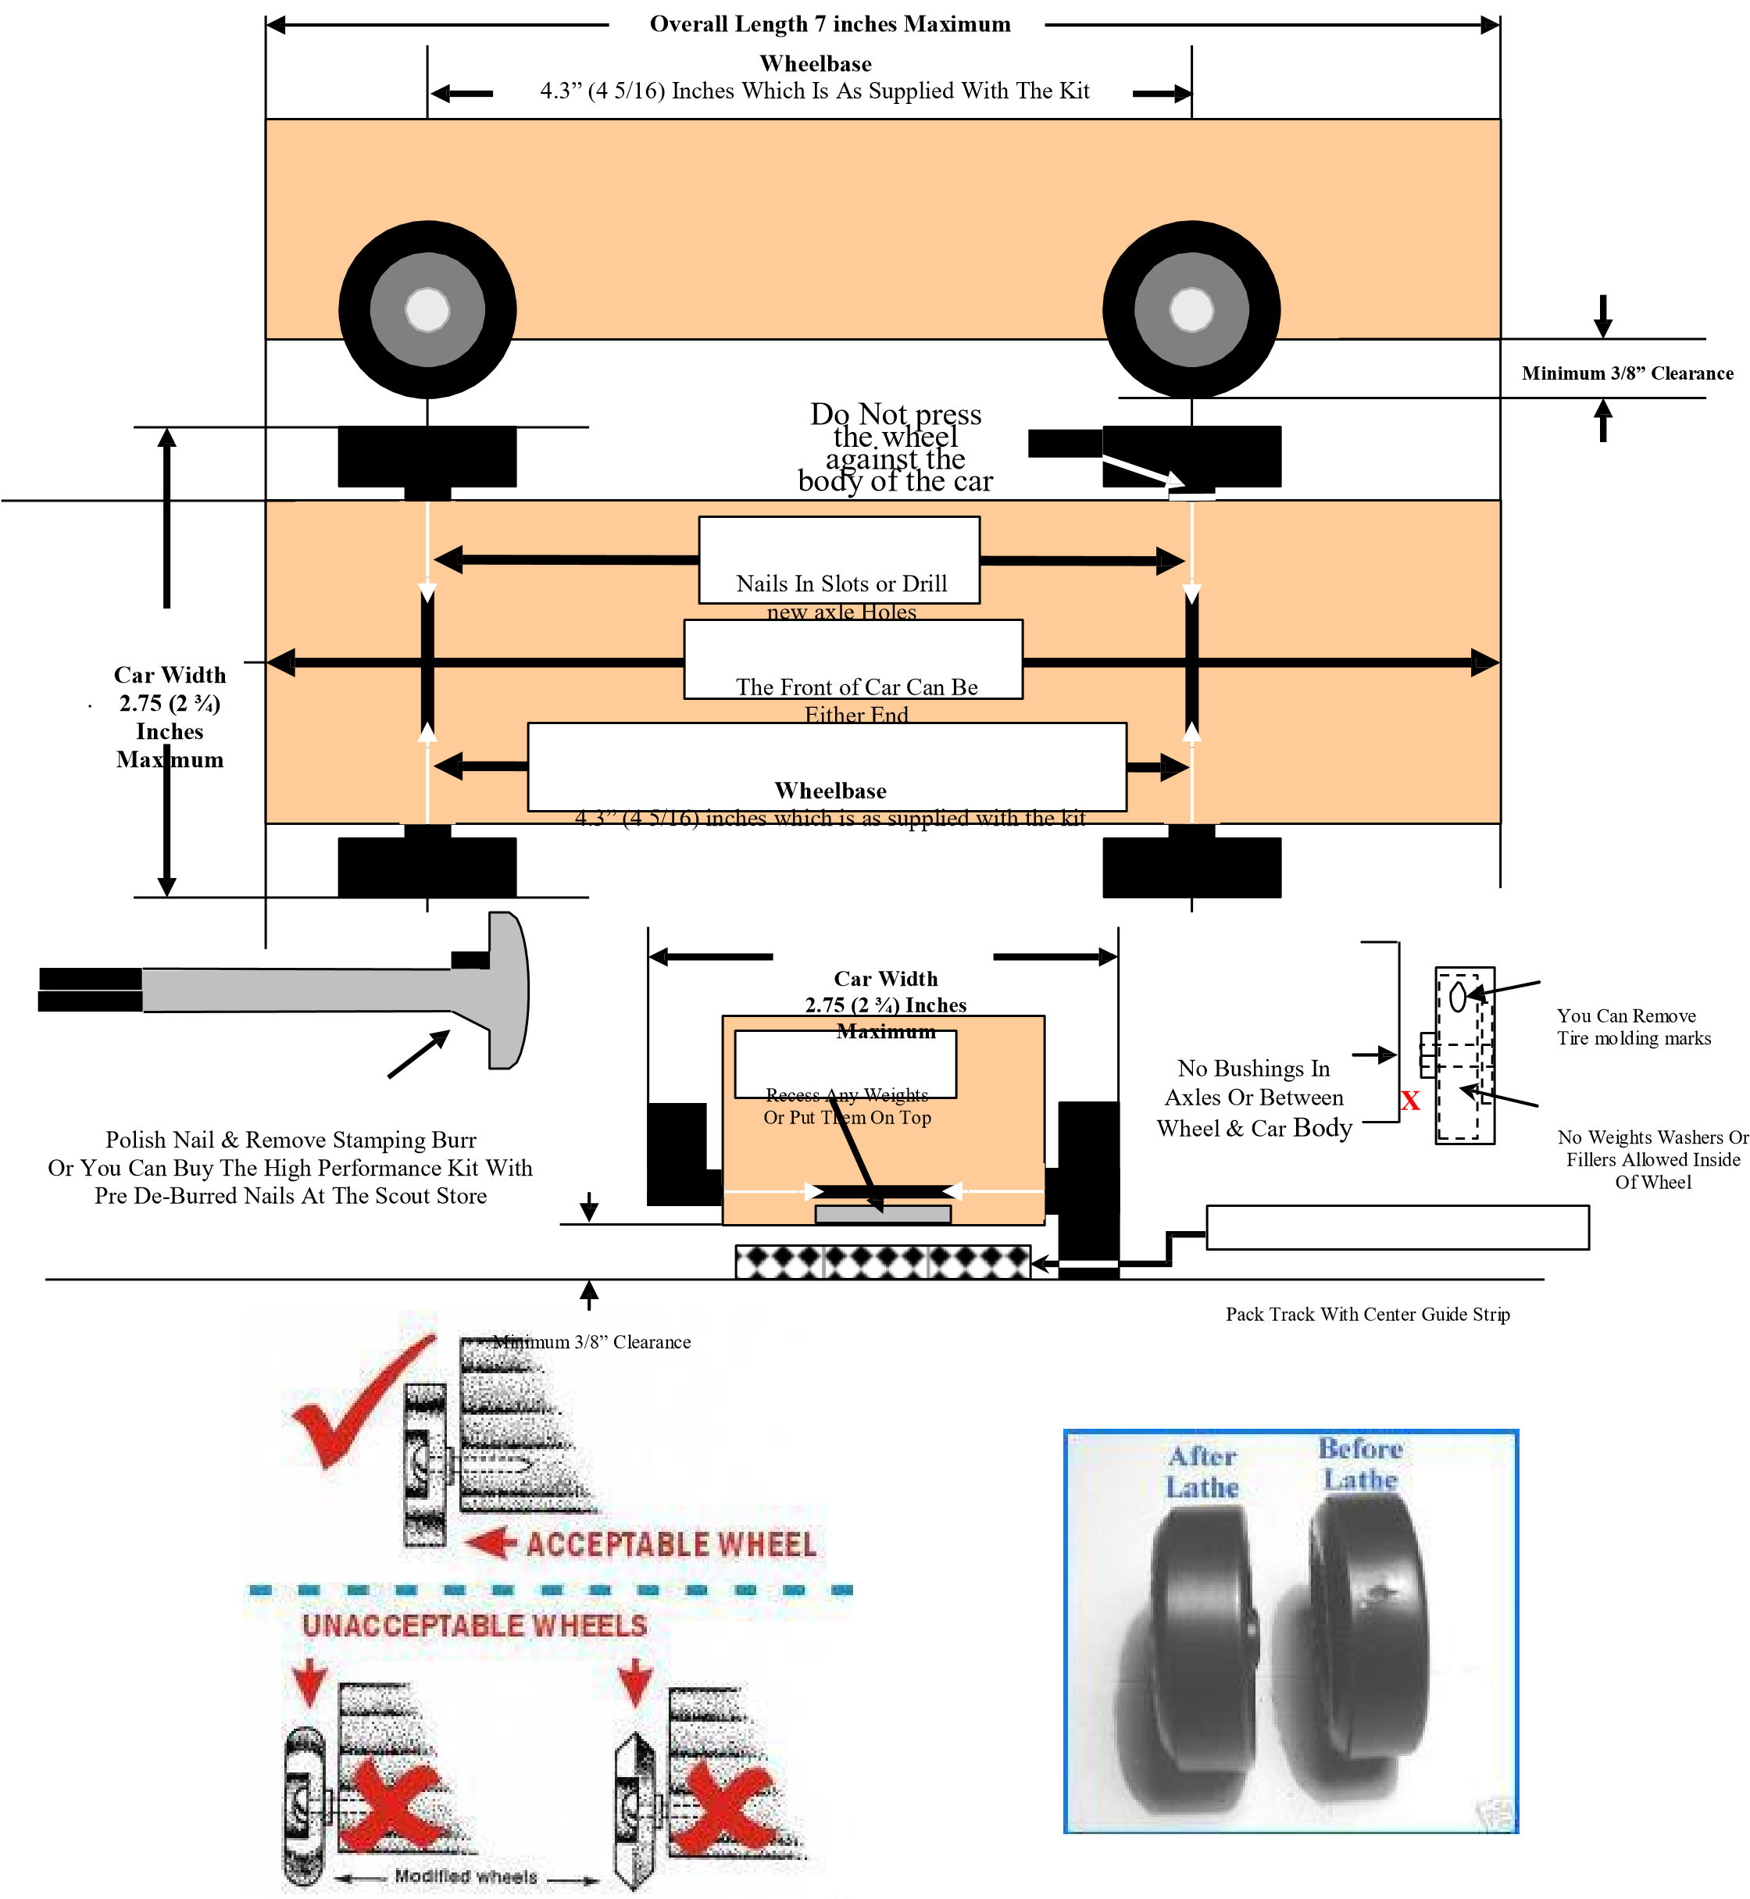

*Wheels may be sanded or lathed to remove imperfections and flattened.*

*Wheels may not be reshaped or altered.*

**A Sampling of Disqualifying / Altered Wheels**



*Wheels will be inspected for lettering; raised lettering may not be sanded off.*

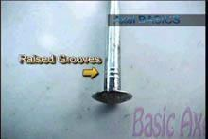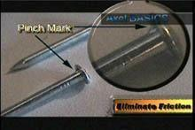

*Axle imperfections can*  *be removed and axles*

*may be polished*