Transatlantic Council Virtual Cub Scout Day Camp
And STEM camps
Parent-Leader Guide
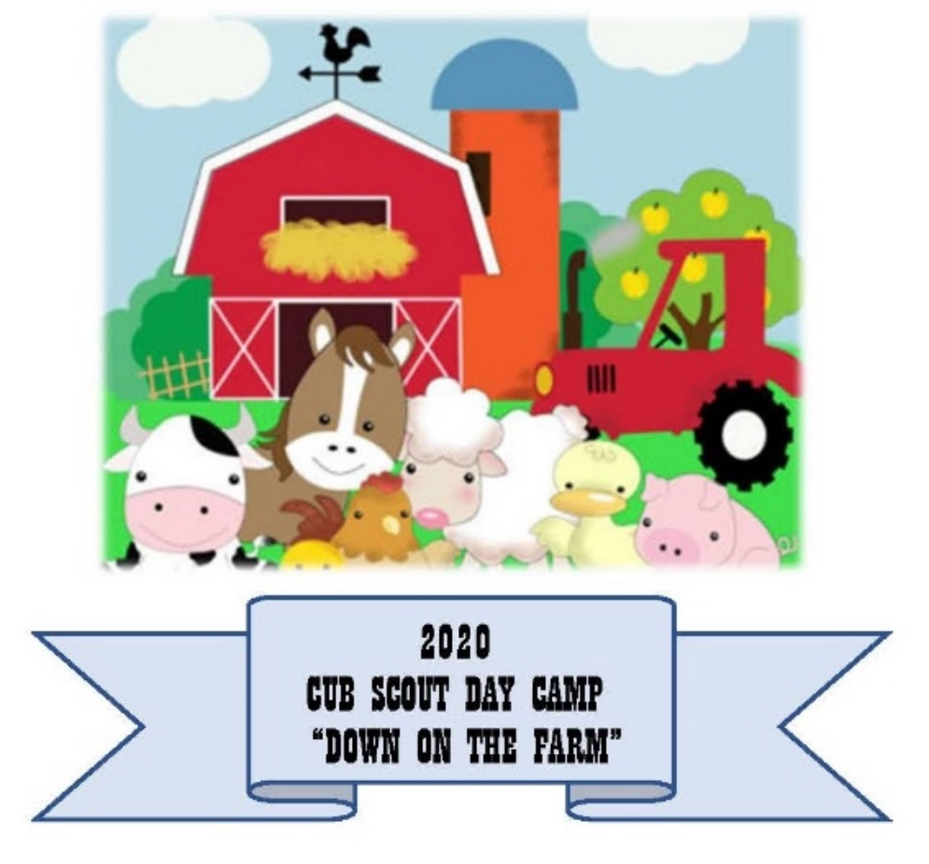
Camp Director: Kelly Wratkowski
Program Director: Natalie Miller
Assistant Scout Executive: John Erskine
Themed day camp June 15-19
*Available to all Cub Scouts*
Down and Dirty STEM camp June 22-26
STEM Nova Wild camp June 29-July 3
STEM Supernova July 6- 10
*STEM Camps are for Cubs who will be Wolves, Bears, Webelos, and Arrow of Light Scouts in Fall 2020”
Online Registration link goes here

Welcome to the Transatlantic Council’s Virtual Cub Scout day camps! These weekly online camps are offered as part of the Transatlantic Council’s Summer Spec-TAC-ular Summer-palooza where we are making Lemonade out of Lemons. Cub Scouts will have the opportunity to participate daily in Cub Scout activities and in following weeks work on acheivements towards the STEM awards. Sorry, the STEM awards programs are not available to Lions and Tigers.
The fee for the day camp- regardless of the number of camp sessions selected- is $10 per registrant. Each participant will receive a patch as part of their registration fee (to be mailed at a later time). Scouts will have the opportunity to purchase Spec-TAC-Ular neckerchiefs and camp shirts. These items will only be available online as pre-sale item. A link for the items will be on the registration page.

Week 1: Down on the Farm June 15-19 (9am-2:30pm)
Week 2: Down and Dirty STEM Nova (9am-11am, Wolf/Bear & 1pm-3pm Webelos/AOL)
Week 3: STEM Nova Wild (9am-11am, Wolf/Bear & 1pm-3pm Webelos/AOL)
Week 4: STEM Supernova (9am-11am, Wolf/Bear & 1pm-3pm Webelos/AOL)

Live sessions will be held via Zoom.
Private Facebook page where prerecorded activites will be posted.
Scouts must have camera on at all times to get credit for STEM activities.
Links will be sent out once the camp director has the registration lists.
Your Cub Scout will be assigned a den (Ponies, Ducks or Lambs). When logging in, please put their den name first. Example: Lambs Smith, John. Their assigned den will be sent out with the links (STEM camps do not have dens)
All Youth Protection and Cub Scout rules apply.
Ranks for camp are based on the child’s grade in the fall of 2020.
- Lions are upcoming kindergartners
- Tigers are upcoming first graders
- Wolves are upcoming second graders
- Bears are upcoming third graders
- Webelos are upcoming fourth graders
- Arrow of Lights (AOL) are upcoming fifth graders.
For the STEM camps (Wolves, Bears, Webelos, and AOLs), not all requirements will be finished in class. There will be homework to earn the STEM awards.

Shopping List week 1

Plastic Bag Green House
- Gallon size plastic resealable bag
- Potting soil
- Seeds (lima beans, popping corn, pumpkin seeds, citrus or other fruit seeds)
Soda Bottle Composting
- 2-liter soda bottle (make sure it is transparent)
- Scissors
- Raw food scraps (vegetable/fruit peel, tea bag, coffee grounds, raw leftovers)
- Soil
- Water spray bottle
Ant Farm Neckerchief Slide
- Tic-tac box
- Plastic ant
- 2 different colors of sand (1 should be dark)
Sponge Grass Barn
- 4 kitchen sponges
- Grass seed
- Medium reusable food storage container
Farm Animal Origami
- Origami paper
Windsock
- Tin can
- Paint/ construction paper
- Glue/ tape
- Streamers, fabric or ribbons
- Rope or yarn
Tin Can Lantern
- Clean tin can
- Paper
- Pencil
- Scissors
- 2 x 4 scrap lumber
- Duct tape
- Hammer
- Flathead nails
- Small candle and holder or batter powered t -light
Non-Newtonian fluid
- Corn starch
- Cup
- Water
- Stir stick
Rock Painting
- Smooth rocks
- Paint pens
- Paint
- Paint brushes
Slime
- Borax
- Water
- School glue
Food coloring
Knots
- Para cord (ten feet length is plenty)

Week 2 Shopping List
Down and dirty
- Corn starch
- Pie tin (2)
- Paint brush
- Sand
- Plastic dinosaurs (small)
- Colored pencils
- Plain white paper

Week 3 Shopping List
Nova Wild
- Small poster board or sketch paper

Week 4 Shopping List
There are no extra materials needed for Week 4.

Week 1 Schedule
Monday | Ponies | Ducks | Lambs | Tuesday | Ponies | Ducks | Lambs
9:00 AM | Opening | Opening | Opening | 9:00 AM | Opening | Opening | Opening
10:00 AM | Farm skills | Craft | Scout Skills | 10:00 AM | games | Craft | STEM
11am | Scout skills | Farm Skills | Craft | 11am | STEM | Games | Craft
12pm |  |  |  | 12pm | Fire station | Fire Station | Fire Station
1pm | Craft | Scout Skills | Farm Skills | 1pm | Craft | STEM | Games
2pm | Closing | Closing | Closing | 2pm | Closing | Closing | Closing
Wednesday | Ponies | Ducks | Lambs | Thursday | Ponies | Ducks | Lambs
9:00 AM | Opening | Opening | Opening | 9:00 AM | Opening | Opening | Opening
10:00 AM | Scout skills | Farm Skills | Craft | 10:00 AM | STEM | Scout Skills | Craft
11am | Craft | Scout Skills | Farm Skills | 11am | Craft | STEM | Scout Skills
12pm |  |  |  | 12pm | Bee Keeping | Bee Keeping | Bee Keeping
1pm | Farm Skills | Craft | Scout Skills | 1pm | Scout Skills | Craft | STEM
2pm | Closing | Closing | Closing | 2pm | Closing | Closing | Closing
Friday | Ponies | Ducks | Lambs
9:00 AM | Opening | Opening | Opening
10:00 AM | Farm skills | Craft | Scout Skills
11am | Scout Skills | Farm Skills | Craft
12pm
1pm | Craft | Scout skills | Farm Skills
2pm | Closing | Closing | Closing

Week 2, 3 and 4 Schedule
 | Monday | Tuesday | Wednesday | Thursday | Friday
9am-11am | Wolf/ Bear | Wolf/ Bear | Wolf/ Bear | Wolf/ Bear | Wolf/Bear
1pm-3pm | Webelos/AOL | Webelos/ AOL | Webelos/ AOL | Webelos/ AOL | Webelos/AOL

Staff
There is a minimal amount of staff needed for a virtual day camp however, the more staff there is the more Scouts we can have join the fun. Camp needs both adult staff and Scouts BSA staff (no age requirement).
The only paperwork I will be requiring is a copy of YPT certificate from Adult Staff.
If you would like to be staff, please click this link to express your interest.

Summer Recognition Items!
Each participant will receive a patch as part of their registration fee (to be mailed at a later time). Scouts will have the opportunity to purchase Spec-TAC-Ular neckechiefs and camp shirts. These items will only be available online as pre-sale item. A link for the items will be on the registration page.

Questions?
Camp Director: Kelly Wratkowski alligatormommy@gmail.com
Program Director: Natalie Miller ihilanimiller@gmail.com
Assistant Scout Executive: John Erskine john.erskine@scouting.org

