Introduction to Outdoor Leadership Skills (IOLS) Facilitator’s Guide
Troop 007 Naples, Italy

Facilitator: Paul S. Duenas, Scoutmaster, Troop 007
Date: August 29-30, 2026
Campground: Carney Park

- Section 1: Overview

- Introduction to Outdoor Leadership Skills (IOLS) is a course tailored for Scouting adult leaders that expounds on the concepts covered in Scoutmaster position-specific trainings with the purpose of helping these leaders guide scouts in their troops. IOLS use a hands-on, discussion-based approach that models the troop patrol method and equips adults with the skills to mentor scouts to safely and effectively lead themselves in an outdoor setting.

- The skills presented in this course are based on those required of scouts as listed in the Scout Handbook. Where applicable, relevant sections of the handbook are cited as it is an excellent guide for both adults and youth as they progress along their scouting journey.

- This specific IOLS course emphasizes “4-Ps” of the scout camping experience:

Plan – Prepare – Participate - Poll

- Participants in this course will be exposed to various camping techniques from both the course facilitator and, more importantly, each other. The goal of this method is for everyone to gain a deeper understanding of the patrol method, feel more confident working with scouts, and be better prepared to guide scouts in outdoor activities. Achieving these skills will hopefully bring a sense of satisfaction and accomplishment.

- Section 2: Planning and Action Milestones

- July 17: Submit Facilitator’s Guide to District Executive for review and approval
- August 8: Open Transatlantic Council portal for participant sign-up
- August 10: Submit IOLS Participant’s Guidebook to District Executive for review
- August 21: Close registration
- August 21: Receive participation list from District Executive
- August 21: Send confirmation letter and guide to participants
- August 27: Purchase food and supplies
- August 29-30: IOLS Campout
- August 31: Submit participant completion certificates
- September 1: Submit completion report and lessons learned letter to District Executive

- Section 3: Materials and Supplies

- Camping and Training Supplies

 | - Large cooler for food  - 5-gal water cooler  - Coffee maker  - 2x Camping stoves  - 6x Propane bottles  - Charcoal  - Charcoal chimney  - Lighter  - Aluminum foil  - Cutting boards  - Paper towels | - 3x Washing bins  - Dish soap  - Bleach  - 2x Dish sponges  - Cooking pans  - Dutch oven  - Cooking utensils  - Knives  - Oven mitts  - Grill tongs  - Extension cord (US) | - 6x Pioneering poles  - Rope and paracord  - First aid kit  - Ladies bag  - Axe yard box  - Tents (1 per participant)  - Fire extinguisher  - US Flag  - Troop flag  - Firewood

- Grubmaster List (Servings to be adjusted based on number of participants)

 | - Coffee  - Creamer and sugar  - Sandwich bread  - Deli ham slices  - Deli turkey slices  - Sliced American cheese  - Sliced Provolone cheese  - Lettuce  - Tomatoes  - Mayonnaise  - Mustard  - Chips (assorted box)  - Meatballs (frozen)  - Macaroni pasta  - Onions | - Parmesan cheese, grated  - Kidney beans  - Mixed veggies, frozen  - Italian seasoning  - Cucumbers  - Pita bread  - Salt and pepper  - Beef broth  - Chicken broth  - Stewed tomatoes  - Baby carrots  - Hummus  - Bananas (ripe)  - Chocolate chips  - Marshmallows (s’mores) | - Mini-marshmallows  - Apples  - Oranges (or mandarins)  - Eggs  - Butter  - Breakfast sausage  - Pancake (shake-n-pour)  - Syrup  - Granola bars  - 2x Peaches, 30oz cans  - French vanilla cake mix  - 1x can Sprite  - Cinnamon  - Graham crackers  - Bell peppers

- Meal Plan

 | Saturday
 | Breakfast:
 | Lunch: | Ham and/or turkey and cheese deli sandwiches. Pita and hummus for non-meat option. Carrots and cucumbers (sliced ahead of time). Chips.
 | Dinner: | Campfire minestrone soup. Vegetarian chili for non-meat option.
 | Dessert: | Banana boats and peach cobbler.
 | Campfire: | S’mores.
 | Sunday
 | Breakfast: | Eggs, sausage, and pancakes.
 | Lunch: | Ham and/or turkey and cheese deli sandwiches. Pita and hummus for non-meat option. Chips.

- Section 4: Schedule Overview

Day | Start | End | Activity
Saturday, August 29 | 0715 | 0815 | Registration, Check-in, and tent set-up
 | 0815 | 0845 | Introductions and IOLS Overview
 | 0850 | 0905 | Flag Ceremony instruction
 | 0905 | 0915 | Break
 | 0915 | 1000 | Planning a camping trip: purpose and place
 | 1000 | 1045 | Making the schedule
 | 1045 | 1100 | Outdoors planning
 | 1100 | 1150 | Packing it up
 | 1150 | 1200 | Break
 | 1200 | 1330 | Lunch prep, Lunch, Clean-up. Meal planning, food handling.
 | 1330 | 1345 | S.A.F.E. checklist
 | 1345 | 1415 | Campsite selection
 | 1415 | 1500 | Knots and Rope/Line Care
 | 1500 | 1515 | Break
 | 1515 | 1545 | That’s ‘in-tents!’
 | 1545 | 1630 | Outdoor Ethics and Activities
 | 1630 | 1645 | Plants and Animals
 | 1700 | 1830 | Dinner prep, Dinner, Clean-up, Dessert prep, Cooking instruction, mess gear clean up and instruction.
 | 1830 | 1915 | Axe and Knife Safety and Toten Chip requirements
 | 1915 | 1945 | Campfire setup and Firem’n Chit.
 | 1945 | 2130 | Campfire Program. Hazardous weather considerations. Fireside chat.
 | 2130 | 2145 | Day 2 agenda review
 | 2145 | 2200 | Hygiene and lights out.
Sunday, August 30 | 0700 | 0730 | Morning roll-out
 | 0730 | 0845 | Breakfast prep, Breakfast, Clean-up.
 | 0845 | 0915 | Camp cleanliness and safety checklist
 | 0915 | 1000 | Pioneering Projects
 | 1000 | 1015 | Break
 | 1015 | 1030 | Interfaith service and prayers discussion
 | 1030 | 1100 | Roses, Thorns, and Buds
 | 1100 | 1200 | Camp clean up, break down, pack-up
 | 1200 | 1230 | Lunch, Dismissed

- Section 5: Course of Instruction

- Registration, check-in, tent set-up
  - Collect forms:
    - Medical forms A and B (C not required)
    - SYT Certificate
    - HWT Certificate
  - Introductions:
    - Name:
    - Troop and position (if not 007)
    - Camping experience (not just Scouts)
    - Why are you taking IOLS? What do you hope to learn?
  - Campsite orientation
    - Safety:
      - Troop first aid kit
      - Location of AED
      - Emergency numbers
      - Location of fire extinguisher
    - Water stations, restrooms, campsite boundaries
    - Meeting point for inclement weather.
- Camp set up
  - Tent set up
  - Axe yard set up
  - Unpack supplies
- About the course…
  - IOLS vs BALOO
    - Basic Adult Leadership Outdoor Orientation – teaches how to plan and lead a camp out for Cub Scouts
    - Introduction to Outdoor Leadership Skills – teaches how to guide and mentor troop scouts as they plan and lead a camp out
      - Focuses on youth leaders building camping skills
        - Activities, ideas, policies, to help adult leaders to mentor scouts in building safe and worthwhile camping experiences.
        - Focus scouts on the patrol method
  - “Scout led” campouts
    - How do we apply EDGE (Explain, Demonstrate, Guide, Enable) method to campout planning and execution? [Chapter 1, Pg 38]
    - How do we teach scouts to use the EDGE method?
  - Role of adult leaders in troop campouts
    - Guides and mentors – Camping experience is helpful but “expertise” is not required
    - Just need a common framework to ask questions, provide guidance, monitor safety
    - “Shepherd” scouts to solid/safe plans – ask “what is your plan?”
  - IOLS required to be “fully trained” in addition to SYT, HWT, and position-specific training.
- My thoughts on the scouting experience: “4-Ps” of the camping experience
    - Plan – Scouts think about what they want to accomplish
    - Prepare – Scouts think/do what is necessary to be ready to execute camping plan.
    - Participate – Scouts execute their plan
    - Poll – Scouts discuss how camp went, focus on how to make the next campout better
- Schedules and Program Guide
  - See schedule in program guide
  - Will try to stay on task but will take time needed to discuss things groups see important
  - May anchor on various topics (sometimes may be random); will support conversation on important or interesting/relevant topics
  - Scout Oath and Law – everything we do starts with this.

- FLAG CEREMONY instruction
  - Many variations, overall goal is to be reverent
  - Orders (Handbook, Pg 49)
    - Advance
    - Display the colors
    - Prepare to raise/lower the colors
    - Raise/Lower the colors
    - Salute
    - Pledge of Allegiance – Scout Oath – Scout Law – Outdoor Code
    - Color Guard reform, dismissed

-- BREAK --

PLANNING A CAMPING TRIP

- PLAN a camping trip – Handbook Page 263-264
  - What is the troop trying to accomplish at this campout?
  - Have a purpose – Why are we camping?
    - Advancements and Merit Badges are a good place to start
      - Advancements – Handbook Pg 268
        - Patrol Leaders identify what requirements their patrol members need
        - “Scout Skills” campout
        - Builds skills ( = confidence)
        - Opportunities for older scouts to teach younger scouts
      - Merit Badges
        - Cooking (Eagle), Camping (Eagle), Hiking, Pioneering, Wilderness Survival, Pioneering
        - Designated merit badge counselors within troop
  - Rules for adult leaders
    - 2-deep leadership, Guide to Safe Scouting
    - At least one female adult leader (21+) when female scouts participate
- Reserving a campsite
  - Where is your troop’s “go-to” campground? Why?
  - Things to consider when picking a campground:
    - Public or private?
- Service project discussion – part of the campout?
  - Conservation project?
  - Reinforces service to community – a way to give back to community and ‘do a good turn’
  - Service hours. Counts to requirement for 2nd Class through Life Scout.
  - What are some types of community service projects? (beach clean up, hiking trail upkeep)
- Making the schedule – this is an area where scouts need a lot of mentorship (either over or under estimate time)
  - “Show time to Go time” When/where to rally scouts?
    - Teach scouts to work backwards in planning
    - Should setting up camp before sunset be a consideration?
  - Build in time for clean up, transition to next event.
  - How much free time is good?
    - White space is important.
    - Too much prevents boredom (trouble)
- Outdoor planning – Hiking, weather, outdoor ethics – Handbook Chap 7 Pag 221, Chap 8 Pgs 237-255
  - Hiking is a fantastic way to get scouts moving, appreciate nature, and learn about the world – Handbook Pg 247
  - Important to plan ahead in order to ensure a safe experience
    - Maps, trails (alltrails.com could be a handy reference)
      - Do scouts know how to read maps and trail guides—perhaps a good troop meeting activity
    - Key considerations:
      - How long is the trail?
      - When was the last time someone used the trail? (if ever)
      - What kind of terrain? What is the difficulty level?
What gear is required?
      - Dangers along the trail? Dangerous plants/animals on the trail?

PREPARING FOR A CAMPING TRIP

- Packing it up – Handbook Ch 8 Pgs 267-273
  - What does the troop bring – Ch 9 Pg 269
    - Flags, flag poles, flag stands?
    - Tables, chairs, cooking/cleaning gear
    - Rope, pioneering supplies
    - Who plans this out? Is there a standard list the scouts can make and use?
  - Troop first aid kit – REQUIRED!
    - What goes in it? – Handbook Ch 9 Pg 109
      - Do scouts (and adult leaders) know what’s in it?
      - Who checks it? How often? Maybe a job for a scout?
  - Other troop item to consider
    - “Ladies Bag” -- Share story about “ladies bag”
      - Be sure it as appropriate items for the females in the troop.
    - Toothbrush/toothpaste – Ther’s always one scouts who forgets. Hotel stuff works great!
    - American Red Cross First Aid app – show on phone
  - What do the Scouts bring?
    - 10 essentials – Good thing for older scouts/patrol leaders to check at scout meetings prior to camp – Handbook Pg 268
      - Pocketknife
      - Flashlight
      - Sun protection
      - Trail food
      - Matches/fire starters
        - Fire starters can be made at home – great Troop meeting activity!
          - Cotton balls and wax
          - Dryer lint lightly wrapped in twine
          - Container that also has duct tape
      - Rain gear
      - Extra clothing
      - Map and compass
      - Water bottle
      - First aid kit* - Handbook Pg 109
        - Personal First Aid Kit – what goes on this? Another great idea for a troop meeting activity
    - Get scouts to think about the “right” gear – see sample packing list
      - What activities are they doing? How many days at camp?
      - Weather
      - How much space will they have?
      - Hiking or swimming?
      - Will they have to carry gear to the campsite?
  - Teaching scouts how to pack – Another good Troop/Patrol time topic
    - Having a good backpack/duffle bag makes a difference
    - Packing methods
      - Avoiding the “dump and stuff” method
      - Ranger rolls and shirt pocket folds
      - Ziplock bags
      - Space cubes

  - Sample packing list – scouts encouraged to make their own list of what they need. We each have our own methods.
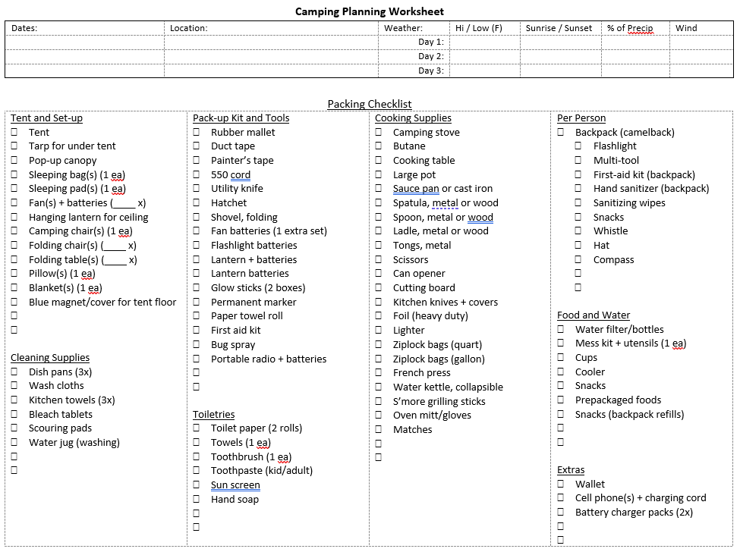

-- LUNCH --
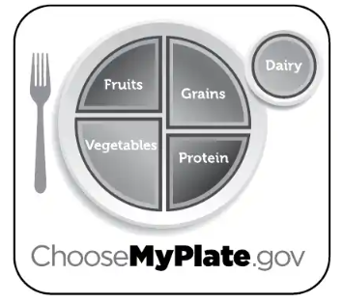

- Meal Planning and Food Handling – Handbook CH 10 Pgs 289-325
  - Keep it simple. Keep it healthy.
    - Plan 3 meals per day. Do you include snacks?
    - Determine per meal/per person costs – Troop 007 typically $5. This will determine the budget.
    - Plan healthy options.
    - Dietary concerns. How do you plan for this?
    - Easy to plan, easy to cook, easy to clean.
  - Grubmasters
    - How are these scouts assigned? By patrol? By Troop?
    - Do scouts know how to shop at the grocery store?
  - Cooking
    - How are the cooks assigned? – Cooking a meal at camp is a rank requirement.
    - How much oversight do you provide?
    - Should we have cooking classes as a Troop meeting topic?
    - Best way to prep cooking kits – Handbook Ch 10 Pg 302
  - Food preparation
    - Pre-packaging can help cut down prep time at camp.
  - Food handling – Keep it COLD, Keep it CLEAN, COOK it thoroughly (3 Cs)
    - Ensure all knives, cooking utensils, cutting boards, and pots/pans are clean
    - Use food gloves when working with food
    - Separate cutting boards for fruits/veggies, meat
    - Perishable foods should be kept in refrigerators (if available) or coolers with ice (33F-40F is the target zone)
      - If in coolers, keep from sitting in melting water
  - Safety considerations for…
    - Gas (propane or butane) grill cooking
    - Charcoal cooking
    - Electric griddle cooking

PARTICIPATING

- S.A.F.E. Checklist -- Guide to Safe Scouting
  - All adult leaders are SAFETY MONITORS.
  - S.AF.E. checklist to be used at all scouting events
    - Supervision – accept responsibility for youth safety. Trained/qualified adult leaders
    - Assessment – Think through each event. What could go wrong?
    - Fitness and Skill – Are activities safe and within capabilities of the scouts (and adults)?
    - Equipment and Environment – Check gear (right gear and it works) and event area
  - Use this quick checklist to verify that campsites and camping activities are either free of dangers or dangers are mitigated.
  - We’ll cover campsite safety tomorrow
- Campsite Selection
  - What do you look for in choosing a campsite area?
    - Handbook: “A good campsite is found not made.” – What does this mean?
  - Chapter 9 provides things to consider in choosing an area for setting up camp.
    - Is the size of the camping area sufficient for the size of the troop?
    - If staying a long time, consider shifting tent spot to avoid killing vegetation.
    - Areas to avoid:
      - Under precarious branches
      - On hillsides or at immediate base of a hill where water runoff can be expected
      - Immediately adjacent to walking trails
      - Near roadways
    - Consider Leave No Trace principles – Well cover this in a follow-on section.
    - Overall ideas: safe, organized, professional appearance
    - Tent organization – Excellent challenge question for SPL, ASPL, and Patrol Leaders: What is your plan to set up camp?
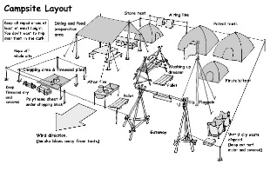
      - Scouting Safely requires clearly defined and separate areas for adults, scouts, females
      - Campsite layout (show diagrams)
        - Patterns: circular, square, rows
        - Create single entranceway
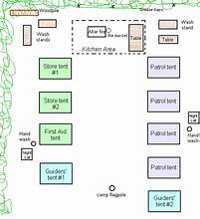
          - Easy access to camp area and other common areas, potable water sources, and restrooms
          - Reduces other campers from accidentally passing through campsite
        - Safety considerations
          - Having all tents face the same direction reduces chances of people tripping on guy lines
          - Tent distance from campfire/cooking areas (at least 15 feet)
          - Axe yard clearly marked off
          - Stay near traveled areas
    - Elements of a campsite (MANY factors)
      - Clearly defined campsite perimeter
      - Troop first aid kit – should be visible and accessible (non-negotiable)
      - Tent lines
      - Axe yard
      - Cooking/eating areas
      - Restrooms

-- FIELD TRIP! –

    - Camp inspection
      - Review elements from previous section.
- Knots and Rope/Line Care
  - Knots – What knot to do. – Handbook Pgs 366-371
      - Square knot
      - Two half-hitches
      - Taut-line hitch
      - Sheet bend
      - Bowline
      - Clove hitch
      - Timber hitch
  - Rope and line (aka cordage) care – Tenderfoot requirement
    - Fusing
    - Whipping

-- BREAK --

- That’s In-Tents
  - Checking tent set-up
    - Ground tarps are not exposed
    - Sides are taut with air gap between rain fly and tent
    - Tent staked down and guy lines not creating trip hazards
  - How do we assign tent buddies?
    - Age requirement – Guide to Safe Scouting
      - “For Scouts BSA…participants shall tent with other youth participants of the same gender and within two years of age.”
      - Adults 18+ CANNOT tent with youth under the age of 18
      - New change, scout may tent with a parent for purposes of special needs or care

-- FIELD TRIP! –-

- Camp “Oh No”
- Tent not tight.
- Tents not facing same direction.
- Tent under tree.
- Tent on a slope.
- Tarp exposed from underside of tent.

- Outdoor Ethics and Activities
  - Stress the Outdoor Code (back of guide)
  - Outdoor Ethics – Handbook Pg 227 (LEAVE NO TRACE PRINCIPLES) – Teach Cub Scout mnemonic
    - Plan ahead and prepare – Know before you go
    - Travel on smooth and durable surfaces – Choose the right path
    - Dispose of waste – Trash your trash
    - Leave what you find – Take only pictures
    - Minimize campfire impacts – Be careful with fire
    - Respect wildlife
    - Be considerate with others
  - Prepare scouts to follow “S.T.O.P.” if they get separated and/or lost on a hike
    - Stay calm
    - Think
    - Observe
    - Plan
  - Map and compass
    - Mobile devices versus Map and Compass
      - Pros:
        - Ease of use
        - Can easily share routes with other devices
        - Keep easy record information of trail (elevation, distance, time, etc.)
        - Can call in emergencies and/or use “find my phone” app
      - Cons: Requires
        - Requires cell signal and battery
        - Over-reliance can distract from orienteering skills
      - Considerations
        - Mobile devices can be a good tool as long as you are aware of the advantages and disadvantages
        - Ensure device is set to “magnetic” if using it to orient a map—can introduce error.
    - If a map is required for a trail, this would be an excellent training item for a Troop meeting
    - Understand how to read contour maps
- Plants and Animals
  - What are some things we’d want to know about regarding the plants and wildlife in and around our campsite?
  - Concerns with plants
    - Plants that can hurt us: Poisonous/irritating, thorns/sharp edges, can cause allergic reactions, unsafe to eat
    - Plants that indicate the environment: poison ivy indicates areas to avoid, some plans can indicate wet lands, some are good for shelter and food
    - Don’t pick, eat, or touch an unknown plant – don’t do the same to a plant known to be harmful or irritating.
  - Concerns with animals
    - 4 rules for dealing with wildlife
      - Don’t touch (observe only)
      - Don’t approach (keep distance, avoid disturbing)
      - Don’t feed (may introduce unwanted attention)
      - Don’t chase (may result in aggressive behavior from animal)
  - We need to be the example.

-- DINNER --

- Cooking Instructions
  - Campfire Minestrone Soup (serves 6)
    - Heat 30oz chicken broth and 15oz beef broth in Dutch oven.
    - Add 1x package of meatballs (about 18oz), 1x can of stewed tomatoes (about 15oz), 1x cup of elbow macaroni, and 1x package of frozen mixed vegetables (about 16oz).
    - Cover Dutch oven and bring to boil (about 10 minutes).
    - Remove cover, stir, and reduce heat to medium. Add 1x drained can of light red kidney beans and 1x teaspoon of Italian seasoning.
    - Simmer, stirring frequently until macaroni is tender (about 6-7 minutes).
- Mess Gear Clean-up – 3 pan method – heat water (not boiling) as everyone is finishing dinner.
  - Empty all food debris into trash.
  - Prep the pans
    - Hot water wash w/ detergent.
    - Hot water rinse.
    - Cold water sanitize.
- Dessert Prep – Need hot coals
  - Dutch Oven Peach Cobbler
    - Line Dutch oven with liner or aluminum foil.
    - Drain 2x cans of 30oz cans of peaches and then dump into Dutch oven, spreading evenly on the bottom.
    - Pour entire box of cake mix on top of peaches and spread evenly.
    - Pour can of Sprite over mixture. (Some recipes add an additional 1 cup of sugar.)
    - Cut 1/3 cup of butter into thin slices and evenly place on tome of mixture.
    - Dust with cinnamon.
    - Cover and place coals to make 350deg F. Cook for 35-45 minutes until top is brown and crisp in texture.
  - Banana Boats
    - Cut halfway to three-quarters way through a whole banana (with peel) down the middle along the concave side without cutting all the way.
    - Open cut and stuff with desired toppings.
    - Wrap banana in parchment paper and then in foil.
    - Place directly on hot coals until warmed through (about 10 minutes).
- Axe and Knife Safety and Toten Chip Requirements
  - Stress safety – Scouts enjoy the privilege of using axes and knives.
  - Toten Chip Requirements
    - Read, understand woods tools use and safety rules from Handbook.
    - Demonstrate proper care, handling, use of pocketknife and cAwood tools.
    - Respect safety rules around uses of knives and wood tools.
    - Cut living and dead trees only with permission.
  - Pocket knife use
    - Safety
      - Safe habits for opening and closing knives
      - Safety circle. Don’t catch a falling knife.
      - Fixed and butterfly blade knives are not allowed
      - Scouts must have a Toten Chip to carry a pocket knife.
    - Practice cutting and/or whittling a piece of soft wood.
      - Scouts love to make pointy sticks.
      - Make a fuzzy stick or kindling for the campfire.
  - Axe use
    - Safety
      - Demonstrate proper way to carry axe
      - Eye protection
      - Proper set up of axe yard
        - Roped off and clearly marked
        - Single entrance
        - Large enough for at least one person to safely use axe
    - Practice chopping wood for campfire.
- Campfire setup and Firem’n Chit Requirements
  - Types of fire lays
    - Star
    - Teepee
    - Log cabin
    - Pyramid
  - Prepping the fire lay: Tiny – Kids – Food
    - Firestarter
    - Tinder – tiny twigs, dry pine needles, dry grass, shredded bark, and leaves that catch the spark. FILL HAT ONCE.
    - Kindling – pencil sized sticks. FILL HAT TWICE.
    - Fuel – fat logs to keep fire going
  - Fire safety
    - Distance from tents and clearance around fire.
      - Scouts BSA requires 15 feet from tents, shrubs, trees, and/or other flammable objects.
      - Check for hanging branches above fire.
    - Check that area under fire (if raised fire pit) is not dry
    - Fire extinguisher, water bucket, or sand.
    - Campfire should be appropriate size and should only last as long as needed.
    - USE OF LIQUID FUELS IS PROHIBITED.

-- CAMPFIRE --

- Campfire Program - Handbook page 387-391
  - Why make a campfire? – iconic campfire
    - Warmth
    - Brings people together.
    - Snacks
  - Why skits?
    - Fun, laughter
    - Builds communication and confidence
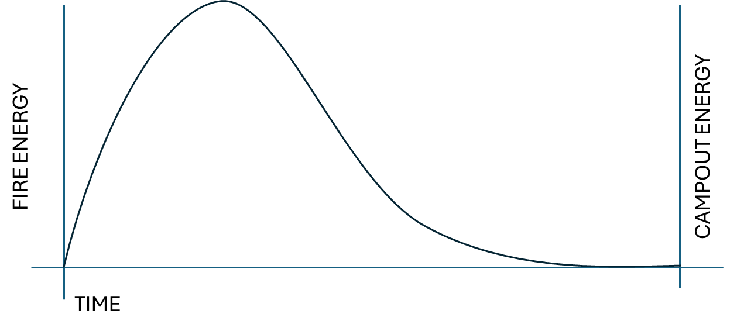
  - Follow the fire
    - Skits
    - Fireside stories and songs
    - Vespers
    - Close out
    - Put out the fire!
- Hazardous Weather Considerations
  - Any one have stories of camping in bad weather?
  - BSA Hazardous Weather Training required for all Scoutmasters and Assistant Scoutmasters
  - Scouts and adults should watch weather forecasts before camp.
    - How to be ready for weather
      - Tent checks – great practice for older scouts to do, especially checking younger scouts
      - Secure loose items (ropes, papers, trash, anything that can blow away)
      - Have a place to keep items (food, equipment, etc) dry such as a storage tent, in cars, or in a pavilion
      - No gear left outside tents
    - Pay attention to changes in weather. Don’t need to be a meteorologist to know that something is different:
      - Quick changes in temperature
      - Changes in cloud cover
      - Quick changes in air pressure or humidity
    - Weather “rhymes” can be found in Handbook Pg 217.
    - What to do when bad weather is forecasted or starts to set in
      - Remove loose items, get items to the dry area.
      - Verify all tents are secure.
      - Make a decision point to move to shelter or break camp
        - Be sure to include time required for transition – share story of Klondike at Atsugi
    - Lightning Risk Reduction – Guide to Safe Scouting
      - “When thunder roars, go indoors.”
        - Safe building—fully enclosed with walls, roof, floor
        - Safe vehicle—hard top
        - Stay inside until 30 minutes after last rumble of thunder
      - When hiking
        - Spread group apart
        - Stay clear of tall, isolated objects
        - Stay clear of metal fences and bodies of water (lakes, puddle, etc.)
- Fireside Chat
  - Why do you Scout?
  - Why did your put your kid(s) in Scouts?
- Day 2 Agenda Review

– LIGHTS OUT --

- Morning Roll-out

-- BREAKFAST --

- Breakfast
  - Scrambled eggs (pre-packaged in ziplock bags)
  - Pancakes (shake and pour)
  - Breakfast sausage
- Camp Cleanliness and Safety Checklist
  - This is an excellent item to teach scouts and have them take ownership.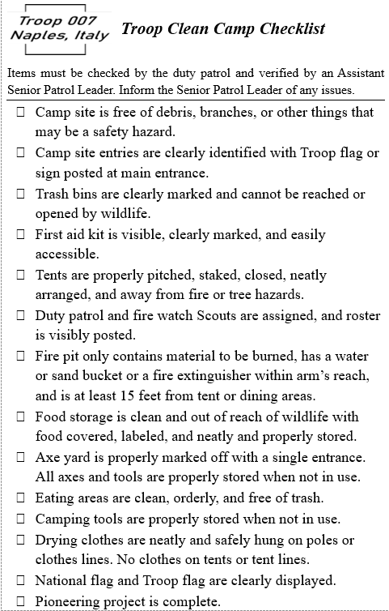
- Pioneering Projects
  - Benefits of campout pioneering projects (they don’t need to be complex)
    - Teach and practice knot tying skills
    - Builds teamwork, problem-solving skills, and a sense of accomplishment
    - Projects can be practical: drying racks, cooking tripods, etc.
    - Can be used to fill time
  - Easy lashings
    - Square lashing – can be used to build a flagpole
    - Shear lashing -
    - Diagonal lashing
    - Tripod lashing – can be used for cooking, doubled to make signs
    - Round lashing
  - Safety:
    - No more than 6 feet high to avoid toppling
    - Avoid creating trip hazards
    - Lines/ropes at eye level or higher to prevent tripping hazards

-- BREAK --

- Interfaith Service and Prayers Discussion
  - "When asked where religion came into Scouting and Guiding, Baden- Powell replied, It does not come in at all. It is already there. It is a fundamental factor underlying Scouting and Guiding." (Religion and the Boy Scout and Girl Guides Movement-- an address, 1926).
  - I will tell you this can be a controversial element. Simple, and yet the deep meaning behind faith makes this take on so many dimensions.
  - Do you think spirituality should be included in our activities? (No right or wrong answer).
  - Is this something we let the scouts decide to include on their own? Or, something we as adults establish and guide them in running like using the patrol method?
  - Scouts has an intrinsic spirituality dimension in order pledge to do our “duty to God.”

POLL

- Roses, Thorns, and Buds
  - Get scouts input on how the campout went. Closer to the event is always better.
    - Keeps them engaged and reinforces that scouting is about them.
    - Uses their ideas to continue and/or improve scouting program
  - Practical
    - Roses: What did you like about this IOLS campout?

    - Thorns: What didn’t you like about this IOLS campout? If we did it again, what should be removed?

    - Buds: If we did it again, what should be added?

- Camp clean-up, break down, and pack up
- Lunch/Dismissed

