**Suggested Packing List For BALOO Training**

• Tent, Sleeping bag and pillow

• Sleeping pad

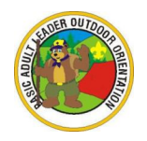• Sturdy shoes

• Change of clothes

• Warm sleeping attire

• Mess kit

• Soap, washcloth, towel

• Sunglasses

• Camp chair

• Notebook, pen, pencil

• Coat or jacket, cap, and gloves

• Cub Scout Six Essentials:

1. First Aid Kit

2. Water Bottle

3. Flashlight

4. Trail Food

5. Sun Protection

6. Whistle

Some classes will be held outside, so please prepare for the German weather!