Hey, new Cub Scout Leaders!
 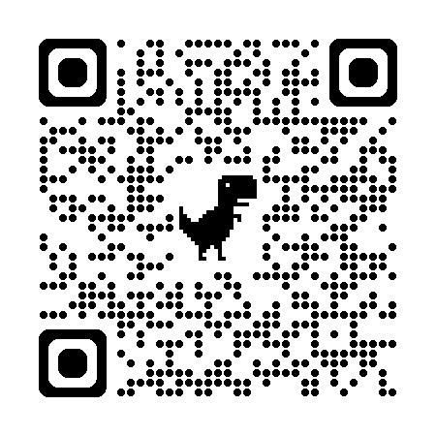
We have four offerings of in-person Cub Scout Leader-Specific Training
Cubmasters and Assistants, Committee Chairs and Committee Members, Den Leaders and Assistants
8:00am – 2:00pm
Limit of 20 per session
Cost is $5
Bring a lunch
Dates/Locations:
September 12th - Pack 25 Scout Hut
33 Ellisor Street, Defuniak Springs, FL

September 19th - Troop 544 Scout Hut
55 Ferry Road, Fort Walton Beach, FL

October 3rd – First Methodist Church
599 8th Avenue, Crestview, FL

November 14th – Mary Esther UMC during Adventure Zone
703 E Miracle Strip Pkwy, Mary Esther, FL

Registration link: https://scoutingevent.com/773-CubLeader2026
Contact Info: Mic Wehmeyer, mic.wehmeyer@gmail.com, (850) 319-1802

